There are 3 sections …

- Linking
- Critical path
- Example of critical path
Linking

There are various ways of creating and changing links….

  - Draw links with the mouse on the screen
  - Link consecutive bars Finish to Start with the LINK icon
  - Link random bars Finish to Start with the LINK icon
  - Using Link List
  - Using Predecessor and Successor columns
  - Using Task Form
  - Bar flag
  - Using Logic Diagram
  - Using Task List

• Linking with a mouse with both bars onscreen

This method is the most common as it is quick and easy to follow. However, both tasks must be on the screen in order to link them.

Links can only be drawn from and to the four corners of a bar. First, move the cursor to the left of the bar or to the right of the bar until the cursor changes to a cross.....you cannot draw a link unless the cursor is a cross 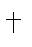

Then click on the mouse and holding the left mouse button down, drag the mouse to the start or the end of any other bar on any other row and then click off the mouse near the bar and Project Commander will align the symbols vertically in time. Whenever you edit any bars or links on the chart, a yellow box (DATA TIP) will appear to left and above the action to confirm or assist you with the action.
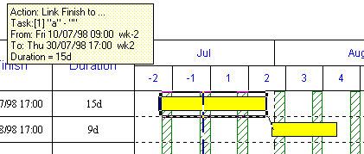

• Link types

There are 4 types of links ….

START FINISH FINISH START
TO START TO FINISH TO START TO FINISH

Links do not have to be always downwards; they can be linked upwards (even though it is usual to create Barcharts in chronological order in a stepped fashion).

Important
If you zoom the screen down, sometimes the bars are too small for you to get the linking cursor to appear and it can be difficult to drag the link and to identify & click off the correct bar.

You cannot use the mouse to link across pages – as Project Commander only displays one page at a time – you need to use the Link List.

• Linking terminology

The bar from which you link to is called the SUCCESSOR and the bar that you link from is called the PREDECESSOR. A straight line link is known as a Simple Link. Where bars need to overlap or there needs to be a delay on the link (for a drying period or delivery time), these are known as LAGS and Complex Links.

• Lags

When you require LAGS, on the bar receiving the link, you can drag the bar to the left or the right.

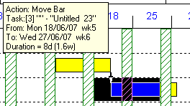
When you drag the TO bar with the mouse, a yellow box (DATA TIP) will appear to left and above the action and the dates into the box will change as you move the bar.

You click off the mouse and it will drop the bar on the date indicated in the box and will calculate the LAG automatically – which is the interval between the current position if the bar and the previous position.

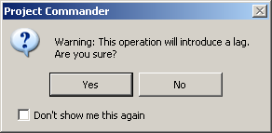
When you click off the mouse button, the following message will appear.

If you click on YES – the lag is calculated and the TO bar will remain where you dragged it to.
If you click NO – the current lag will be abandoned and the TO bar will return to its previous position.

Note. If you creating many lags, this message can get tiresome, so you click on DON’T SHOW ME AGAIN and you will not see this message again.

If the link points to the right – it is known as a positive lag and if it points to the right it is known as a negative lag.

    - START TO START LINK WITH A FIVE DAY POSITIVE LAG
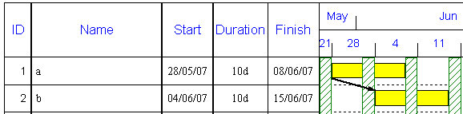

    - FINISH TO START LINK WITH A FIVE DAY POSITIVE LAG
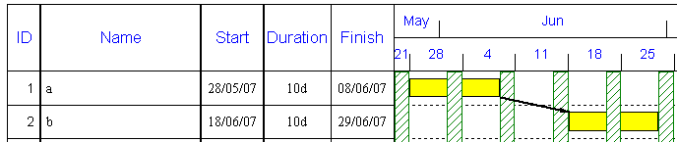

    - FINISH TO START LINK WITH A FIVE DAY NEGATIVE LAG
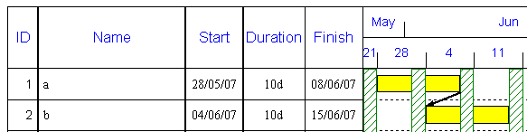

• Rescheduling

As soon as the link is drawn and release the mouse, the bar receiving the link will move according to the type of link drawn.

The great benefit of linking, is that when any bar moves in the future all connected bars (that are not locked) will also move and be rescheduled.
If there is a lag on the link, that interval is retained when bars move.

Important
You can have as many links going from a bar and as many links going into a bar. If there are more than one link going into a bar, the bar is scheduled using the link that sends it to start at the latest date.
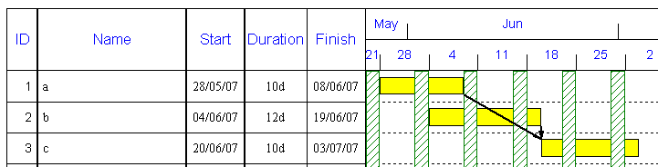

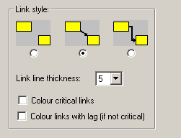
• Link Style

The link can appear as a straight line between bars (default) or as a jagged link.

Select OPTIONS menu PREFERENCES and & LINKS (Tab) and then click on the appropriate box.

The type link and thickness can also be changed from the default of 5 – which makes lines appear quite thick.

In order to differentiate between simple links and complex links (ie. with lags), you can click on COLOUR LINKS WITH LAGS and it will display them as blue links (instead of black – which is the default).
• Hide Link

There are 2 ways to hide links for printing.

Select OPTIONS menu PREFERENCES and & LINKS (Tab) and then click on the appropriate box. Even though the links are hidden, they still exist and will cause tasks to be rescheduled using the links.

Also you can click on the HIDE LINKS icon on the toolbar

• Link two bars Finish to Start with the LINK icon
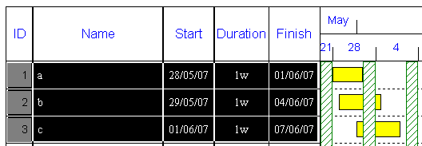
If you have two bars or a block of consecutive bars, that you want to link FINISH TO START, with the mouse drag down the rows under the ID column

Next click on the LINK icon in the toolbar
The following message will appear. Click on YES to activate the linking. 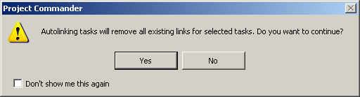

The bars will be rescheduled immediately ..
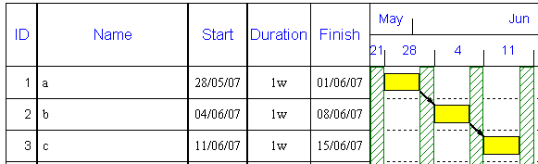

Note. The toolbar icon only can be used for FINISH TO START links. You cannot create other link types.

• Link random bars Finish to Start with the LINK icon

You can hold the CONTROL key down and click on ID Numbers to select random bars for further action.
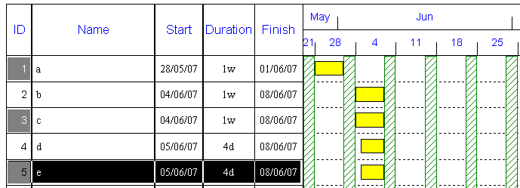
To link rows 1,3 & 5, click on the respective rows while holding the CONTROL key down.

Then click on the LINK icon in the toolbar and FINISH TO START links will only be created between the highlighted bars in sequence.

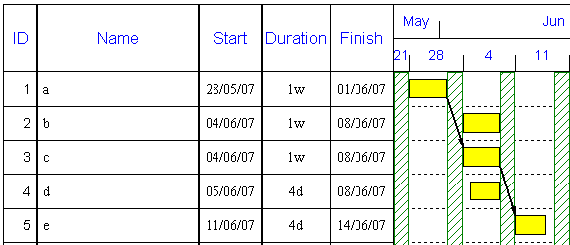

• Linking via the LINK LIST

As an alternative to linking with the mouse – which can be difficult if a long timescale is compressed on the page.
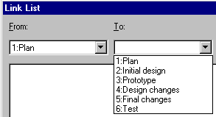
Click on LINK LIST icon or select the EDIT menu LINK LIST

The link is specified by choosing a FROM task and a TO task. Click on DOWN ARROW of FROM and TO and choose the tasks to link.

The next step is to specify the link type by clicking on DOWN ARROW of TYPE and selecting the appropriate LINK TYPE ..

FS – Finish to start SS – Start to start

FF – Finish to finish SF – Start to finish

The LAG is optional and can be left blank. When the ADD button is clicked, the link will appear in the white box below. When you click on CLOSE, the links will appear on the chart and the bars will be rescheduled.
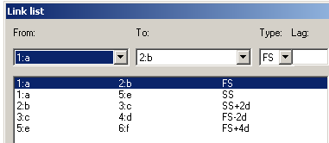
In the list, the first column is the FROM bar, the second column is the TO bar and the third column is the link and attached to it is a LAG if appropriate.

If there is no + or – sign after the link, then that
means that these are simple links. The + and – lags will cause the link to point backwards or forwards.

Note. The days in the lag, mean working day intervals.
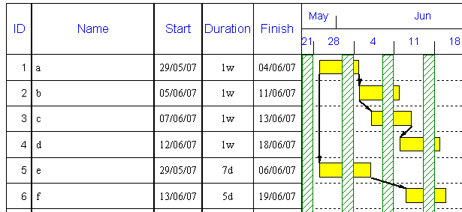

Important
Using the Link List is the only way that you can link bars across pages, as you can only view one page at a time on-screen.

Cross page links show an arrow going into/out of the bar with a reference to the ID number, task description and link type.
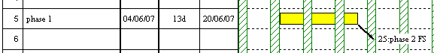

• Using Predecessor and Successor columns

The bars that link to the current bar are called Predecessors and the bar the current bar links to is called the Successor. There are columns are available to include in any views/reports. There is a View that already contains them, select the VIEW menu MORE VIEWS and TABLE

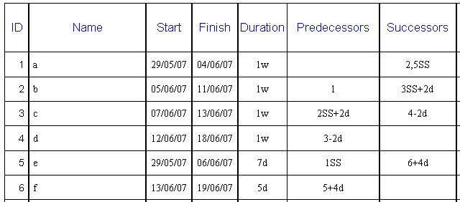

If a bar is unlinked – then there is no entry in either the Predecessor or Successor fields.
If either the Predecessor or Successor field for a bar is blank, it means that no link exists.
If the link is a simple Finish to Start link, the link is shown as a row number only – any others are shown with the letters SS,FF,SF.

If there is more than one link, the link formulas are divided by a comma (see ID 1 Successors.

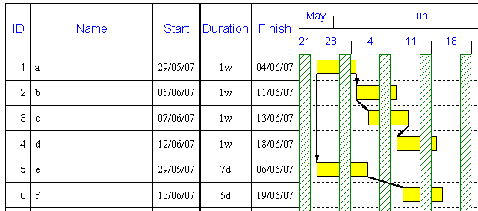

• Using the Task Form

You can split the screen and have a view/report at the top and a TASK FORM at the bottom – which holds most of the information under tabs at the bottom. Select the VIEW menu TASK FORM.

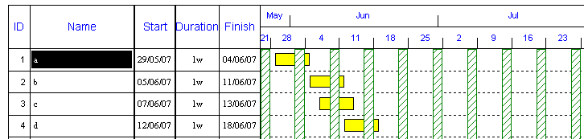

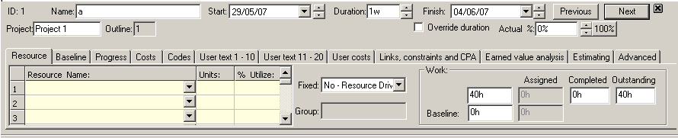

When you click on the Task Name – the Task Form will change as it displays information about the highlighted task in the top window.

If you click on the LINKS tab, it will show any entries in the Predecessor or Successor field.

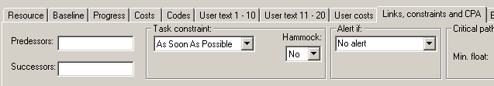

You can in fact edit and add new links by typing directly into the relevant fields above.
For example, enter 2 in the Successor field and click on OK in the Task Form.
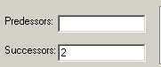

The link will be show in the chart above and the bars are rescheduled.
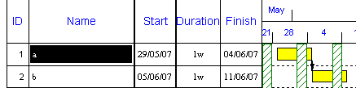

If there are more than one link, the formulas are divided by a comma and an entry in each the Predecessor or Successor fields

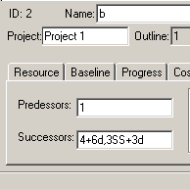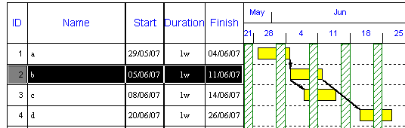

In the TASK FORM is a TASK CONSTRAINT box. This puts extra constraints on a link.
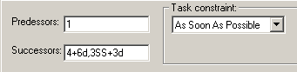

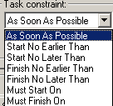
The default is As Soon as Possible … means the bar will start as soon as the link allows it.
Start no Earlier Than … means the bar will not start any earlier than the date input.
Start no Later Than … means the bar will start before the date input .
Finish no Earlier Than … means the bar will finish always after the date input.
Finish no Later Than … means the bar will finish before the date input.
Must Start On & Must Finish On … means the task is fixed on the start or end date input.

When you click on any Date Constraint other than AS SOON AS POSSIBLE, the form will ask for a relevant date
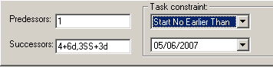
The Date Constraint overrides the link if it schedules the bar to an earlier or later date.

The default Date Constraint is AS SOON AS POSSIBLE and has no effect on the link.

• Using the Task Flag

The dates scheduled for bar that are linked can be overwritten by Date Constraints. Sometimes a task is needs to be locked to a definite date. This can be done quickly by clicking on the centre of a bar to highlight it and clicking on the blue FLAG in the toolbar
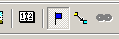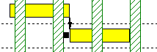

A flag will appear at the front of the bar in the chart.

If the bar linking to this bar, then moves, the bar with the flag stays fixed and will not move – in either direction.

Note. This is an alternative to a MUST START ON Date Constraint. Any Date Constraint will override the flag.

The flag can be removed by clicking on the blue flag – but when removed the bar will be rescheduled according to the link.

To retain the flags, but hide them all for printing, select the OPTIONS menu PREFERENCES, CHART tab and click the tick OFF
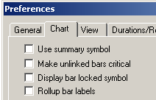

• Using the Logic Diagram

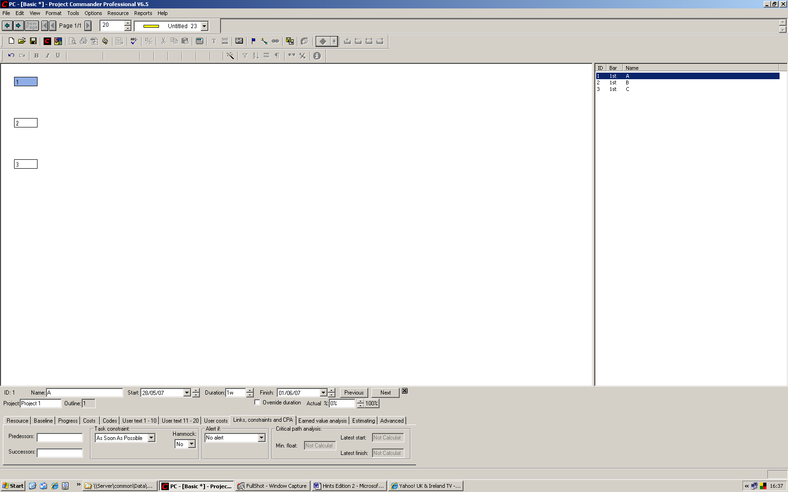
Task and links can be changed or entered in the Network Diagram View. Select the VIEW menu NETWORK DIAGRAM.
The screen is made up of 3 parts ..
  - Left – a box for every task
  - Right – a list of task bars in ID sequence
  - Bottom – the TASK FORM open at the LINKS tab.

As you click on a task in either area, all the information in each window is synchronised to that highlighted task.

You can use this to input links in the TASK FORM.
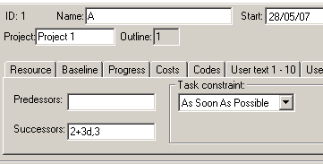

The logic diagram changes to this …..

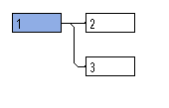
If you change back to the VIEW menu BASIC, the chart now looks like this …

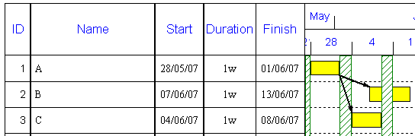

Note. Traditionally, a Network Diagram shows boxes with ID, Task description, Duration, Start & Finish, Latest Start & Finish, Links and Float.

When you click on a box (say ID 3), all this information is shown in the TASK FORM below …
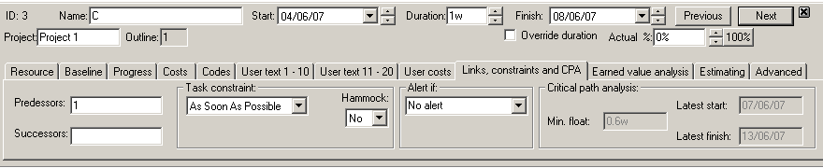

In order to see the Critical Path data, you must click on the CPA icon in the toolbar. The critical boxes will show in red with the critical links.

This unique way to show the Network Diagram means you can concisely see all information one screen for the task data and get as much of the Logic Diagram on the screen as possible.

For large diagrams, on the screen you can scroll left and right and up and down to follow the paths. If you click on any task in the list on the right hand side, the Network Diagram will use focus this box centrally in the Diagram.

• Using the Task List

When you first enter tasks and you need to link them, instead of using the WYSIWYG option – what you see is what you get (which is the default), which represents the project into separate pages, you can choose to have a long list of tasks and link tasks anywhere on the list.

Now if you want to enter tasks (and link them) in a list, you can select the VIEW menu, TASK LIST. This opens up a list of up to 999 consecutive rows with the same fields as the Basic View. Note it is not possible to Zoom this screen.

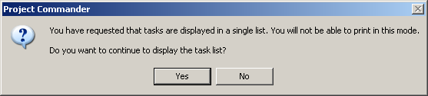
Two messages appear. Click on YES. As the message says, the print is disabled in this mode (you will need to exit this View and choose another View in order to set the LINES PER PAGE and determine the number of pages required)

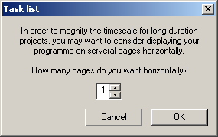
The whole project timescale is fitted by default to one screen’s width. If you wish to spread the timescale over several screens horizontally, change the 1 to a higher figure.

Linking with the mouse
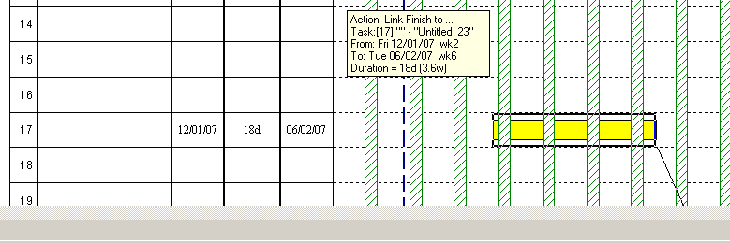
Normally you cannot link beyond the bottom of the screen or across pages. In the TASK LIST view, if you have a mouse with a scroll wheel, you can start to draw a link (key your finger pressed down on the left hand mouse button) and then with a second finger, turn the wheel forward to scroll down the chart and release off when linked to the other bar.

To print

In order to return to the normal WYSIWYG mode and to be able to print, you must choose another View.

Other useful information - linking
- More than one link can be drawn on to a bar or from a bar.

- When there are more than one link to a task, the one that schedules the task latest is the one that determines the start of the bar.
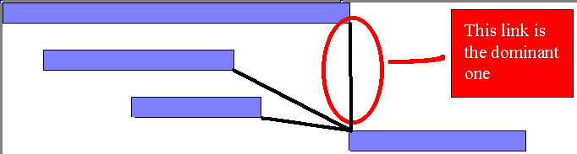

- Links can point up as well as down and the arrow on the link shows the direction of the connection and which bar is dependent on the link ....

- Bars on the same line can be linked with other task rows ...

In fact, it is possible to link bars on the same line together and introduce a LAG, this will create the bars to be linked, then by dragging the second bar, a delay will be created.

Editing and deleting links

To delete links, you can click on a link to highlight it and press the DELETE KEY on the keyboard. To highlight the link, move the mouse to where the link attaches to the end of the bar until the CURSOR changes to a cross + . When the DELETE KEY is pressed the link will disappear.

The LINK LIST can also be used to delete a link, simply click on the appropriate link to highlight it and click on the DELETE button.

Another way to delete a link is to delete the BAR and any link that is associated with it will automatically removed.

Changing links is best achieved through the LINK LIST. First click on the link to highlight it in the list.

To change the link to say START to START and with a 2 day lag .... click on the DOWN ARROW for TYPE and click on SS and type “2d” in the LAG box....

Then click on CHANGE

CRITICAL PATH ANALYSIS

The Critical Path through a project calculates its duration and identifies the important tasks that determine which bars influence the project duration.

In order to prepare a project for critical path analysis, all or most of the bars need to be linked to each other.

Warning
If only a few bars or no bars are linked the Critical Path calculation would only highlight the last task as being CRITICAL.

A network merely shows the different routes through the linked tasks and the longest one represents the length of the project. There is another useful tool in the Project Manager’s bag for identifying the tasks that cannot be delayed (CRITICAL) and those that can (NON CRITICAL) - and if so what is the maximum slippage allowed (SLACK or FLOAT).

Critical Path Analysis is a mathematical formula which performs the requirements above. Using the network - it identifies all paths, calculates the length of each path, makes the longest one the CRITICAL PATH (the length of the project) and subtracts the other path lengths from it to calculate the FLOAT(SLACK) available for all tasks on that path.

So the Critical Path identifies the important tasks that determine which bars influence the project duration.

In order to prepare a project for critical path analysis, all or most of the bars need to be linked to each other.

There are two types of float - FREE & TOTAL FLOAT. The most important is TOTAL FLOAT and is the amount that a task can slip before putting back the project. Therefore, it can be said to be the amount of slippage until the task itself becomes critical ... since critical items have no float.

Free float is the amount of slippage between two tasks and is the period that a task can be delayed before effecting another task that it is linked to. Free float may never effect the project end date and is only used by more experienced project planners - inexperienced planners should concentrate only on TOTAL FLOAT.

Warning
If only a few bars or no bars are linked the Critical Path calculation would only highlight the last task as being CRITICAL.

In the following example the CRITICAL PATH is A B E

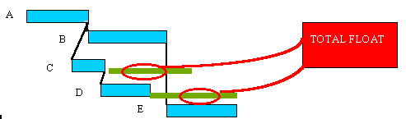

Since the Critical Path determines the length of the project, there is no margin for delay - since if
any bar on the Critical Path is late to start or takes longer to do than planned - this would put the
end of the project to a later date.

For Non Critical tasks, the amount that it can be delayed before it effects the project - is called in
the UK - FLOAT in the USA - SLACK....... Therefore, the FLOAT for Critical tasks is equal to ZERO.

The FLOAT is measured in time units (eg Days) and is shown below highlighted at the end of the normal task bar.

In the following example the NON Critical items are C & D .....

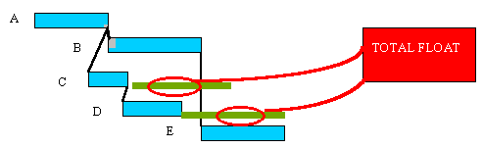

Critical Path Analysis besides providing details of FLOAT, it calculates for Non Critical tasks, the LATEST START and LATEST FINISH DATES for each task .... this represents the latest possible dates to perform tasks in order to not put back the end date of the project.

The LATEST START DATE = START DATE + FLOAT
The LATEST FINISH DATE = LATEST START DATE + FLOAT + DURATION
or
FINISH DATE + FLOAT

Important
There are two types of FLOAT ..... TOTAL FLOAT and FREE FLOAT

TOTAL FLOAT is the most important one in that it measures the possible slippage before it
effects the project end date.

FREE FLOAT is the amount of possible slippage between tasks.

In this example, there are 3 paths

A - B = 5 + 3 = 8 DAYS

C - B = 2 + 3 = 5 DAYS

D only = 10 DAYS

Therefore the CRITICAL PATH is just D.

FREE SLACK is calculated as the potential slippage between individual tasks ......
and can be defined as the margin needed available before the delay on one tasks
effects the next linked tasks..

TOTAL FLOAT is calculated as the difference between the Critical Path total and the total of each Non Critical Path.

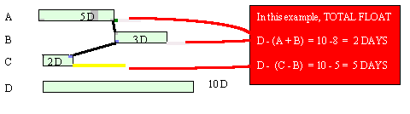

FLOAT is represented by a blank bar or line at the end of the finish that is equal to the appropriate period.

You must not get mixed up between tasks you regard as important and CRITICAL TASKS.

Critical Path Analysis is a mathematical calculation using durations and links to identify the length of the project and the importance of each task to the overall project’s timescale. It does not take into account how prestigious the task is or the value of the task.

Critical Path can only be calculated when all project bars are fully linked. When you link bars, the bars are scheduled immediately. The CRITICAL PATH is calculated when the CALCULATOR ICON is clicked. The CRITICAL PATH is then highlighted by a RED outline ..

Therefore it is important that if you use Critical Path, not to use red as a colour for a bar or symbol or milestone.

As soon as there any changes to the project, the critical path is no longer displayed until the CALCULATOR ICON is clicked again.

The non critical items are not highlighted and the TOTAL FLOAT is represented by a blank bar that is equal to the appropriate period

The value of TOTAL FLOAT, can be displayed in the FLOAT VIEW showing the MINIMUM FLOAT - which is the actual FLOAT to single bars on a line or the lowest FLOAT of any multiple bars on a line. The LATEST START & LATEST FINISH dates are also shown here.

In older versions - the FLOAT VIEW is called the FULL VIEW and does not have the LATEST START & FINISH DATES.

The FLOAT durations can be displayed around the bar ...

This is done, by “double-clicking” on the bar and the BAR EDIT window will appear and click on the DOWN ARROW opposite FLOAT and click on RIGHT and then OK.

The FLOAT can also be seen in the STATUS LINE at the bottom of the screen, when you simply place the mouse over any bar....

Unlinked tasks can be shown as critical ... by “double-clicking” the mouse on the bar, clicking the MAKE CRITICAL.
Any bar that has a FLAG to indicate that it is fixed to that date, then it will be made critical - whether linked or not.

To put a LOCK (flag) click on a bar and then the FLAG ICON. To remove a LOCK that exists - simply click on the ICON again.

- Links

When you click on the Critical Path calculator icon in the Toolbar, there are now 2 further options. You can colour links between critical bars in red and any links that have a lag in blue. If both boxes are ticked any lagged links will be overridden by red.
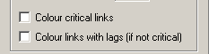

This will hide links and associated text (for off-page and hidden tasks). You re-click to display again.

Network Diagram

You can view a Network diagram for linked tasks. The window is constructed in such a way that the only the ID numbers are shown in boxes linked and a full list of tasks down the right hand side and the Task Form at the bottom.

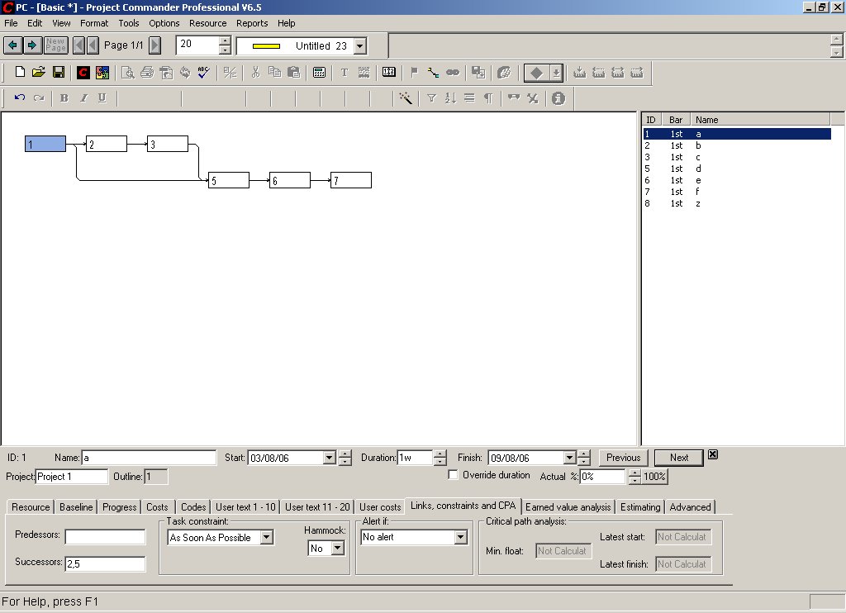

Each compartment of the window is synchronised on the same task. You can choose the highlighted task by …
- Click once on a box
- Click on a task in the task list
- Click on NEXT/PREVIOUS buttons in the Task Form

It is possible to enter new links in this window to existing tasks by highlighting the ID number on the list and entering a Predecessor or Successor.
If you wish to enter a new task, click on the last task on the list and then click on NEXT on the toolbar and enter a Name, Start date & Duration (as normal)

If the network diagram area is insufficient to contain all the tasks, a scroll bar will appear on the bottom and right hand side of the diagram. If the list area is not long enough, a vertical scroll bar will appear.

If there a large number of tasks/links, you can highlight any task and the diagram will centralise the network graphic around that task in the centre.

The Network Diagram is only available as a on-screen report (it cannot be printed out). However, the Link List can be printed still in order to report all links in hard form.

Task List

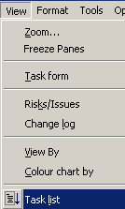
When you start up Project Commander, it defaults into WYSIWYG mode – which means you see each page on the screen as it would print.

Now if you want to enter tasks (and link them) in a list, you can select the VIEW menu, TASK LIST. This opens up a list of up to 999 consecutive rows with the same fields as the Basic View. Note it is not possible to Zoom this screen.

Two messages appear. Click on YES. As the message says, the print is disabled in this mode (you will need to exit this View and choose another View in order to set the LINES PER PAGE and determine the number of pages required)

The whole project timescale is fitted by default to one screen’s width. If you wish to spread the timescale over several screens horizontally, change the 1 to a higher figure.

Linking with the mouse

Normally you cannot link beyond the bottom of the screen or across pages. In the TASK LIST view, if you have a mouse with a scroll wheel, you can start to draw a link (key your finger pressed down on the left hand mouse button) and then with a second finger, turn the wheel forward to scroll down the chart and release off when linked to the other bar.

To print

In order to return to the normal WYSIWYG mode and to be able to print, you must choose another View.

Show Critical Path as red and non critical bars as blue

After calculating the Critical Path, by default, it colours the outside of each bar with a red frame. Sometimes, this can be difficult to see if some of bars are coloured red/orange/brown.

To make the critical bars stand out more prominently, you can choose to colour the bars (similar to Microsoft Project) .. critical bars red and others blue.

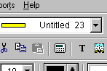
The majority of bars must be linked in order to produce a correct critical path. It is calculated by clicking on the Calculator icon on the toolbar.
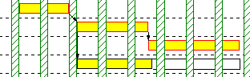

By default, the bars are framed in red – so you should avoid using red-based colours for bars.

The default does not make the critical bars stick out, but if you select the VIEW menu, COLOUR CHART BY, MICROSOFT PROJECT DEFAULTS.
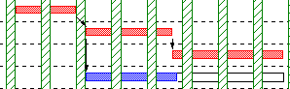

In order, to turn the Critical Path OFF, click on the icon. To switch back to the normal bar colouring, VIEW menu, COLOUR CHART BY, TASK.

Latest start and finish dates

To see the latest dates and float, select the VIEW menu, MORE VIEWS, FLOAT

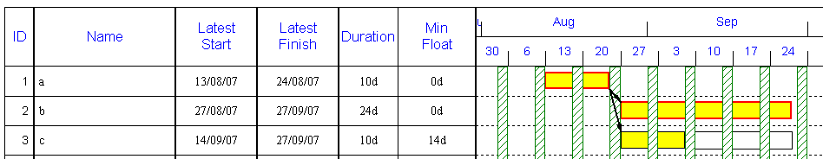

Important
If there are two bars or more on a line that are linked, then the value in the MIN FLOAT column represents the lowest float value on any bar on that row.

If you place your mouse over the coloured part of the bat, it will show the individual bar float on the grey status line at the bottom of the screen.

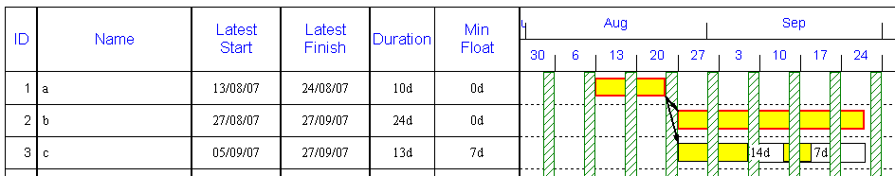

Exercise : Critical Path Analysis

This tutorial shows the user how to …

- Link bars
- Calculate critical path
- Show floats
- Hide links & floats
- Show Latest start & end dates
- Copying between files
- Risk allowance

In order to calculate Critical Path, it is important that most tasks have links either going into them or leaving them. It is also essential that there is a definite continuous linked path from the first task in the project to the end of the project.

The Critical Path is calculated for the whole file, so if there is more than one project on a file, the path will show across all tasks and projects – so it is important that tasks across projects are linked too.

In a multi project file, to isolate the Critical Path for a single project, you must copy & paste those tasks out to another new Project Commander file.

• Setup chart

Start up Project Commander or select FILE menu NEW. Click on SKIP QUICK SETUP.

- Change time range
Click on the DOWN ARROW on the START DATE and click the left hand scroll arrow to go back to January 2002 and click on the 7th. Then click on the CREATE NEW PROJECT button. Zoom up the screen by selecting the VIEW menu, ZOOM, ACTUAL SIZE and then click on the OK button.

- Add tasks
Enter the following items in the BASIC View in the NAME, START & DURATION columns (the FINISH column is calculated automatically) …
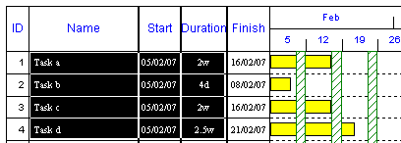

- Simple linking
If bars are linked, then the bars are scheduled using the links and therefore the START and FINISH DATES are automatically recalculated. So when bars are linked the bars will move after linking.

All tasks will be linked by "Finish to Start" links.

- The fastest way to set a "Finish to Start" link between TASK A and TASK B is to place the mouse cursor on the end (bottom right hand corner) of the TASK A bar to be linked, wait for the cursor to change to a cross + click and hold the mouse button and drag the mouse to the start (top left hand corner) of the TASK B bar and release.
- To link between TASK B and TASK C is to place the mouse cursor on the end (bottom right hand corner) of the TASK B bar to be linked, wait for the cursor to change to a cross + click and hold the mouse button and drag the mouse to the start (top left hand corner) of the TASK C bar and release.
- To link between TASK A and TASK D is to place the mouse cursor on the end (bottom right hand corner) of the TASK A bar to be linked, wait for the cursor to change to a cross + click and hold the mouse button and drag the mouse to the start (top left hand corner) of the TASK D bar and release.

In this case the chart will look as follows …
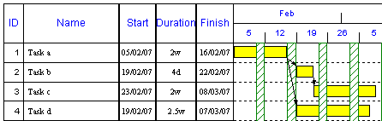
All the task bars start and finish dates have been recalculated using the links.

- Calculate Critical Path
Click on the CALCULATOR ICON in the toolbar …
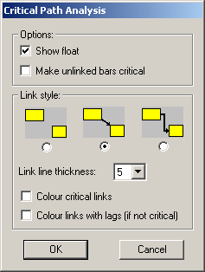
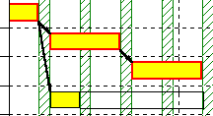

The Critical path is shown as a RED OUTLINE against tasks A, B & C. The FLOAT is shown as a CLEAR (transparent) bar on the end of all non-critical bars (Task D).

There are 2 other options to colour the link lines, colour links that link critical bars and colour links that have lags. If a critical link has a lag, then the dominant colour is always red for critical.

- Identify Float

Place the mouse over any non critical bar (Task D) and FLOAT information is displayed a the bottom of the screen in the STATUS LINE …

- Print Float
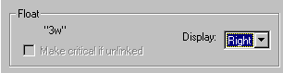
- To display the amount of Float around the bar, double click on the centre of the Task D bar and in the BAR EDIT window. At the bottom where it says FLOAT, click on the DOWN ARROW for DISPLAY and select RIGHT from the drop down list….
When any changes are made to the chart, CRITICAL PATH is turned off and the red surrounds for Critical bars and the clear bar for float are removed and the letters NA are displayed to the right of Task D – meaning NOT AVAILABLE until the Critical Path is recalculated.

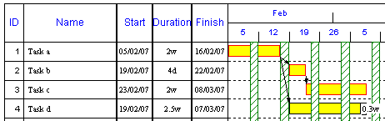
- Click on the CRITICAL PATH icon (CALCULATOR) in the toolbar and the FLOAT will show as 0.3w for three weeks on the Task D…

To remove the CRITICAL PATH, simply click on the CALCULATOR again.

- Hide float & links
Click on the Calculator icon again and click on the following diagram – on the left….
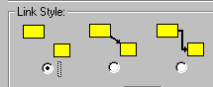

- Show Latest Start and Finish dates for tasks
Select the VIEW menu, MORE VIEWS & FLOAT. All the fields associated with critical path will contain the wording “not applicable” until calculated. Click on the CALCULATOR icon again.

Important notes
- Links
The appearance of the links and the ability to hide them (for printing) can be achieved by selecting Options menu, Preferences, Links tab.
- Lock linked bars
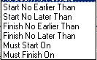
It is possible to override the linking effect on dates, by locking the bar into it’s existing position. First click once on the centre of a bar and then click on the blue flag in the middle of the toolbar.
- Date constraints on linked bars
You can also put date constraints on tasks that will effect the start/end dates of tasks and may also override the links if the constraint type/date conflicts with the link calculated dates. By default, the constraint status is as soon as possible – which means no constraint present.

