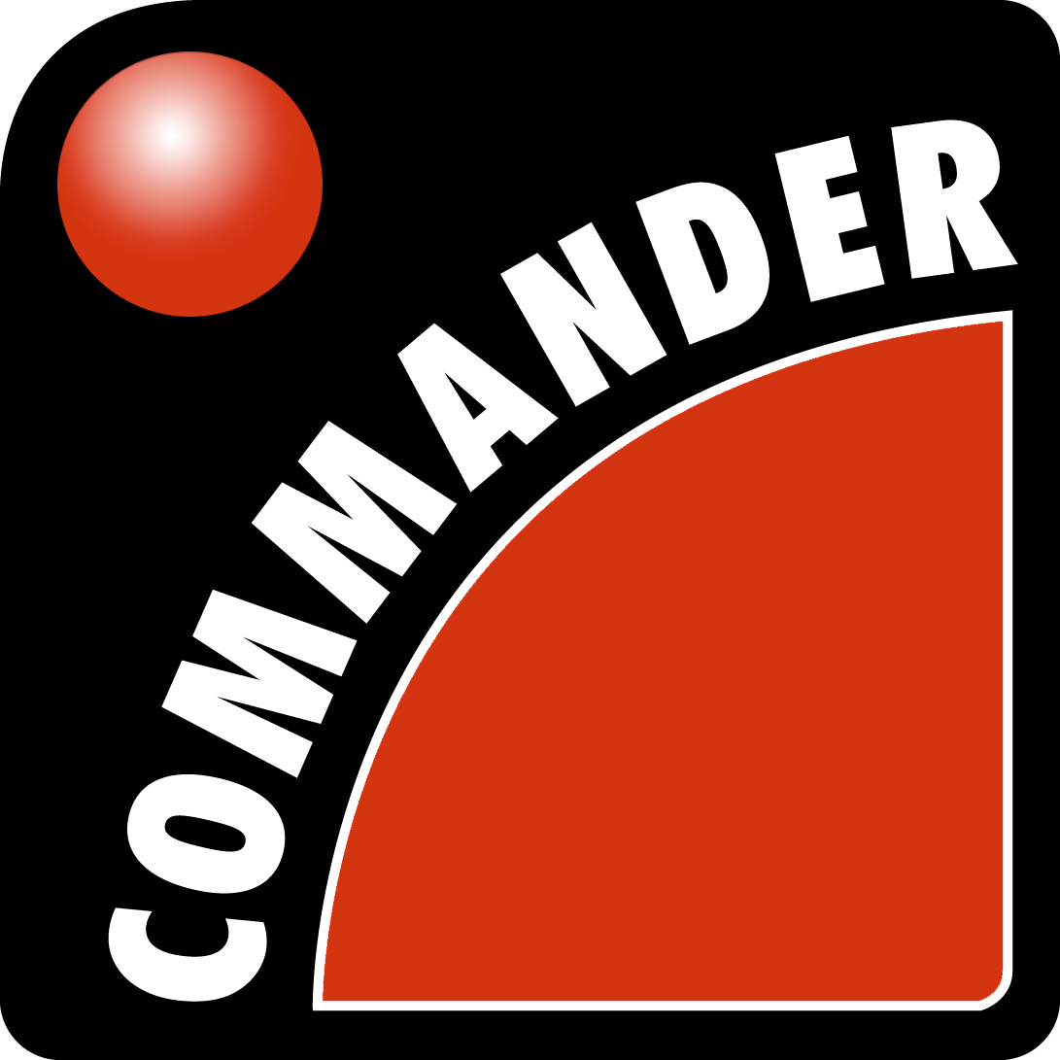

If you are viewing in PDF you made need to change the zoom so that the graphics are not distorted , by selecting the VIEW menu ZOOM .

There is a Word version of this on our website, which may show the graphics better.
http://www.projectcommander.co.uk/pmsc/new-users.html

FOLLOWING INSTALLATION FOR FULL WORKING COPY, YOU MUST ENTER THE SERIAL NUMBER BELOW & TELEPHONE PMSC FOR AN AUTHORISATION CODE.

When installing type S (beginning with the letter S) as the serial of this copy in the following screen for the FULL EDITION.

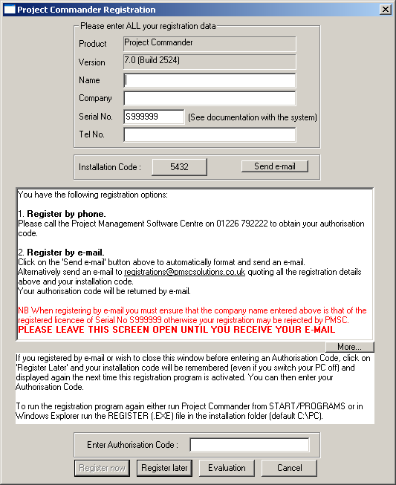

Note this copy has been registered to you or your company and should not be copied for unauthorised use.

© PMSC 2018
LICENCE TERMS & CONDITIONS
- SINGLE USER LICENCE
Unless otherwise stated in a separate Licence Agreement document, only one licence is purchased for a named person or user company. For a standalone installation – the software needs to be registered in a specific users name.
- OWNERSHIP
It is assumed that if the purchase is made a company cheque or credit/debit card – the software is owned by the company not the user. If the software is ordered in an individuals name or using the user’s credit/debit card – the company should inform us of the ownership of the software. If the company reimburses a company employee for using a personal credit/debit card – it is the responsibility of the company to inform PMSC of the correct ownership. If the user leaves the company, the company must ensure the software is uninstalled from the user in order to allow it to be allocated to another user. If the company ceases to trade – any licences in a company’s name will be deemed as cancelled and cannot be resold or transferred, unless official Administrator sells all the assets to a new company or the company is purchased as a whole.
- SERIAL NUMBER
Even though it is accepted that there is widespread software fraud by computer users, quite often it is done unwittingly and without the full knowledge of the company. It is really important the user companies control carefully the software and be wary before releasing the SERIAL NUMBER – which is unique to each company.
- USE AT HOME or OTHER PC’s & LAPTOPS by the REGISTERED USER
We do allow the registered user to load the software on other PC’s at work and home for use solely of that registered user. However, single user licences do not allow multiple installations of the software on several PC’s for use by more than one user. These conditions do not apply to LAN installations. Licences installed on a LAN, do not allow further full installs on personal computers.
- MULTIPLE LICENCES
- In order to cover for more than a one-user licence, you must have an invoice from Project Management Software Centre that states clearly you have a defined number of users. This gives the company the licence to have that number of current users on separate PC’s.
- It is important that the user company uninstalls the software off PC’s that no longer are covered.
- Even though the individual users do not need to be identified to Project Management Software Centre, the registered user is fully responsible for ensuring that these terms and conditions are fully exercised.
- As regards use of other PC’s & home computers or printing – the above conditions are applicable to authorised copies as in the terms above.
- Multiple licences can cover both individual PC’s and LAN’s – as long as the total users do not exceed the number of licensed users for each PC and number of concurrent users on the LAN.
- LAN LICENCES
- If the software is installed on a LAN (computer network), the licence covers ONE CONCURRENT user, unless otherwise stated. This means that only one person should use the software at a time.
- In order to cover for more than a single user licence, you must have an official certificate from Project Management Software Centre that states clearly you have a defined number of users. This gives the company the licence to have that number of concurrent users.
- SITE/REGIONAL LICENCES
The software can be copied onto any PC’s and LAN belonging to any employee of the company on the Site address or any office in the Region address specified on the official letter from PMSC.
- COMPANY LICENCES & GROUP LICENCES
The software can be copied on to any PC’s and LAN belonging to any employee of the company or group of companies specified on the official letter from Project Management Software Centre.
- WHY FIGHT SOFTWARE FRAUD?
- A great deal of investment is put in our product by this company (against modern trends) to update the software 2-3 times per year, fix bugs immediately, provide support, nationwide training and develop features that especially the UK users want … all at a cost well below competitive products.
- In order to allow us to continue to provide this unique service at such a low price and high level of quality, we need you to co-operate with us to stamp out this practise. Inevitably, like any fraud it reduces our profit and funds to reinvest in the product. Since we have over 25,000 users we are extremely committed to continuing the development of the company, product and services provided for the benefit of all users.
These above conditions refer only to users in the United Kingdom. Other terms refer to companies operating outside the UK.
Copyright
PROJECT MANAGEMENT SOFTWARE CENTRE 1994-2012
All rights reserved. No part of this publication may be reproduced in any form without the written permission of the PMSC. You should contact PMSC for any other arrangements.

PROJECT MANAGEMENT SOFTWARE CENTRE (PMSC)
6 WHINMOOR WAY
SILKSTONE
BARNSLEY
SOUTH YORKS
S75 4JE
ENGLAND

TEL (01226) 792222 EMAIL Office@projectcommander.co.uk
FAX (01226) 792945 WEB PAGE http://www.projectcommander.co.uk

INTERNATIONAL TEL: +(44) 1226 792222 INTERNATIONAL FAX: +(44) 1226 792945

Microsoft Project, Microsoft Excel, Microsoft Word, Microsoft PowerPoint and Windows are trademarks of Microsoft Corp... PowerProject is a trademark of Asta Development Corp. Ltd.

Table of Contents

If you are viewing this document in MS Word , click on the word below to link straight to the appropriate page automatically. If you are viewing in PDF go to the appropriate page number in brackets. There is a Word version of this on our website.

STAND-ALONE FEATURES….
- SIMPLE BARCHART (7-20)
- SIMPLE PROJECT (21-31)
- HELP SETTING UP A TASK LIST (32)
- MULTIPLE JOBS/PROJECTS (33-35)
- COMPLEX SINGLE PROJECT WITH LINKS & SUMMARY LEVELS (36-45)
- CRITICAL PATH ANALYSIS (46-55)
- RESOURCES – SINGLE PER TASK (56-69)
- RESOURCES – MULTIPLE PER TASK (70-72)
- MULTIPLE PROJECTS WITH SUMMARY LEVELS (73-77)
- LUMP SUM COSTING (78-84)
- FULL COSTING & ESTIMATES (85-87)
- ADVANCED TOPICS (88-92)
- MANAGEMENT INFORMATION (93-107)
- INTEGRATION WITH MICROSOFT PROJECT & OTHER PROJECT SOFTWARE (108 -109)
- INTEGRATION WITH MICROSOFT EXCEL (110)

There is also HINTS & TIPS, with valuable advise on our website ….
http://www.projectcommander.co.uk/pmsc/existing-users.html
STAND-ALONE FEATURES….

- SIMPLE BARCHART (7-20)
Choose a bar type and default bar
Zoom the screen
Enter title
Choose time range
Amend calendar
Page fitting
Enter tasks
Edit the chart
Colouring bars and text
Add text to bars
Create a legend
Cell formatting
% Complete
Quick setup
Save & print

- SIMPLE PROJECT (21-31)
Customise timescale headings
Shade the chart
Use Project Week numbers
Amend the calendar
Change column widths
Customise gridlines
Shift the project
Baseline
Show actuals vs plan
Progress reports
Draw bars with a mouse
Add milestone symbols

- HELP SETTING UP A TASK LIST (32)
Project Templates
Drag & drop tasks form Library

- MULTIPLE JOBS/PROJECTS (33-35)

Create new jobs/projects
Filter jobs

- COMPLEX SINGLE PROJECT WITH SUMMARY LEVELS (36-45)
Use Quick Chart entry
Link bars
Create delays on links
Summarise information
Create sub tasks
Hide sub tasks
Show % complete
Display Progress Line
Add freeform text
Add logos/graphics

- CRITICAL PATH ANALYSIS (46-55)
Link bars
Calculate critical path
Show floats
Hide links & floats
Show latest start & end dates
Risk allowance
Copying between files

- RESOURCES – SINGLE PER TASK (56-69)
Add resources
Resource assignment
Resource histograms
Resource reports
Automatically colour bars by resource
Resource calendars
Split screen
Filter resource data

- RESOURCES – MULTIPLE PER TASK (70-72)
Assign more than 1 resource to a task
Show resource sub level
Change resource assignments

- MULTIPLE PROJECTS WITH SUMMARY LEVELS (73-77)
Create multi level projects

- LUMP SUM COSTING (78-84)
Attach costs to tasks
Create a Cost Graph / S curve
Actual vs Planned graphs
Display a Cost chart
Export to MS Excel
Insert cost column in any report

- FULL COSTING (85-87)
Cost labour resource
Resource hourly rate
Cost materials
Total costs
Estimate costs

- ADVANCED TOPICS (88-93)
What ifs
Copy & paste cells
Undo
Copy & paste tasks
Copy & paste to & from MS Excel
Transfer data to MS Excel
Transfer data to MS Access
Transfer data to MS Word

- MANAGEMENT INFORMATION (93-107)
Comments
Alerts
Material Notes
Material Lists
Log File
Timeline
Calendar View
Calendar export to Outlook
To Do List

- INTEGRATION WITH MICROSOFT PROJECT & OTHER PROJECT SOFTWARE(108 -109)

- INTEGRATION WITH MICROSOFT EXCEL(110)

New Ribbon Interface

A new Ribbon – User interface similar to most Microsoft products 2007 and above – has been introduced to replace the Menus & Toolbars used in Version 7.1 and previous versions.

The old menus are replaced by a Tab Bar ….
Tab Bar
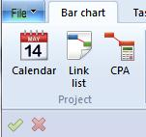
Under each Tab, similar options (some with picture icons) are positioned together under a GROUP (eg Project).

The command is made up TAB | GROUP | ICON

So to access the calendar opposite – the user will be shown to go to BAR CHART | PROJECT | CALENDAR.

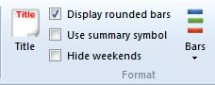
These options can be shown as a picture : a tick box or a down arrow (to access other options).

The operating software, will automatically fit the whole tab contents to the width of any screen. That means, the descriptions can be truncated or disappear – but if you hover over the icon – a Data Tip should appear to identify the actual icon/item.

Help
On the right hand side of the TAB BAR, there is a FAQ tab (Frequently Asked Questions) that links to our website and so needs an internet connection & also a HELP tab that has access to various documents by clicking on SUPPORT MATERIALS.

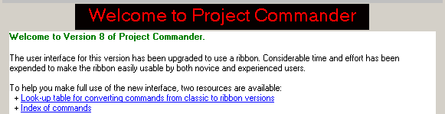

On the WELCOME screen, for existing users of previous versions (7.1 and before) you can access a LOOK UP table (in Excel format) that shows all previous Menu/Toolbar commands and where the equivalent commands are located on the Ribbon.

There is also a INDEX OF COMMANDS (in Excel format) that shows an alphabetical order of commands and where the commands are located on the Ribbon.

Tutorial 1: Simple Barchart

This tutorial shows the user how to …

- Zoom the screen
- Enter a title
- Choose the time range
- Amend the calendar
- Page fitting
- Enter tasks
- Edit the chart
- Colouring bars & text

- Add text to bars
- Create a legend
- Cell formatting
- % Complete
- Quick setup
- Save & print

• Initial start up screen

On startup Welcome screen, click CLOSE on the first 2 windows. The next screen that appears is a barchart with a NEW PROJECT window in the centre, asking for the START DATE and the PROJECT DURATION. By 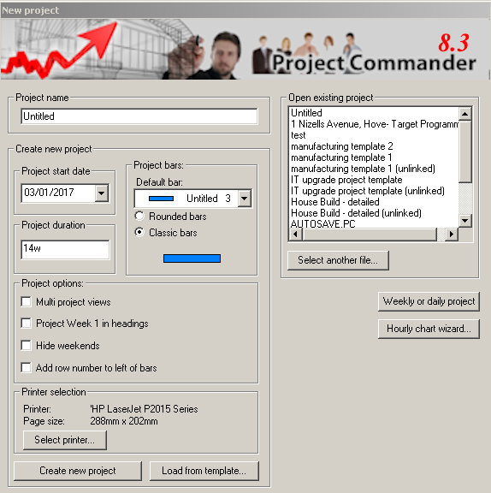default, they are set at today’s date and a period of 14 weeks.

So in order to print a 10-week chart click on the DOWN ARROW on the START DATE and select the appropriate date. Then click in the PROJECT DURATION box and edit it to read 10w . (Note: completing the Project Name is optional). If you enter one – it places it in the first line of the Project Title.

• Project bars

All task bars are rectangle by default (ie. CLASSIC BARS). It is possible to choose Rounded Bars.

• Project options

By default, the timescale headings include 2 rows – month and week commencing date (normally on a Monday). Leave this unticked.
Note: By ticking PROJECT WEEK 1 – you can include a third heading showing the Week Number and set the date from which to count Week one from.

By default, the weekends are highlighted by a green shading – tick the HIDE WEEKENDS to remove these shadings and replace them with a vertical gridline down each week. Tick this.

Click ADD ROW NUMBER TO LEFT OF BARS to number all task bars and milestone symbols.

Note : Multi Project Views is not normally ticked if you use one file for each project. This feature if ticked allows you run several projects on one file.

• Printer options

Project Commander is WYSIWYG (what you see is what you get) – which means that it shows on-screen exactly they way it is printed. The dimensions of the page are taken from the printer. When you start up the system, an empty barchart is opened on-screen. Only one page can be seen at a time, so the first page is displayed and the dimensions of the chart are taken from the default printer – usually A4 or letter and always LANDSCAPE.

To change the printer click on SELECT PRINTER – but do not click on this and use your default printer.

(Note : The setting can be seen and changed later by selecting the FILE tab | PRINT | PRINT SETUP. Click on CANCEL to return. On a network, it is important to choose the printer before entering information. The chart is automatically defaulted to show the whole chart fitting on the screen.)

Then click on the CREATE NEW PROJECT button.

To zoom the chart up, select the BARCHART |VIEW | ZOOM and choose the ACTUAL SIZE option and then OK … now the chart can be scrolled around.

To zoom the chart back so it is visible fully on-screen, select the BARCHART | VIEW | ZOOM % and choose the PAGE HEIGHT option and then OK.

A major advantage of the system is that the chart is automatically fitted to a page. The printer and the setting you use when saving the file is also saved with the document and is automatically set when opening that file later.

Other information …..

Other new project setup wizard

There are 2 extra wizards that allow you to set up a Daily/Weekly project (that has more set up options) and a Hourly Chart for short-term projects over 1 to several days.

Load from Template

There are several project templates (for different industries) that can be opened as a starter.

Opening a previously saved file

All recent files previously saved on this pc will be in the list and can be opened by a single click. To access other files , click on SELECT ANOTHER FILE.

- Prompt to Autosave

In all versions – The Autosave is an option which is switched off as a default.

Now, the window below will appear after one minute when you edit a chart in a new session. If you click AUTOSAVE, this file will start to autosave to the file you have saved it to and will continue to overwrite it.

Note: If the file has not been saved, the autosave will save to a file called Autosave.pc (in the installed folder) until you do a FILE menu | SAVE AS.

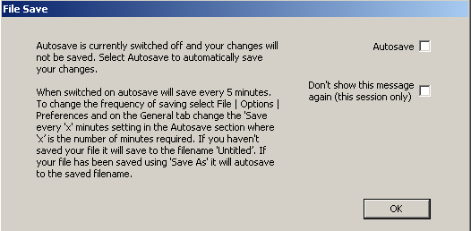

If you close the current file and open a new or existing file, the above window will appear again.

To prevent the window appearing again in this session – you can click on the DON’T SHOW option.

Important: The Autosave can be switched on before the above window appears FILE menu | OPTIONS | PREFERENCES | General tab.
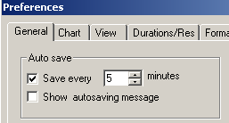

The Autosave is switched off when you re-open the file.

If the SET DEFAULT button is clicked when the AUTO SAVE option is ticked, then future files will be automatically auto saved and you will not see the Autosave message.

Optionally, you can click on SHOW AUTOSAVING MESSAGE and this will cause an automatic message to appear at the specified time intervals.

The number of minutes can be changed to a minimum of 1 minute up to 1440 minutes.

• Setup chart

The dates shown below will differ – as it will default to the current (today’s) date.

The system automatically displays the BARCHART tab – which shows most of the functions needed for a simple barchart.

- Enter full title
Click on the BARCHART | FORMAT | TITLE. Change the project title in the top white box named DOCUMENT TITLE and add a second heading in the SUB HEADING box below and then click on OK. The heading will be centred at the top of the page. Even though, more than one line can be used for the title, the more room taken up by the heading, will leave less space on the page for the rest of the chart.

- Add non working days
By default, the system uses a standard calendar. That calendar has 5 working days per week from Monday to Friday, for 8 hours a day and no holidays (public or other) included. The weekends are shaded in green on the chart. To add holidays, choose the BARCHART | PROJECT | CALENDAR. The dates on the calendar in the top left corner, show days with a white and grey backgrounds. White ones represent working days and grey ones represent non working days (weekends or holidays).

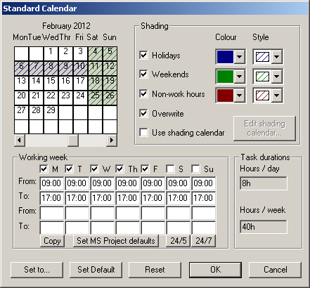
The calendar shows just one month at a time. To move the calendar by month, click on the LEFT HAND SCROLL ARROW or RIGHT HAND SCROLL ARROW to move backwards or forwards through the months.

Make the dates holidays by clicking on each date . … so all non working days contains all grey dates. Then click on OK. On the chart, the non working days will be shaded in blue on the barchart. (Note : To change a working day to a non working day, click on any date that has a white background and it will change it to grey)
No task bars can be started or finished other than on working days.

- Number of lines per page
By default, the number of lines per page is 20…this is shown in the white box in the BARCHART | PAGE LAYOUT . To change to 25, click on the UP ARROW to the right of the box 5 times (or edit the figure in the white box by changing the 0 to a 5).

Changing the number of lines per page does not affect the page size or the area used for the chart itself. However, increasing the number will reduce the height of each row and decreasing the number will increase the row height.

It is important to note that the text font does not change automatically with the lines/page option. Therefore, for A4 printers the LINES PER PAGE figure should not exceed 30/35 for LANDSCAPE mode, in order to avoid having to change the font.
To zoom the chart up, select the BARCHART |VIEW | ZOOM % and choose the 75% option and then OK.
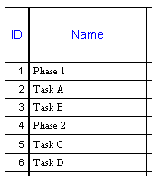
(For A3 printers the LINES PER PAGE figure should not exceed 60 for LANDSCAPE mode)

- Add task descriptions

Working down the NAME column, enter the following by clicking on the cell and typing and it will appear in the top left hand corner of the screen in the ENTRY BAR. It will not transfer into the cell until the ENTER key is pressed on the keyboard or you click on the TICK
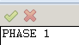

- Edit task descriptions
Task descriptions can be changed and whole rows deleted and inserted.

To change the wording of cell 1 from Phase 1 to Planning Phase click on that cell and the text appears in the top left hand corner ENTRY BAR (where it can be edited). Change the description to Planning Phase and then click on the TICK or press the ENTER KEY on the keyboard…. It will now replace the previous text.

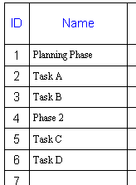
To delete a whole line (with descriptions and/or bars), click on the ID (row) number 5 and then right mouse click & DELETE TASK … this will not only delete the current row 5, but will now move all the rows below it up one and so renumber them from 5 again.

To insert a whole new blank line (for descriptions and/or bars), click on the ID (row) number 5 and then press the INS (Insert) KEY on the keyboard … this will not only insert a new blank line at the current row 5, but will now move all the rows below it down one and so renumber them from 5 again.

In that new row, click on the cell under the NAME column & type the description Task C, followed by the ENTER key.
- The chart will look like this ...when completed.

- Enter bars by typing
There are 2 methods of entering bars onto the chart – by mouse or by typing.

- To create a bar for 3 weeks; first click on the START cell opposite Task A and then type in a start date dd/mm/yy format … this will create a ONE DAY BAR by automatically entering 1d in the DURATION column and a date in the FINISH column and drawing a Bar on the chart on the right.

- Then click on the DURATION cell and type 3w and press the ENTER key…. this will recalculate the FINISH DATE. The chart is redrawn.

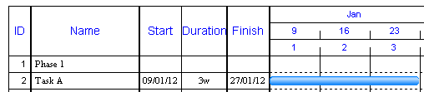

There are different ways of inputting the duration … as weeks, days, hours or minutes using the suffix of the first letter of each unit – w, d, h, m.

So the duration could be entered as 15d, 120h or 7,200m – since the default calendar is based as standard on 5-day working weeks and 8 hours working per day.

(The duration entered represents working time and not calendar time – so if a task starts on a Friday and is 2 days long, it will finish on a Monday evening).

- Create a second bar with a start date and a duration of 6d.

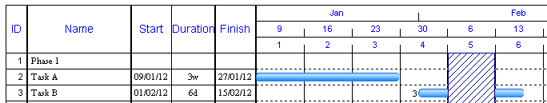

This will force the FINISH DATE after the February holiday.

- Create further bars as follows by typing into Task C & D in the START & DURATION columns …
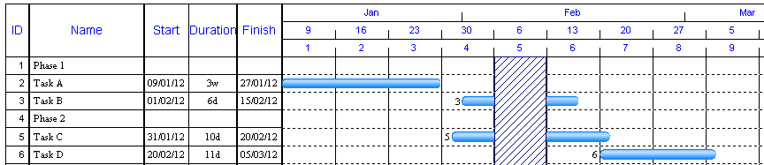

There are two ways of scheduling tasks, inputting bars direct on to the chart using the start and duration or by linking bars and the links schedule the start and end dates automatically.

Note: Bars can be drawn direct on to the barchart by dragging the mouse in the chart area.

- Changing bar colours

By default, all bars are coloured blue. The colour of the bar can be changed after the bar is created or you can choose the colour before drawing the bar.

To change an existing bar...

Click once on the middle of the blue bar for Task A in the chart to highlight the bar.

Click on the DOWN ARROW of the BAR SELECTOR in the BARCHART | TASK | BARS (at the top of the screen).

- Click on the green bar marked UNTITLED 2 and click on it… this changes the bar colour to green.
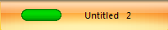

When you change a bar colour, the system prompts you to enter a legend (ie. a key at the bottom of the page). Click on CANCEL in this example.

Note : Bars can be solid bars or be represented as bars with start and end symbols attached

Click on the middle of the blue bar for Task B.
- Click on the DOWN ARROW of the BAR SELECTOR in the toolbar and click on the following bar from the list …


and then on CANCEL in the next window.

- Changing text colours
By default, all text on the left hand side is in black and the font is Regular 10pt New Times Roman; the cell background is white by default. In any cell or range of cells the text font/background can be changed.

- Click on the cell - PLANNING PHASE.
- BARCHART |FORMAT | FONT
- Then click on the down arrow for the font size (default 10) and select 12
- In the next box, click on the down arrow for the font colour (default black) and select red.
- In the next box, click on the down arrow for the fill colour (default white) and select grey.
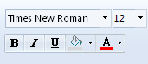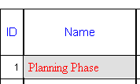
- Repeat the above for the cell PHASE 2.
When changing fonts, it is possible to change ranges of cells (by dragging across them) or whole columns in one command.

- Add text to bars
User text and task information can be displayed around any/all bars.

To attach text to a bar …
- Double click on the middle of the green bar for Task A.
- In the first white box marked TEXT, type FIRST DRAFT.
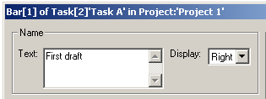
- Then click on the DOWN ARROW to the right of DISPLAY opposite.
- From the list of options, click on RIGHT and OK.
The text will now appear attached to the right of the bar.

To attach task information to a bar …
- Double click on the middle of the blue bar for Task C.
- Then click on the DOWN ARROW in the white box marked DISPLAY opposite the DURATION – PROJECT.
- From the list of options, click on LEFT.
- Then click on the DOWN ARROW in the white box marked DISPLAY TASK ID.
- From the list of options, click on RIGHT.
- Click on OK.
The row number (ID) will now appear on the bar to the right and the duration to the left.
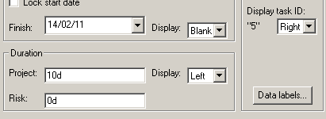

- Moving bars
Individual bars can be moved either by editing the START DATE or dragging the bars using the mouse.

To move Task A to next week …
- Click on the START cell on row 2, either type the full new date and the ENTER key on the keyboard or click into the white EDIT BOX at the top right of the screen and edit the current date and click on the tick.

Alternatively, to move it with the mouse …
- Click on the middle of the green bar for Task A and holding the left hand mouse button down, drag the bar to the right – as you drag a message box will appear to assist you and when the FROM DATE in the box changes to the required date, then release the mouse button.

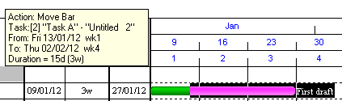

- Creating a key or legend
One of the main reasons to colour bars is to distinguish tasks for phases, skills, etc. By default no legend is shown.

Each time you change a bar colour – Project Commander prompts you to create a legend or key at the bottom of the page. If you wish to change the legend or create one later….

- Select the FORMAT | SYMBOLS | FORMAT SYMBOLS
- Click on the green bar marked UNTITLED 2
- Click in the DESCRIPTION box and delete the existing text and type PLANNING
- Put a tick in the DRAW LEGEND box and click OK.
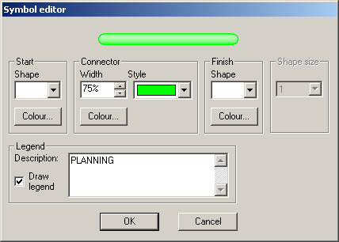
- Scroll down the list and click on the blue bar marked UNTITLED 3.
- Click in the DESCRIPTION box and delete the existing text and type DEVELOPMENT
- Put a tick in the DRAW LEGEND box and click OK and click OK again.

When it returns to the chart, if you scroll to the bottom of the page, you will find a key with both bars and corresponding descriptions in a box. Then scroll up again.

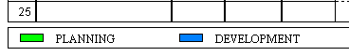

It is possible to change the layout and order of the legend bars by selecting FORMAT | SYMBOLS | FORMAT LEGEND.

- % Complete
To mark up the tasks that are in progress,
- Select the VIEW | VIEW | VIEWS | PERCENT COMPLETE
- Click on the DOWN ARROW and select the date
- Click a tick on PROGRESS LINE
- Click on OK

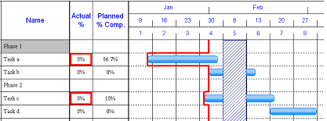

The PLANNED % COMPLETE is calculated automatically.

Important – it is essential that you choose the correct date – as the PLANNED % COMPLETE uses this for it’s calculation. The date you enter should represent the END of the working day on which you are reporting progress up to (not necessarily today’s date). The above and following screen shots show that any tasks that are behind plan, the Actual% cell is highlighted with a coloured box – with different colours to show severity – RED being the most severe – BLUE just behind.

- Enter the following % figures in the ACTUAL % …
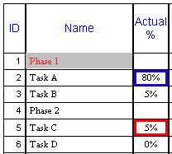

The following will show the bars marked up with a black shading inside each bar and a RED JAGGED PROGRESS LINE down the chart.

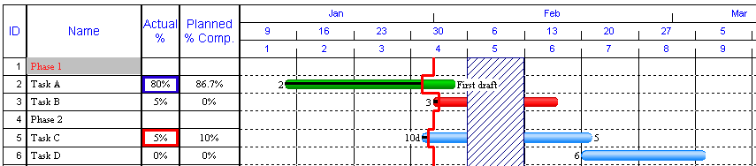

The coloured box in the Actual % column (VIEW menu PERCENT COMPLETE) is switched off by default.
To switch it on (for display and printing) FILE menu | OPTIONS | PREFERENCES .... click on GENERAL tab & then tick ALERT ON %COMPLETE BEHIND SCHEDULE.
So now we have made it WYSIWYG - they will only print if on-screen.
It is possible to show a Progress Graph; select the REPORTS | PROGRESS | DURATION GRAPH. Click a tick on SHOW COMPLETED DURATIONS….
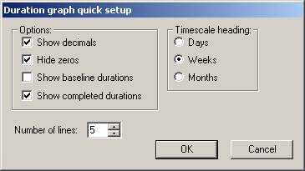

This now graphs at the bottom of the page, a blue are graph representing the whole project duration against a yellow line for the completed duration representing the days achieved calculated by the duration and % complete…

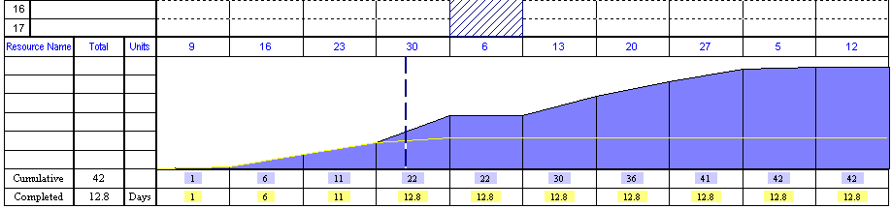

- New Page
Only one page can be shown on the screen at a time and the current page number is shown on the top left of the page.

To open a new one, click on BARCHART | TASK | NEW PAGE button in the toolbar and this will now show a blank page numbered from 26 to 50.

To return back to page 1, click on the small black left arrow to the left of the Page 2/2 message in the toolbar at the top. This will return the screen to page one and will automatically delete page 2 if no task information was input there.

• Save & print

To save the file for the first time, select the FILE |SAVE AS and enter the FILE NAME in the appropriate white box. The system will automatically allocate a .PC extension on the end of the file name.
To print, select the FILE | PRINT | PRINT and then OK.
Important notes

- Rounded bars
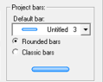
In the startup screen, you can choose what is the colour of the default bar used for this new project and whether the appearance is the classic square look or a curved end with the colour graded inside the bar.

Once have chosen the types of bar appearance – that is the global setting for the bars in that file.

The bar appearance can be changed BARCHART | FORMAT | DISPLAY ROUNDED BARS. The setting is global and you cannot mix classic bars and rounded bars in the same project.

- Lines per page (and Automatic Repagination)
When you change the LINES PER PAGE, Project Commander will change the number of pages. For instance, if you have the Lines per Page as 25 and you have 76 tasks – then that would need 4 pages. If you change the Lines to 38, then Project Commander will change the number of pages to 2 – putting tasks 1-38 on page 1 and tasks 39-76 on page 2.

- Page Breaks
The Lines/Page box still controls the automatic paging – but within that you can force a new page. To insert a new page on the second heading (Phase 2), click on that task and BARCHART | TASK | NEW PAGE. This will blank out the rest of the page after the last task before the page break.

- Saved printer / Opening saved files
When you save a file, it saves the actual printer and paper size plus orientation(landscape/portrait). So when you open this file next time – it will select the printer and settings saved.

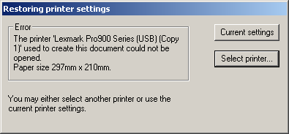
If you try to open a file from another person or another computer - it is possible it cannot find the printer on your system, a message will appear prompting you to use another available printer. If you click on keep CURRENT SETTINGS – you can keep the original page sizing – but you would not be able to print out. You can chose to SELECT PRINTER so that it fits to a new paper size.

- Changing printer
It is possible to easily change printers and change the layout. If the file is saved, in A4 as 2 pages of 20 tasks. In order to change it to a A3 printer on 1 page, select the FILE | PRINT | PRINT SETUP and change the printer/paper size, then later change the Lines per page to 40 and all the tasks will appear on 1 page.

- Global Fonts
The fonts for most areas can be changed globally by clicking on FORMAT | FONTS | WIZARD.

- Scale to print one page
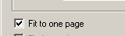
If you wish to scale any number of pages to one page for the current paper size, select the FILE | PRINT | PRINT and click on the FIT TO PAGE box and when you print the font will be automatically chosen to fit all the tasks on one page. (Note this function will remain ON until removed )

In order to check what the output looks like before printing – select the FILE | PRINT | PRINT SETUP and click on the FIT TO PAGE box and then FILE | PRINT | PRINT PREVIEW.

(Note: The FIT TO PAGE option is only operational for printing purposes. On screen – the project returns to multiple pages.

- Changing Views
It is possible to set different appearance of each View. When you start up Project Commander with a new file, the default View is called Basic and is listed on the VIEW | VIEW | VIEWS.
If you change the font and background colours on a cell or range of cells – the columns/cells colours are used in other Views

- Saving files
After you save a file for the first time, it later saves a backup file of the same name in the same folder every time you open the file. Project Commander files have a .pc extension and backup files have a .bak extension. After you save a file for the first time, it later saves a backup file.

- Task List
We have included a TASK LIST view that allows you to enter a list of tasks (up to 999) with no paging.

When you start up Project Commander, it defaults into WYSIWYG mode – which means you see each page on the screen as it would print.

Now if you want to enter tasks (and link them) in a list, you can select the BARCHART | VIEW | TASK LIST VIEW. This opens up a list of up to 999 consecutive rows with the same fields as the Basic View. Note it is not possible to Zoom this screen.

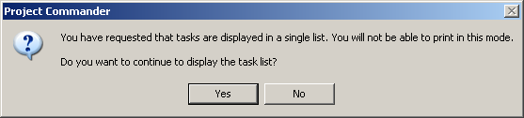
Two messages appear. Click on YES. As the message says, the print is disabled in this mode (you will need to exit this View and choose another View in order to set the LINES PER PAGE and determine the number of pages required)

The whole project timescale is fitted by default to one screen’s width. If you wish to spread the timescale over several screens horizontally, change the 1 to a higher figure.
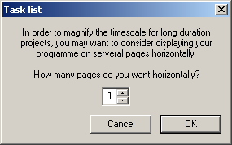

(Note : To be able to print – you need to return to the normal WYSIWYG mode and to be able to print, you must choose another View like the Basic View - BARCHART | TASK | VIEWS | BASIC

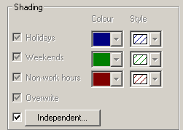
- Calendar shading

There are two calendars; the default Standard one for scheduling (and shading) or an option one Independent Calendar. It was chosen by BARCHART | PROJECT | CALENDAR

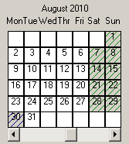
The first Standard calendar will show shadings for non working days and a new Shading Calendar that will allow you to show other periods shaded in a different colour (but not effect the scheduling).

Then click on USE SHADING CALENDAR & the EDIT SHADING button to the right, and click on the relevant dates …
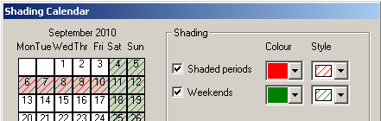

Click on OK twice. This means the chart would look like this …

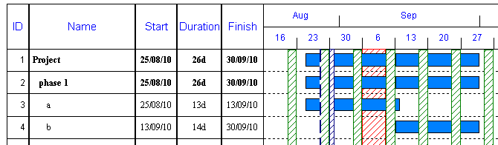

The blue shading is a public holiday and by default is overriding the bars and the red shading is behind the bars. For the Shading Calendar, the shadings will always be behind the bars; whether the shadings for the Standard Calendar are behind or in front depends on the OVERWRITE box.

If certain dates are shaded in each Calendar, then preference is given to the Project Calendar.
Tutorial 2: Simple Project

This tutorial shows the user how to …

- Customise timescale headings
- Shade the chart
- Use Project Week Numbers
- Amend the calendar
- Change column widths
- Customise gridlines
- Shift the project
- Baseline
- Show actual versus plan
- Progress reports
- Draw bars with a mouse
- Add milestone symbols

• Initial start up screen

The dates shown below will differ – as it will default to the current (today’s) date.

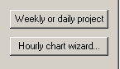
Select the FILE | NEW. In order to print a 9 months project, click on the Quick Setup – WEEKLY OR DAILY PROJECT button in the bottom right …
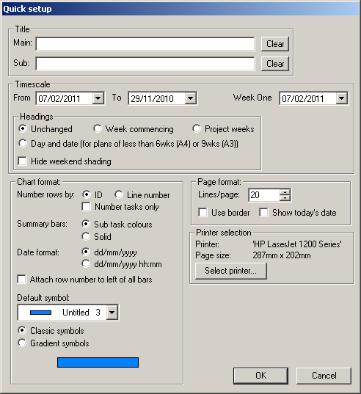

- HEADINGS
First enter the chart titles - the heading will be centred at the top of the page.

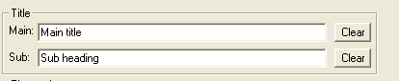

- PROJECT DATE RANGE
Next, DOWN ARROW on the FROM date and click the right hand scroll arrow to choose the start date . Then change the TO date to 9 months later.

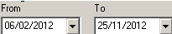

- TIMESCALE HEADINGS & WEEKEND SHADINGS
Since the default is to show all weekends shaded in green, the chart looks a little cluttered.

By default, the system uses a standard calendar. That calendar has 5 working days per week from Monday to Friday, for 8 hours a day and no holidays (public or other) included. The weekends are shaded in green on the chart.
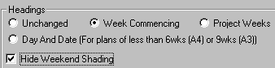

The green shading will disappear.

Click on OK and the empty page will appear …
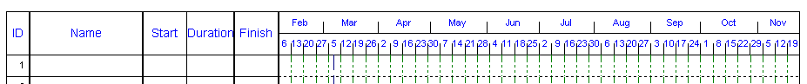

There are many other options .

• Setup page

When Project Commander is started up, the chart defaults always to LANDSCAPE. In order to change it to PORTRAIT, you can either select the FILE | PRINT | PRINTER SETUP and click on PORTRAIT & OK, or click on PAGE LAYOUT | PAGE SETUP | ORIENTATION.

Important - normally the default printer used is A4 – you can just about fit a 9 months project on one page landscape – but the paper is not wide enough to show A4 portrait. If you require portrait – you need to change the printer to an A3 by selecting FILE | PRINT | PRINTER SETUP.

To zoom the chart, select the BARCHART |VIEW | ZOOM% … and choose the ACTUAL SIZE, then option and then OK.

• Setup chart

- Change View
By default, the view displayed initially is the BASIC VIEW for a single project, which includes dates and durations.

Whatever is currently on-screen is what is to be printed – so the views are in fact on-line reports. To change the view, click on the BARCHART | TASKS | VIEWS | and choose CHART – this is a very common view used for printing barcharts with just a Task Description column and chart.

(Project Commander is capable of controlling single or multiple projects. All single project views are by default on the VIEW tab; and the multiple projects are shown after clicking on the VIEW | VIEW | MULTI PROJECT VIEWS. The list of Views is similar for single or multiple projects – but the main difference is that the latter has an extra column in all Views to identify every task to a particular project or job) and all the Views are prefixed with the words multi project).
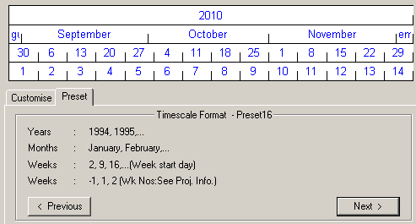
- Change timescale headings
The chart shows three headings, the top is the month and below, week start date using the Monday date.

To change this quickly, click on the BARCHART | VIEW | FORMAT TIMESCALE and then click on the NEXT button repeatedly until the screen arrives to TIMESCALE FORMAT – PRESET 16…this is a library of 31 predefined headings with different settings for months, weeks and daily charts and click on OK.

Then the chart will show headings of Year, Month, Week commencing date and Project week number. However, due to the length of the project and the portrait orientation, the standard headings do not fit into the columns and are too wide.

To set the Week numbering up, select the PROJECT | PROPERTIES |WEEK ONE DATE and change the date.

To change them manually, click on the BARCHART | VIEW | FORMAT TIMESCALE & click on the CUSTOMISE tab, and the current settings are listed in the white box above.

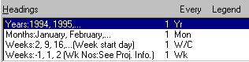
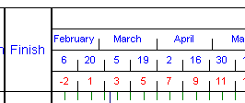
We will change the appearance of the fourth row showing Project Week Numbers. Click on the fourth row HEADING … Weeks -1,1,2 …(Wk Nos:). Then click the FONT button and change the COLOUR to RED and click on OK and then in the EVERY box and change the frequency from 1 to 2. Then click OK.

The chart will now show that the last row will read -2,1,3 – only labelling every fortnight.

- Number of lines per page
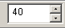
A4 portrait can list more lines than the default of 20… this is shown in the white box in the BARCHART | PAGE LAYOUT | LINES PER PAGE . Change this to 40.

- Change the Column width and heading
To change columns, double-click on the heading NAME and then a COLUMN DEFINITION WINDOW appears. Click in the TITLE box and change the text from Name to Task Description and the WIDTH box from 38mm to 48mm and OK. If columns are widened, the chart is re-sized automatically to fill the rest of the paper.

(The measurements could be imperial if that is set as the default in Windows).
The width of columns can be adjusted by dragging the right the vertical column lines in the heading area.

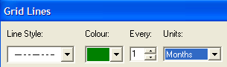
- Grid lines

In order to change them to monthly, select the FORMAT | GRIDLINES | GRIDLINES.

On the top line, click on the DOWN ARROW under UNITS and click on the MONTHS option from the list and OK.
Note: You can put up to 4 different types of vertical lines at different frequencies.

- Enter task descriptions

Enter the following …
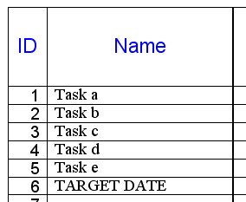

- Drawing bars with the mouse

If you move the mouse along the chart (without clicking) on the first row; the current row number (ID), the TASK DESCRIPTION (if entered) and the current date where the mouse sits on the chart, is shown on the STATUS LINE, which is in the grey area at the bottom of the screen.
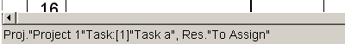
Important – If you make a mistake drawing a bar, to clear it and start again, select the UNDO icon in the QUICK ACCESS TOOLBAR (top left).

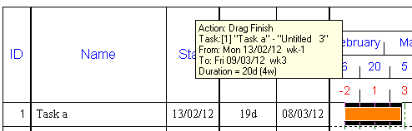
Move the mouse on ROW 1 “Task a”, to a specific date ... this can be verified as correct by looking at the STATUS LINE and then (being careful not to move) click on the left hand mouse button and while holding it down, drag it to the right. A yellow message box – as opposite will appear while dragging. Then click off the mouse when the TO DATE in the box says the date you require.

The DURATION is calculated automatically as days. This figure represents the number of working days between the two dates – using the standard 5-day Calendar as a default.

It is possible to draw more than one bar on a line – but they cannot overlap. When drawing bars, the lowest duration unit is a full day and only whole days can be drawn. You cannot start and end bars on a weekend or holidays. If you attempt to draw a bar on a non working day, a message will appear and the bar will be moved automatically to the next appropriate working day after clicking on OK.

- Editing mouse drawn tasks

(Sometimes it is difficult to draw bars accurately using the mouse, so you can draw a bar on a line approximately in the right place and with the approximate duration. The bar can then be edited by double-clicking on the middle of the bar – so a BAR EDIT window appears; the START DATE and PROJECT DURATION boxes can be entered and when the OK button is clicked, the bar is redrawn on the chart.)

When keying information, avoid using the FINISH DATE, as if this date is edited, the bar will be drawn backwards from that date using the DURATION and the START DATE will be recalculated (only after the OK button is clicked).

Click on the BARCHART | TASKS | VIEWS | and BASIC to check the start and end dates are correct.

Enter a second bar for the task for ROW 1 as follows using the mouse …on row 1, draw the second bar for 10 days. The START and FINISH dates are changed from both bars. The Start Date is now the start of the first bar and the Finish Date is the end of the last bar on that row and the Duration is the summation of each individual bar duration.

To create more than one bar on a line, you must draw on the second and subsequent bars – you cannot type them into the table on the left.

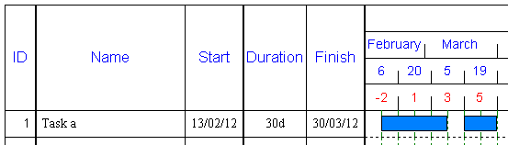

Enter the next set of tasks row 2-5 as follows …

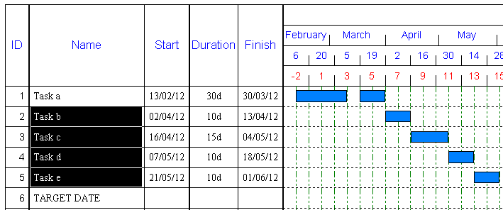
- Entering milestone symbols
There are 2 types of tasks; bars (as above) which represent the duration of a task from start to end and milestone which are represented as symbols to depict events in time as opposed to a task. A milestone example is an Opening Ceremony, Meeting, Launch Date – which happen at a specific time on a specific date and is a key date.

- First, click on the BARCHART | TASK | MILESTONES a list will appear. 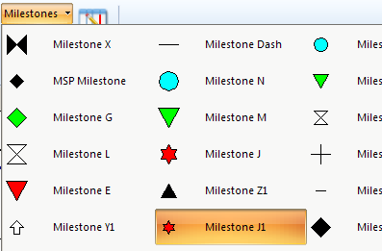
- Click on the RED STAR (MILESTONE J1) on the list and CANCEL (to avoid creating a Legend) as the mouse is moved now across the chart (without clicking) a ghosted diamond shape is attached to the cursor.
- Click on the chart on a specific date opposite ROW 6 “TARGET DATE” using the STATUS LINE at the bottom of the screen to confirm the row and date.

When you click the milestone symbol on to the chart, the system will prompt to add this to the legend at the bottom of the chart. If you do not want to do this – click on CANCEL.

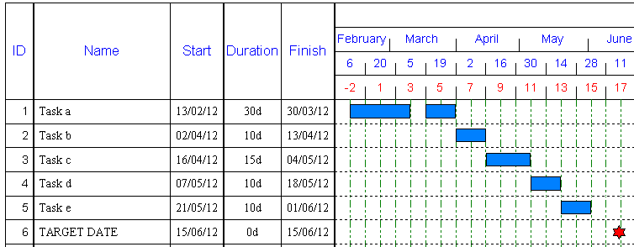

• Updating the plan

1. Shift Project
Part or all the project can be moved forward or backwards. In order to move all the bars (not the milestone symbol) forward 2 weeks….

- Drag down the ID COLUMN 1-5 from Task a to Task e
- Select the PROJECT | SCHEDULE |SHIFT PROJECT
- Enter 2w in the MOVE BY box
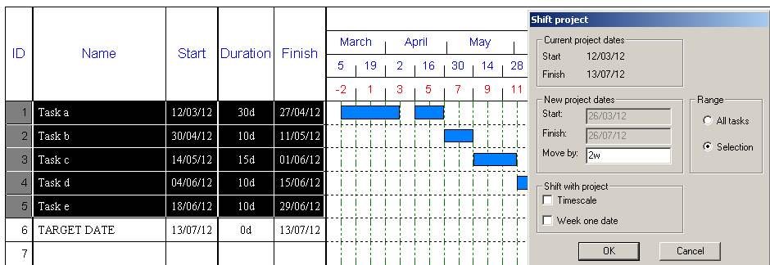
- Click on OK

The result will be to move the bars.
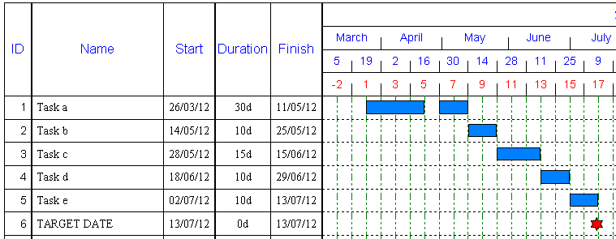

- Baseline

It is possible to save the ORIGINAL PLAN and monitor progress against the PLAN when updating actuals. This is called Baselining. However, the project plan must be agreed before being saved as a Baseline – as it is frozen and used for comparison.

- Select the PROJECT | BASELINES | SAVE and click on OK.

This will now show 2 sets of bars on each row; the bottom blue bar is the ORIGINAL PLAN; the top bar is the CURRENT PLAN and will be edited based on progress information. Obviously initially the both bars on each line are in parallel.
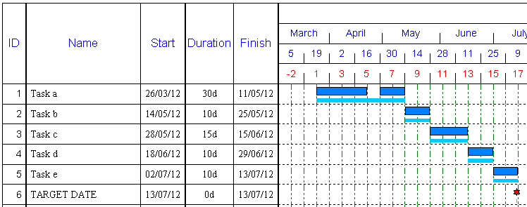

- Progress
It is possible to then move the top bars by any editing method (such as dragging the bar, or double-clicking on the bar and editing it or editing any columns).

Move (or change the START DATE) the bars on top for rows 2,4 & 5 by 1 or 2 weeks later …

The chart will show whether each task is on time (as above).
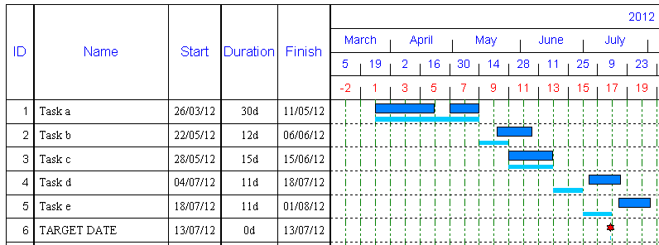

- Performance Reports

It is possible to see the Progress Report as a spreadsheet type report without the barchart. Select the REPORTS |REPORTS | PROGRESS | VARIANCE.

The BASELINE START & FINISH columns represent the ORIGINAL PLAN and the START & FINISH columns represent the CURRENT PLAN – of actual history (before today’s date) and future forecasts (for bars after today’s date).

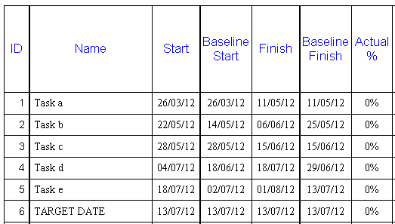

• Save and Opening Files

Before saving, select the BARCHART | VIEWS | CHART to see how it looks without all the columns on the left.
Important notes
- Multiple bars
You can have as many bars and symbols on a line. The only restriction is that bars cannot overlap and symbols cannot be positioned on top of a bar.

- Lines per page
If the number of Lines per page is too high, then the text in the rows may be topped and tailed – which means that the tops and bottoms of the text may be cut off. In order to solve this you can either, reduce the number of lines (recommended) or you can change the fonts for the columns (FORMAT | FONTS | CURRENT VIEW ). PMSC have invested a lot of time in ensuring that the best fonts are used in each View/Report/Screen.
Changes to one View/Report using FORMAT | FONTS | CURRENT VIEW will only effect the current screen and not others – so you can customise all output individually.
If you change the text on a particular cell (or range of cells), then it overrides any changes for changes in global settings using FORMAT | FONTS | WIZARD.

- Split bars
Select TASK | CHART | SPLIT BAR and then hover over the bar on Row 2 and as you move the mouse – a box will appear above the bar to give you help of how to split the bar into two further bars.

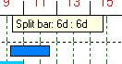

This will split the bar highlighted into 2 separate bars..

The separate bars can be moved as normal…

Note: Bars can be further split down.

Important: If the timescale is based on days/weeks – then the bar is split into based on full days. If a task is say 45. days – the first part of the bar is split on full days and the rest of the bar becomes the next bar.

If the timescale includes hours – then the bar will be split based on full hours (displayed as a decimal of a day).

- Recurring tasks
Click on a blank line or if you click on an existing task, it will insert the new task here (moving all existing tasks one row down the list) and on the TASK | INSERT RECURRING TASK.

The following window will appear..
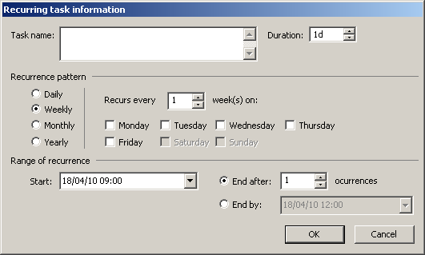

You enter ..

- Task Name
- Duration (default days – but you can enter durations as m/h/d/w and also with decimals)
- Recurrence Pattern - the options change based on which chosen
- Start
- End after occurrences
- End by

It is important to enter the Start Date as a working day.

DAILY
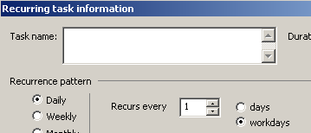

There are 2 options days or workdays.

Days – it works out the date for each occurrence and then it may reschedule any task to the next working day. This may mean that the working day interval between certain tasks rescheduled will vary depending on the calendar.

Working days - each task only gets scheduled on a working day at set intervals.
WEEKLY
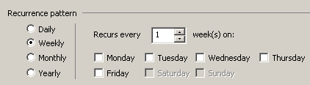
MONTHLY
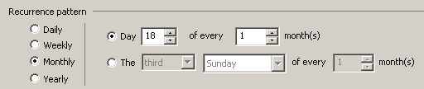

YEARLY
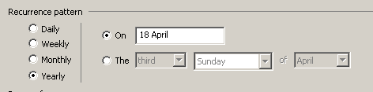

- Undo/Redo
There are 20 levels of Undo/Redo that are available while you are in Project Commander, that will even allow you to go back to previous files used within the 20. The undo’s are lost when you exit or when you open Project Commander again.

- Shift whole project
As well as moving selections of tasks, it is possible to move the whole project. (PROJECT | SCHEDULE | SHIFT PROJECT and enter a new Start Date).

- Insert new columns
Any columns from the project database can be inserted into any report. Click once on a heading name to mark the place where you want to insert and right click and from the menu, Insert Column. The full list of columns in the database are revealed by clicking on the TYPE drop down. If you wish to input your own text/data (like comments, status information, manager’s name), then insert a User column (User 1-20) from the list. When the file is saved, that column will appear now in that View permanently.

- Baseline
When you save a Baseline, if there are resources and costs assigned to tasks, it will save this data too as well as the bar dates. For one Baseline, you should only save this once (when everything in agreed) as any further saves may overwrite the original baseline and it may not be possible to retrieve it. After saving a Baseline, you can switch the display ON or OFF by selecting the VIEW | SHOW/HIDE | BASELINES.

- Baseline date revisions
Once a Baseline has been saved, you can change the date of the primary one by changing the Baseline Start, Baseline Finish (and Baseline Duration).

- Advanced progress – Jagged Progress Lines & Baselines
Normally users only show one current progress line, but there is a feature that allows you to save and display multiple periodic Progress Lines and save multiple Baselines. It is then possible to choose which lines to show on the chart at any time.

- % complete Baselines
The % complete can be marked not only on the current bars, but also on the Baseline bars (FILE | OPTIONS | PREFERENCES | Chart tab).
Tutorial 3: Help setting up a Task List

This tutorial shows the user how to …

- Create new projects from a template
- Drag and drop tasks

- Project Templates
When in the New File screen, there is a new LOAD FROM TEMPLATE.
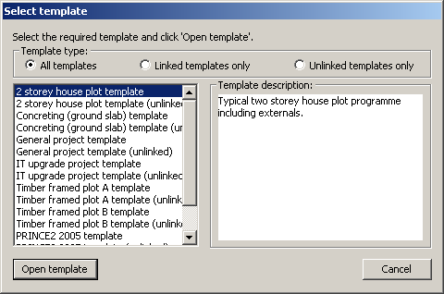
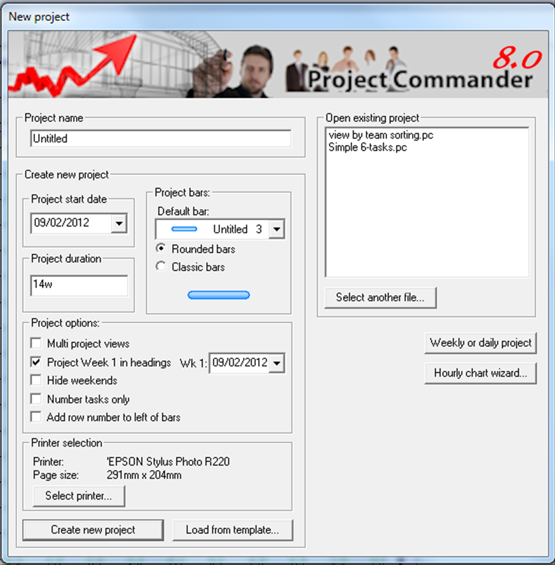

It allows users to insert a suggested task list capable of being added to and edited as a starter pack.

Templates are either linked or unlinked. Linked projects allow project start dates to be moved easily. For unlinked templates – the bars can be moved manually or by using the SHIFT PROJECT function.

- Drag & drop task descriptions

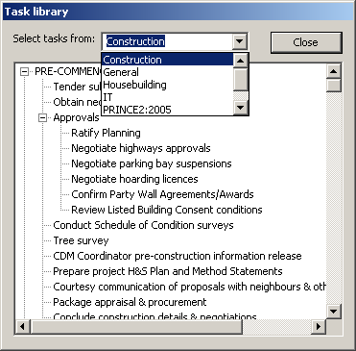
BARCHART | TASK | TASK LIBRARY opens a small window of 7 task libraries shown in the drop down list at the top. There libraries are Construction, Housebuilding, Specialist Trades, General, IT and Prince2 (2005 & 2009).

There are headings in capital letters and underneath each section is a list of tasks or a summary task and sub tasks.

Tasks can be dragged individually from the library into a blank row on the chart. It creates a one day task (system default) or a heading (not in capital letters) and you can drag the heading as a summary bars and it will take all the tasks underneath and make them into sub tasks on the project plan.

Tutorial 4: Multiple Jobs/Projects

This tutorial shows the user how to …

- Create new jobs
- Filter jobs

• Initial start up screen

The dates shown below will differ – as it will default to the current (today’s) date.

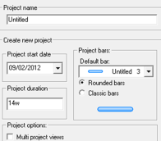
Select the FILE | NEW. First enter the PROJECT NAME as Job123. You can use the default settings. Then click on the tick on MULTI PROJECT VIEWS and CLASSIC BARS, then click on the CREATE NEW PROJECT button.

• Setup chart

Zoom up the screen by selecting the VIEW | ZOOM | ACTUAL SIZE.

1. Change the View
This changes the View list to refer to more than one project - where all tasks are identified to a particular project and a client - by number or name. The default View now is the BASIC View and caters for more than one project and you will see a specific extra column in the View to enter the Project identity.

2. Enter the first task line

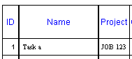
- Type Task A in the NAME column and then press on the ENTER key.

The system automatically puts the Project in the PROJECT column. In order to enter a new Project name and (optionally) a Client …

- PROJECT | PROJECTS | VIEW PROJECTS and click on the Project Name and then EDIT
- Enter a client
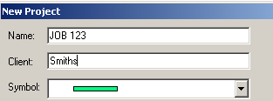
- Click on OK and then CLOSE.

- Enter the following in the START and DURATION columns (The dates you input would be different from the those shown in the tutorial) …
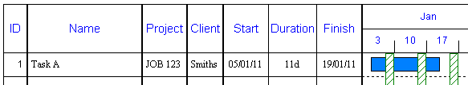

The FINISH column is calculated automatically.

- Next type the following in the next 3 tasks on Rows 2-4 under the NAME column (the PROJECT description & CLIENT is automatically repeated) …

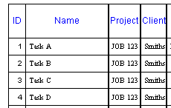

- Enter the following in the START and DURATION columns …
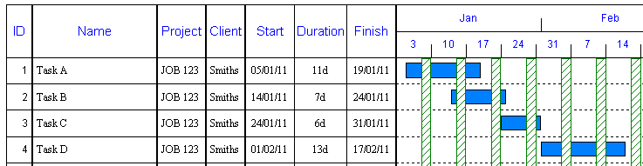

- Enter the first task for ID5 and assign the new project to this task ..
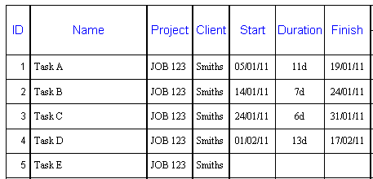

- Enter a new project, PROJECT | PROJECTS | VIEW PROJECTS and click on NEW.
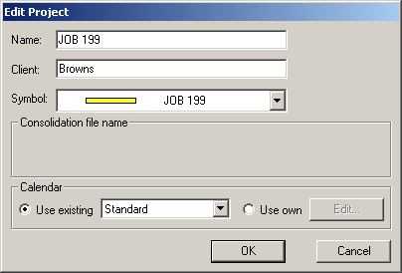

- Then after clicking OK, then highlight JOB 199 and click on the ASSIGN button
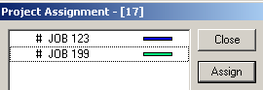

- Enter the following in the next 5-7 rows …
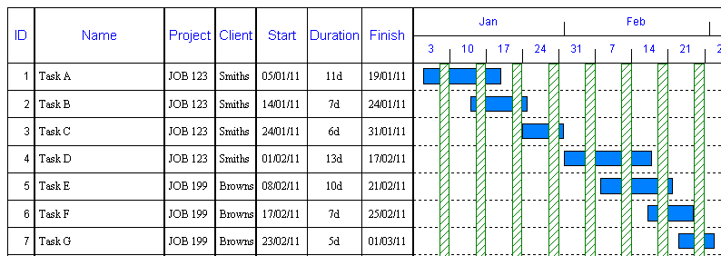

• Filter projects

To select only one or certain jobs …
- Select the VIEW | DATA | FILTER | PROJECTS DISPLAYED. This gives a full list of all the jobs entered.
- Click on the CLEAR BOX
- Click on the item JOB 199
- Click on OK.

This displays just the JOB 199 …
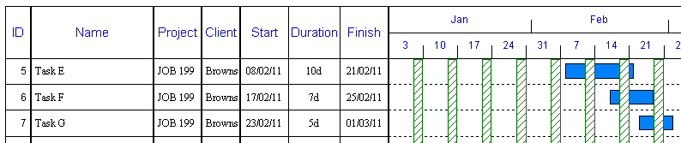

- To redisplay all information, select VIEW | DATA | FILTER | ALL PROJECTS.
- Click on NO to return to the ID numbers for each line.

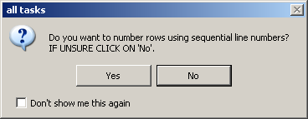

Tutorial 5: Complex Single Project with Links & Summary Levels

This tutorial shows the user how to …

- Use Quick Chart entry
- Link bars
- Create delays on links
- Summarise information
- Create Sub tasks
- Hide sub detail
- Show % Complete
- Display a Progress line
- Add freeform text
- Add logos (graphics)

• Setup chart

The dates shown below will differ – as it will default to the current (today’s) date.

Start up Project Commander or select FILE | NEW. Leave the default options and then click on the CREATE NEW PROJECT button.

On Tutorial 1 & 2, descriptions were entered as a simple list of tasks with certain rows used purely as headings and did not contain bars. Here the headings will be now used to create summary information.

- Enter task descriptions

Enter the following …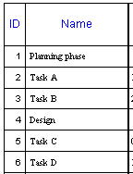

- Quick Entry
There is a simple quick method of creating a chart with bars cascading one after each other.

First enter a Start Date for Task A near today’s date (ignore the actual dates below …
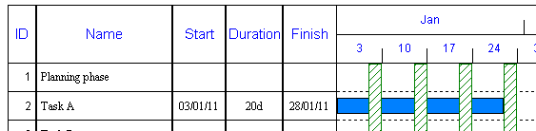

Then only in the DURATION columns of the following tasks and enter the Durations … this will cause the START and FINISH DATES to be calculated as if in a sequence.

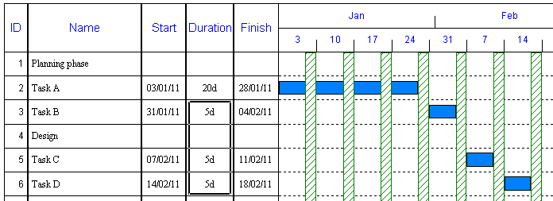

(If no START DATE is entered for TASK A, then the system defaults to the Project start date.)

This Quick Method gives the impression that bars are linked – but they are not. If any of the bars are edited and move, other bars below will remain static.

- Simple linking
If bars are linked, then the bars are scheduled using the links and therefore the START and FINISH DATES are automatically calculated. So when bars are linked the bars may move after linking.

Most tasks are usually linked together when work on a task can't start until a previous task is complete. This is known as a "Finish to Start" link and is the most common type of link. However, there are three other types of link that can be applied; "Start to Start", "Start to Finish" and "Finish to Finish".

- The fastest way to set a "Finish to Start" link between TASK A and TASK B is to place the mouse cursor on the end (bottom right hand corner) of the TASK A bar to be linked, wait for the cursor to change to a cross + click and hold the mouse button and drag the mouse to the start (top left hand corner) of the TASK B bar and release.
- To create a "Start to Start" link between TASK B and TASK C is to place the mouse cursor on the start (bottom left hand corner) of the TASK B bar to be linked, wait for the cursor to change to a cross + click and hold the mouse button and drag the mouse to the start (top left hand corner) of the TASK C bar.
- To create a "Finish to Start" link between TASK C and TASK D is to place the mouse cursor on the end (bottom right hand corner) of the TASK C bar to be linked, wait for the cursor to change to a cross + click and hold the mouse button and drag the mouse to the start (top left hand corner) of the TASK D bar.

It is not always necessary to link all bars – only those that need to be in a sequence. In this case the chart will look as follows …
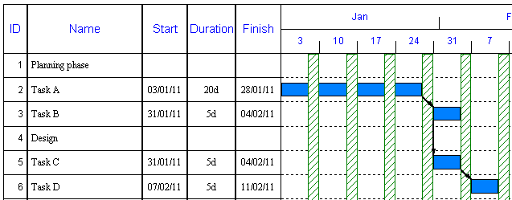
All the task bars start and finish dates have been recalculated using the links.

- To show the benefit of linking, edit TASK A, by clicking on the DURATION cell and typing 6w and then press the ENTER key on the keyboard… this will extend the end of TASK A and since other tasks are linked, the three other bars are moved 2 weeks later.

It is possible to link upwards as well as downwards – but since most planners like to see a ladder effect, it is usual for most links to be in a downward direction. It is crucial that the direction of linking is correct, as it is the bar receiving the link that is the one that is rescheduled and will move. An ARROW HEAD on the link line shows which way the link goes.

- Linking with delays
It is possible to create what is called a LAG on the link which forces a delay or pushes the linked bar to earlier in time.

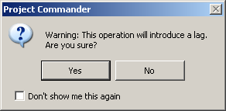
- Click on the middle of the bar Task B and drag the bar to the right (a small yellow box will appear on the screen with information to show where you are moving the bar to) for approximately a week and release. A message will appear on-screen – confirming your wish to create a delay on the link …
- Click on YES to confirm.
The barchart is redrawn with the link pointing forwards and the Task B has moved forward – taking along with it the other 2 bars following.

The delay factor is permanent – and will keep that delay always between Task A and Task B unless changed. Lags can be also be dragged to the left to produce links that point to the left – so bars partially overlap.
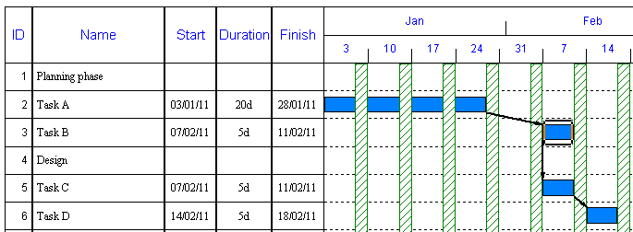

- Creating summary tasks
It is possible to create special tasks that summarise information and bars in a hierarchical manner.
- Click on the task name Task A and then drag the mouse down over Task B

- Click on the BARCHART | TASK | INDENT (RIGHT ARROW)

This will indent the names Task A and Task B in the column. The heading Planning Phase will now be displayed in bold and the start and finish date columns are calculated automatically from the bars below – the START DATE is the start of Task A and the FINISH DATE is the end of Task B. On the chart area, the bars are summarised also on the Planning Phase summary task.
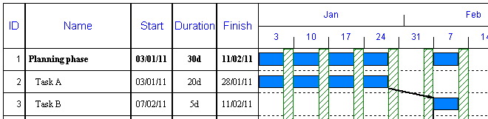
- Click on the task name Task C and then drag the mouse down over Task D
- Click on the INDENT ARROW again
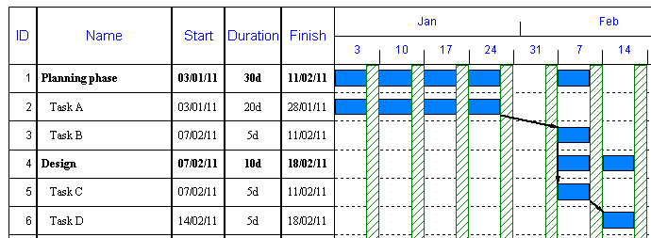

- Creating sub tasks
It is possible to break tasks down into sub levels.
- Enter further 3 tasks D1 to D3 from row 7 and type 1W in the DURATION column for each task (again the bars will follow sequentially – since no start date is entered)
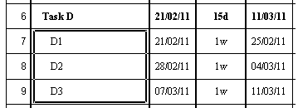

- Click on the task name D1 and then drag the mouse down over D3
- Click on the INDENT ARROW
Summary tasks cannot be edited or moved – as they are created from the tasks below them.
This will mean Task D now becomes a summary task and the link between TASK C & D is deleted automatically. All the information is recalculated as follows (with the information flowing up to the DESIGN summary level too….
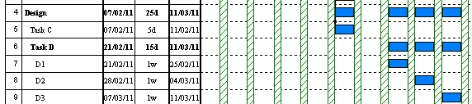

By making TASK D now a summary bar, it loses the link to TASK C (as summary bars are not allowed to be linked)

In order to keep the integrity of the linking, you would need to link TASK D1 to D2 and D2 to D3 and also TASK C to D1- using the ID column.
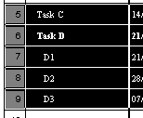
A quick way to create finish to start links is to highlight Task C to D3 and click on the TASK | SCHEDULE | AUTOLINK TASKS and then YES.
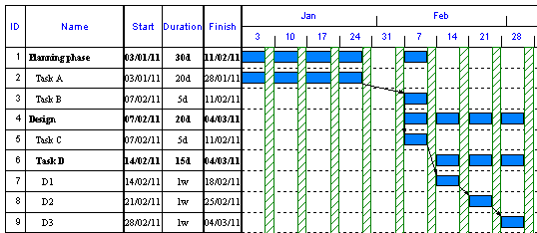

It is not possible to link summary bars to any bar. You can only link task bars and milestone symbols.

The benefit of summary levels is that detail below can be hidden on-screen.
- Double click on the task name Planning Phase – this hides the 2 tasks below.
- Double click on the task name Planning Phase again – this displays the 2 tasks.
- Double click on the task name Design – this hides all the tasks below.
- Double click on the task name Design again – this shows the next level down.
- Double click on the task name Task D – this shows all the tasks below this level.

- Bar colouring – summary bars

Colour all the task bar D1-D3 (non summary bars) differently; by clicking on the middle of the bar and clicking on the BARCHART | TASKS | BARS of the Bar Selector box
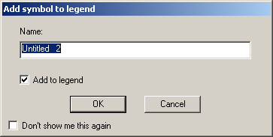
When you change the colour, the system prompts to enter the coloured bar into a Legend at the bottom of the page. If you click on CANCEL to all changes – it will not create a Legend at all.

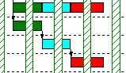
At the summary levels, the colour of the sub level bars are rolled up to the levels above….

(If colours overlap at the sub task level, the bar at the SUMMARY level is split into a maximum of 5 colours. If at the SUMMARY level, there are more than 2 colours overlapping at any one point, then that part of the bar overlapping is shown in a white (default) colour).

As an option, all summary bars can be shown globally as a standard default bar by clicking on the BARCHART | FORMAT | USE SUMMARY SYMBOL
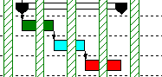

- % Complete
The bars can be automatically marked up with a black line inside the bar to show how much of the bar is finished. There are other columns that are calculated automatically to show if the tasks are ahead or behind.

- Select the VIEW | VIEW | VIEWS | PERCENT COMPLETE
- Click on the DOWN ARROW the date and click on a date that is a month or so ahead of today’s date
- Click on REPORTING LINE
- Then type the following values into the ACTUAL % column (do not type the % sign – this included automatically) against the tasks – do not try to input %’s the summary bars…

Task A | 100%
Task B | 80%
Task C | 60%
Task D1 | 20%

Each bar is marked up automatically with a black line inside each bar. The summary tasks are automatically calculated with % complete figures from the levels below and are also marked up a black line based on the lower levels too.

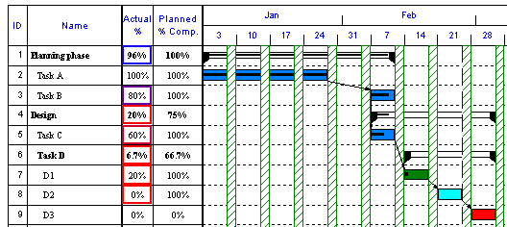

Note : The cell highlighting on the Actual % column is only displayed onscreen to assist the user – they are hidden when printed.

- Progress line
In order to emphasis progress, a line can be drawn down the date at which information is up to date.

Select the VIEW | VIEW | VIEWS | PERCENT COMPLETE and click ON the Progress Line… This will cause a jagged PROGRESS LINE will be drawn down the chart …
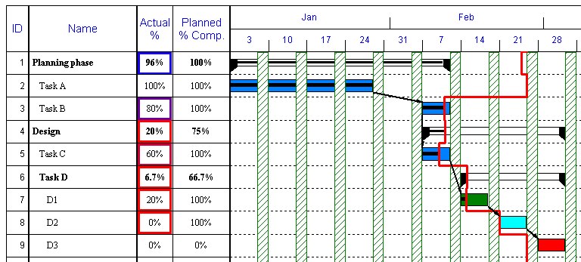
The PROGRESS LINE is drawn down the date and jags to the left when behind and to the right when ahead of today’s date.

- To see less detail on the left of the chart, select VIEW | VIEW | VIEWS | CHART.

- Reschedule
Tasks that have progress behind the Reporting date can be automatically rescheduled – so that any outstanding portion of the bar outstanding will be moved after the Reporting date and any outstanding links will cause other tasks yet unstarted, to be rescheduled using the links.

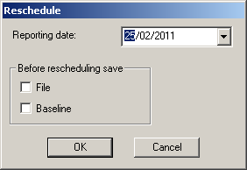
- To reschedule, select the PROJECT | STATUS | RESCHEDULE. In order to retain the original position, you can save the file to another file name or save a Baseline (i.e. a second bar per row underneath the current bar).

In this case, ignore the FILE and BASELINE box and then click on OK.

- Click on OK again. The result is….
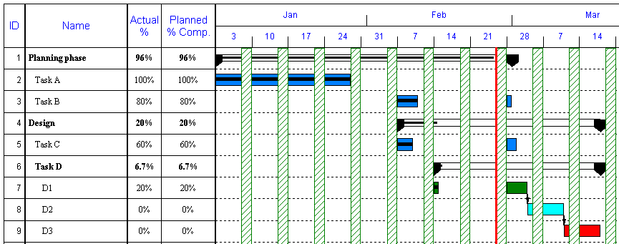
All the task bars that have started but are incomplete (if behind schedule), have been split in two between the % part done and the % part remaining and the latter bar will start after the Reporting Date. Any completed bars will remain or be forced behind the Reporting Line (ie. to the left) and all bars not tasks yet to do with 0% will be to the right of the Reporting Line.

Any relevant links between uncompleted bars are retained and any links between completed or part completed bars are removed.

- Freeform text
It possible to place text anywhere on the page and it can be placed horizontally, or pointed upwards or downwards.

To place a notation down the red line above….
- Click on the PAGE LAYOUT | GRAPHICS & TEXT | FREEFORM TEXT to put the system into TEXT MODE and then move the mouse and click on the chart next to the red line where the text is to be positioned. Then, a white box appears.

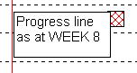
- Type in that box the text opposite, clicking on the ENTER key on the keyboard to go onto a different line.

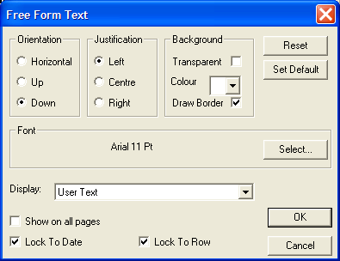
- Double click inside the middle of the white box and the following window will appear. Change the options as follows …

This makes the text point down, the text have a border (frame) and the fill colour to be light blue (by clicking on the DOWN ARROW). The TRANSPARENT option is clicked off. Since the default text font colour for such text is NAVY BLUE, the fill colour should be a light colour.

Click on LOCK TO DATE & LOCK TO ROW.

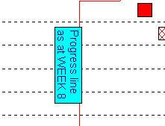
Click on OK and then the T FREEFORM TEXT icon on the Ribbon - to end the system in TEXT MODE.

This makes the text look as opposite …

The frame around the text is automatically drawn using the font size for the text. Text can only be moved and edited when in the TEXT MODE, by clicking on the FREEFORM TEXT icon on the Ribbon and then on the text itself – making a white box appear. The text can be moved by dragging the centre of the box around. Do not forget to click the T FREEFORM TEXT icon on the Ribbon - to end the system in TEXT MODE.

- Add logos (graphics)
It is important before adding any logos that the TITLE area at the top of the page is large enough to accommodate the graphic.

- Select BARCHART | FORMAT | TITLE to enter a title at the top of the page. It may be necessary to insert extra blank lines in the title area to create more space – by simply pressing the ENTER key on the keyboard at the end of a title line.
- Then, select the PAGE LAYOUT | GRAPHICS & TEXT | GRAPHICS. The cursor appearance will change.
- Click and drag the mouse down and across as if drawing a box on the page where you wish the graphic to be drawn.
- A window will automatically open in the middle of the screen requesting the file name and source directory.
- As an example there is a graphic file in the BORDERS subdirectory of the PC folder – so double click on BORDERS and then double click on the first WMF file in the list and the graphic will appear in the box.

The graphic can be moved and resized.

Graphics and Freeform Text are only saved on the View in which they are placed and would disappear when displaying another View.
Important notes
- Five colour Summary bars
If the coloured option for summary bars is ON, then up to five colours would roll up from the sub task levels below.

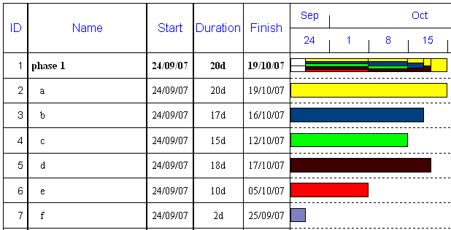

If more than 5 colours overlap, then the rollup colour is shown as white (only for that period).
Tutorial 6: Critical Path Analysis

This tutorial shows the user how to …

- Link bars
- Calculate critical path
- Show floats
- Hide links & floats
- Show Latest start & end dates

- Copying between files
- Risk allowance

In order to calculate Critical Path, it is important that most tasks have links either going into them or leaving them. It is also essential that there is a definite continuous linked path from the first task in the project to the end of the project (normally).

The Critical Path is calculated normally for the whole file, so if there is more than one project on a file, the path will show across all tasks and projects – so it is important that tasks across projects are linked too.

Note: If there are more than one independent paths (sub projects) in an overall plan – it is possible to calculate one or more Critical Paths by putting a Date Constraint (Must Start On or Must Finish On) at the end of each path. This would also apply to Multi Project files.

• Setup chart

Start up Project Commander or select FILE | NEW.
The dates shown below will differ – as it will default to the current (today’s) date.

- Change time range
Click on the DOWN ARROW on the START DATE and choose a date. Click on CLASSIC BARS for Project Bars. Then click on the CREATE NEW PROJECT button.

- Add tasks
Enter the following items in the BASIC View in the NAME & DURATION columns (the FINISH column is calculated automatically) … please ignore dates below ….
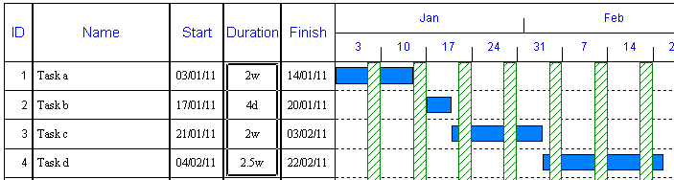

- Simple linking
If bars are linked, then the bars are scheduled using the links and therefore the START and FINISH DATES are automatically recalculated. So when bars are linked the bars will move after linking.

All tasks will be linked by "Finish to Start" links.

- The fastest way to set a "Finish to Start" link between TASK A and TASK B is to place the mouse cursor on the end (bottom right hand corner) of the TASK A bar to be linked, wait for the cursor to change to a cross + click and hold the mouse button and drag the mouse to the start (top left hand corner) of the TASK B bar and release.
- To link between TASK B and TASK C is to place the mouse cursor on the end (bottom right hand corner) of the TASK B bar to be linked, wait for the cursor to change to a cross + click and hold the mouse button and drag the mouse to the start (top left hand corner) of the TASK C bar and release.
- To link between TASK A and TASK D is to place the mouse cursor on the end (bottom right hand corner) of the TASK A bar to be linked, wait for the cursor to change to a cross + click and hold the mouse button and drag the mouse to the start (top left hand corner) of the TASK D bar and release.

In this case the chart will look as follows …
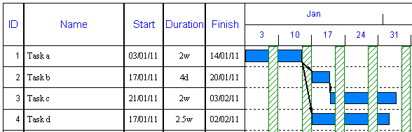
All the task bars start and finish dates have been recalculated using the links.

- Calculate Critical Path
Click on BARCHART | PROJECT | CPA …
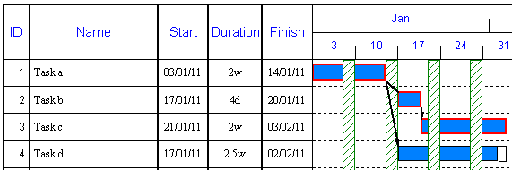
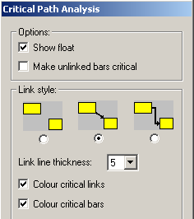
The Critical path is shown as a RED OUTLINE against tasks A, B & C. The FLOAT is shown as a CLEAR (transparent) bar on the end of all non-critical bars (Task D).

There are 2 other options to colour the link lines, colour links that link critical bars and colour critical bars – as a solid red bar.

- Identify Float

Place the mouse over any non critical bar (Task D) and FLOAT information is displayed a the bottom of the screen in the STATUS LINE …

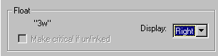
- Print Float
- To display the amount of Float around the bar, double click on the centre of the Task D bar and in the BAR EDIT window. At the bottom where it says FLOAT, click on the DOWN ARROW for DISPLAY and select RIGHT from the drop down list….

When any changes are made to the chart, CRITICAL PATH is turned off and the red surrounds for Critical bars and the clear bar for float are removed and the letters NA are displayed to the right of Task D – meaning NOT AVAILABLE until the Critical Path is recalculated.

- Click on the BARCHART | PROJECT | CPA and the FLOAT will show as 0.3w for three weeks on the Task D…
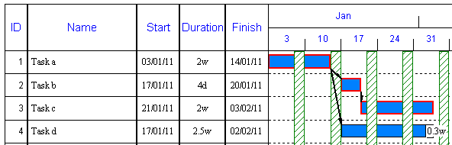
To remove the CRITICAL PATH, simply click on BARCHART | PROJECT | CPA again.

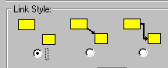
- Hide float & links
Click on the BARCHART | PROJECT | CPA again and click on the following diagram – on the left….

- Show Latest Start and Finish dates for tasks
Select the VIEW | VIEW | VIEWS | MORE VIEWS & FLOAT. All the fields associated with critical path will contain the wording “not applicable” until calculated. Click on the BARCHART | PROJECT | CPA again.

Previously there was a column called Min Float that only showed the lesser of the Float values – if there was more than one bar on a line.
The Min Float column has now been deleted and replaced by a column called Now Float is shown on all bars on a line …
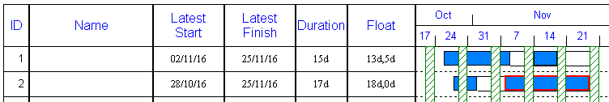
The Float for each bar is separated by a series of commas.

- Risk
Project Commander now deals with recording Risk durations in 2 ways..
- Show a value of Risk as part of the Duration of a bar
- Show a value of Risk as extra to the Duration of a bar

New feature
In the Risk View (VIEW | VIEW | VIEWS | RISK) , it displays a Risk Estimate column. You can enter a duration into the Risk Estimate column as a memo to say how much of the total duration is regarded as risk.
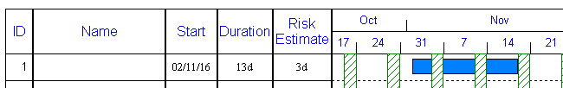

Old Feature
In the Risk it used to display a Risk Allowance and Risk Duration column. The columns are still present.. so you can insert it if needed…
If you enter a duration into the Risk Allowance – it adds an extra bar on the ends that represents the risk and updates the Risk Duration
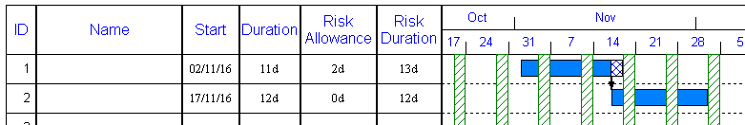
However, any links will be drawn to the Duration value not the Risk Duration.
Note : In the first option, the links would be drawn from the end of the bar as usual and so take into account the Risk in scheduling any bars linked.

• Copying between files

It is possible to open up more than one session of Project Commander and copy records across files. This is useful where projects or tasks need to be isolated in another file to calculate individual Critical Paths, Resources or Costs.

- Click on FILE | START ANOTHER SESSION .
This will open up another Window and a blank project file. Select the Project Start Date of today and 14 weeks.

So now two copies of the file are open and can be changed separately. Each copy is made active by clicking on the PROGRAM BAR at the bottom of the window….
Click on the other Project Commander button at the bottom of the screen to open up the other file with the tasks.

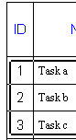
- To copy all the first three records only, click on Row 1 and holding the left hand mouse button down, drag down to Row 3.

- To copy click on BARCHART | TASK | COPY (or right click on mouse)
- Click on the other Project Commander button at the bottom of the screen to open up the blank file.
- To paste click on BARCHART | TASK | PASTE (or right click on mouse)
- and this copies everything including links (costs and resources – if present).
When copying to a new file, the new file may have different settings – such as Calendar and Resource details will not be present – so calculated data may be different from the copied file – if these settings are not changed to be similar.

Important notes
- Links
The appearance of the links and the ability to hide them (for printing) can be achieved by selecting FORMAT | LINKS.
- Lock linked bars
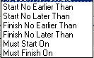
It is possible to override the linking effect on dates, by locking the bar into it’s existing position. First click once on the centre of a bar and then click on TASK | CHART | LOCK | BAR.
- Date constraints on linked bars
You can also put date constraints on tasks that will effect the start/end dates of tasks and may also override the links if the constraint type/date conflicts with the link calculated dates. By default, the constraint status is as soon as possible – which means no constraint present.
To access these settings TASK | PROPERTIES | TASK FORM & click on the LINKS, CONSTRAINTS & CPA tab.
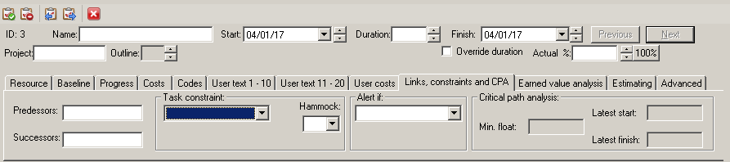

- Network diagram
You can view a Network diagram for linked tasks VIEW | VIEW | NETWORK DIAGRAM. The window is constructed in such a way that the only the ID numbers are shown in boxes linked and a full list of tasks down the right hand side and the Task Form at the bottom.
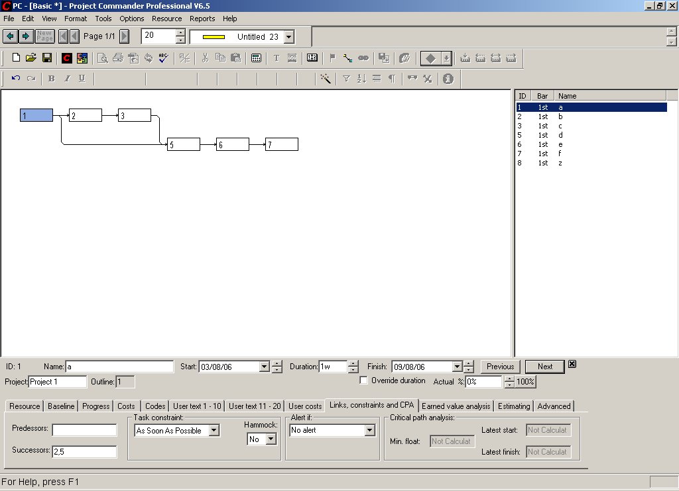

Each compartment of the window is synchronised on the same task. You can choose the highlighted task by …
- Click once on a box
- Click on a task in the task list
- Click on NEXT/PREVIOUS buttons in the Task Form

It is possible to enter new links in this window to existing tasks by highlighting the ID number on the list and entering a Predecessor or Successor.
If you wish to enter a new task, click on the last task on the list and then click on NEXT on the toolbar and enter a Name, Start date & Duration (as normal)

If the network diagram area is insufficient to contain all the tasks, a scroll bar will appear on the bottom and right hand side of the diagram. If the list area is not long enough, a vertical scroll bar will appear.

If there a large number of tasks/links, you can highlight any task and the diagram will centralise the network graphic around that task in the centre.

The Network Diagram is only available as a on-screen report (it cannot be printed out). However, the Link List can be printed still in order to report all links in hard form.
- Mid bar links
A popular feature in a more expensive package such as PowerProject is that links can be shown as going from mid points where tasks are overlapping instead of from the bar corners.

We have now introduced this feature, so you can convert an existing linked barchart to look like this or you can link from scratch using this mode.

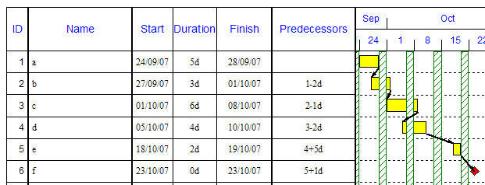

Select the FILE | OPTIONS | PREFERENCES & then the LINKS tab. Click a TICK in the USE POWERPROJECT-LIKE LINKING box.

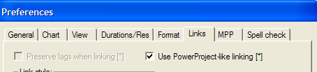

Now all the links for overlapping bars will be drawn straight from the relevant point of the FROM bar.
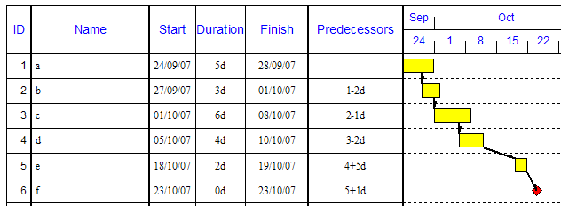
USING THE MOUSE

Besides converting existing links, with this option ON, you can draw links from the mid point of any bar to the start or end of any other bar. You will see that in this mode, the cursor appearance …..

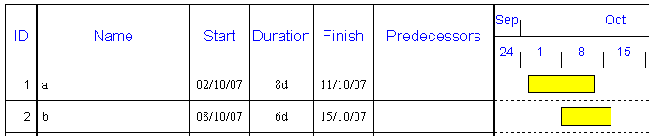

In the above example, to create a downward link, place the cursor on the top bar on the bottom side of the bar on 8 October (it will display the expected lag) and click on left hand mouse button and drag down on to the top left hand corner of the second bar.
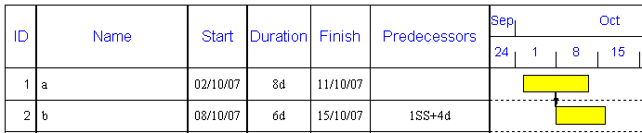

The system create effectively a START TO START link and calculate the LAG.

Note: Links can also be drawn upwards, by drawing links from the top of the FROM bar to a bar higher up the list.

Important
If you position the cursor very close or at the end of the first bar, it will create a FINISH TO START link.
The TO bar will always line up vertically with the mid point link on the FROM bar ..

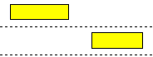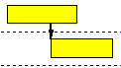

You cannot draw a link from the mid point of a bar to the mid point of another bar. The link to the TO bar will go to the start or the end of the bar.

USING THE LINK LIST
With this option ON, you can still enter links in the LINK LIST ( BARCHART | PROJECT | LINK LIST)
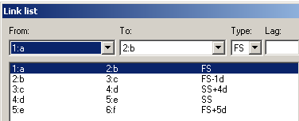
All overlapping bars will show as mid point links; but bars with lags that do not overlap will be shown as normal.

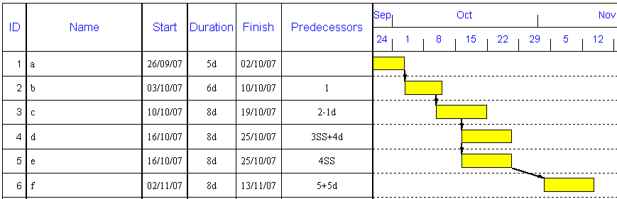

If the OPTION is taken OFF, the linking style will return to normal …

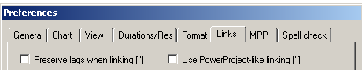

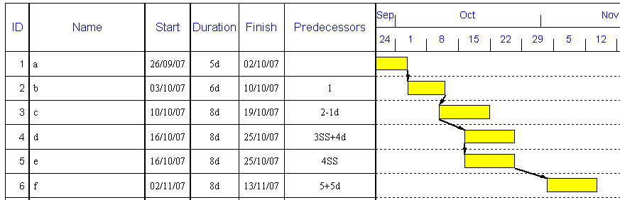

- Optional linking technique
For some time, users have been searching for a way of creating a barchart (unlinked) and then linking it without moving the bars. Currently in 6.5 and before, if you link 1 bars, the second bar can move as it reschedules immediately and if you want that bar to retain it’s original position, you had to move it back with the mouse.

In order to keep the same bar positions after linking, we have created an option to do this and no matter what link you create – Project Commander will calculate any LAG automatically between 2 bars linked.

Note : This option can be turned on or off at any time – so that you can use it in conjunction with existing normal feature.

So if you have an unlinked barchart like this …

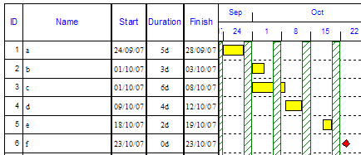

First select the FILE | OPTIONS | PREFERENCES | LINKS tab and click on PRESERVE LAGS WHEN LINKING.
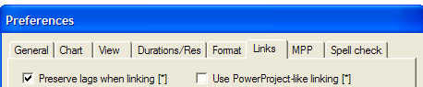

Now only when you draw links with the mouse, it will draw the link – but keep the TO bar in place and calculate the LAG.

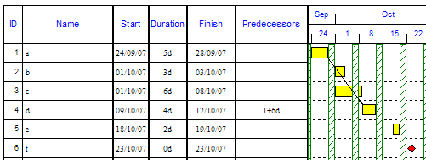

Above, we have drawn a link between bars a & d as if Finish to Start and we have inserted a PREDECESSOR column to show that it has calculated a 6 day lag on the link.

Important: All links should not be entered in this way – as it would put all the tasks on the Critical Path. It should only be used for to control the Critical items.

Note:
The LINK LIST overrides this option and so you can only use mouse links (or Finish to Start links using the auto link ( TASK | SCHEDULE | AUTOLINK TASKS)

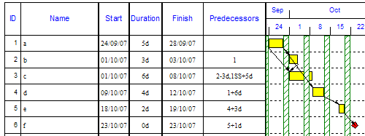

Note: In order to make it easier to use the mouse to link bars, you should turn off the paging, by selecting the VIEW | VIEW | TASK LIST as this displays all the tasks in a long list without any pagination. You can then scroll (if you have a mouse with a scroll wheel) while linking off screen by using your left hand finger on the left mouse button fully down and scrolling the mouse wheel with another finger to another bar some way down the list. To return to pagination, select any View like BASIC (VIEW | VIEW | VIEWS | BASIC).

There is a comprehensive document on all aspects of critical path analysis on our website.

http://www.projectcommander.co.uk/pmsc/existing-users.html

- CPA Analysis Report
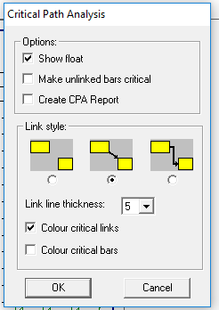
When calculating CPA – there now is an extra option to Create a CPA Report – which fully analyses the project plan to assess potentially issues/errors in your CPA.

To both calculate CPA and initialise the CPA Analysis Report – click on option below and then OK.
You can choose what you want the Report to analyse. To choose full analysis click on SELECT ALL
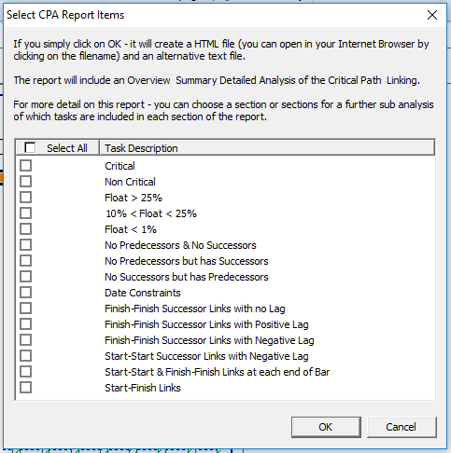

The Analysis Report is then created and you will be asked to save it in .html format – that can be opened using your Browser. It will also save a text version to the same file name – that can be opened in Notepad or Word.

The Report will be in three sections ..
An overview of CPA
An INITIAL ANALYSIS
A DETAILED ANAYSIS

The Analysis is broken down into sections of ….
Number of Critical items
Floats
Broken Links
Date constraints
Unusual Links
Accuracy score

Tutorial 7: Single resources per task

This tutorial shows the user how to …

- Add resources
- Perform quick resource assignment
- Show resource histograms
- Create resource reports

- Automatically colour by resource
- Create resource calendars
- Open a split screen
- Filter resource information

On the VIEW tab, the default options refer to single projects and the MULTI PROJECT VIEWS option refer to more than one project - where all tasks are identified to a particular project - by number or name.

• Setup chart

The dates shown below will differ – as it will default to the current (today’s) date.

Start up Project Commander or select FILE | NEW. On the initial start up screen, click on the CREATE NEW PROJECT button.

- Change time range
Click on the BARCHART | FORMAT | FORMAT TIMESCALE.

- Add tasks
Enter items in the BASIC View using the NAME, START & DURATION columns (the FINISH column is calculated automatically) and using your own dates …
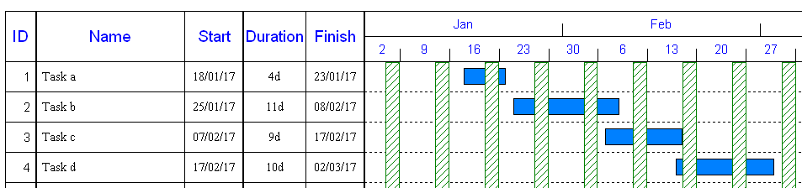

- Add resources

- Click on the RESOURCES | VIEWS | ASSIGN

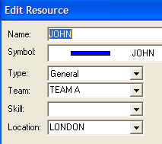
Resources are defined as meaning mainly Labour Resources - but they could include any owned/leased equipment or plant. Resources can be individually named persons/machines or in groups/teams of similar skills as a number – not identified as individuals.

- Click on NEW

- Type the first RESOURCE NAME as JOHN

- Enter LOCATION & TEAM (optional)

The MAXIMUM UNITS will default to ONE. Leave the COST RATE unchanged. It is also possible to create a Calendar especially for the resource. If a special resource calendar is created (see later), this will be used instead of the Project Calendar to schedule the task associated with that resource.
- Click on OK.

- Click on the NEW button again to create a new resource …

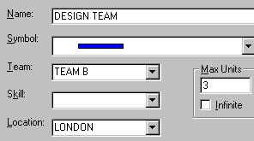
The LOCATION can be entered by clicking down on the DOWN ARROW (as it is saved as an option when entered for the previous resource).
- Click on OK.

To add a further named resource...
- Click on the NEW button.
- Type the first RESOURCE NAME as ANNE.
- For TEAM, click on the DOWN ARROW and choose TEAM B.
- For LOCATION, click on the DOWN ARROW and choose LONDON.
- Click on OK and then CLOSE.

• Resource assignments

1. Resource chart and assignments
There is a quick way to assign resources to tasks...
- Select the RESOURCE | VIEWS |RESOURCE VIEWS | RESOURCE CHART.
- Click on TASK A on the chart behind.
- Click on JOHN in the list in the RESOURCE ASSIGNMENT window.
- Click on the ASSIGN button.
- Click on the top of the RESOURCE ASSIGNMENT window and drag it down to the bottom right of the screen.
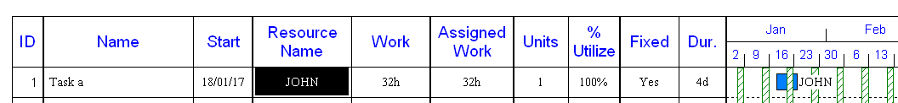
It will reveal the Resource Assignment made to the task...
- JOHN is the named resource.
- The FIXED column shows YES (which means that the duration is locked and will not change no matter how many resources are assigned to it.
- The UNITS default to ONE.
- The % defaults to 100%.
- The SCHEDULED EFFORT is calculated as Duration x Units x %.

- Next, click on TASK B on the chart.
- Click on DESIGN TEAM in the list in the RESOURCE ASSIGNMENT window.
- Click on the ASSIGN button and it assigns one unit of resource by default.
- Click on the WHOLE UNITS cell containing 1 for TASK B.
- Type 2 (for TWO persons) in the UNITS and press the ENTER key on the keyboard 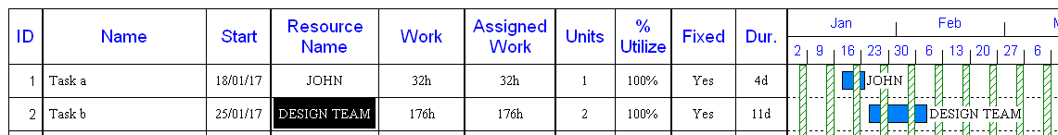

Part time assignments can be made…
- Next, click on TASK C on the chart.
- Click on JOHN in the list in the RESOURCE ASSIGNMENT window.
- Click on the ASSIGN button.
- Click on the % UTILIZE box at the bottom of the window and type 50(for 50%) – the WORK will change.
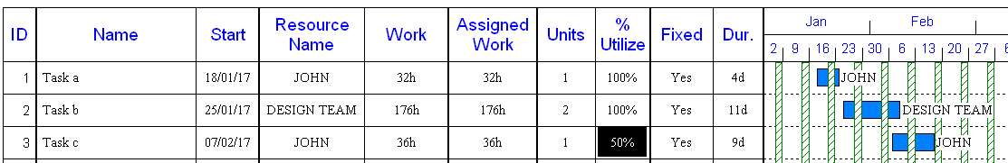

- Non fixed (or Resource/Effort Driven) duration tasks and assignments
There is another type of tasks – known as NON FIXED DURATION.

Here the Duration is recalculated by using Work as the driving force or by changing Resource Units or % Utilisation…
- Select the RESOURCE | VIEWS | RESOURCE VIEWS | RESOURCE CHART
- Next, click on TASK D on the chart.
- Click on DESIGN TEAM in the list in the RESOURCE ASSIGNMENT window.
- Click on the ASSIGN button.
- Then close the RESOURCE ASSIGNMENT window.
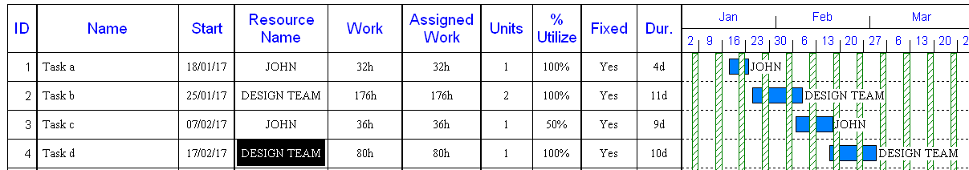

- In the Resource Chart above - Click on the FIXED cell containing YES for TASK D.
- Type N (for NO) and press the ENTER key on the keyboard– the FIXED COLUMN will change to NO – just for that task.
- Click on the UNITS cell containing 1 for TASK D.
- Type 2 (for TWO persons) and press the ENTER key on the keyboard – the EFFORT COLUMN will remain fixed – but the DURATION will halve.

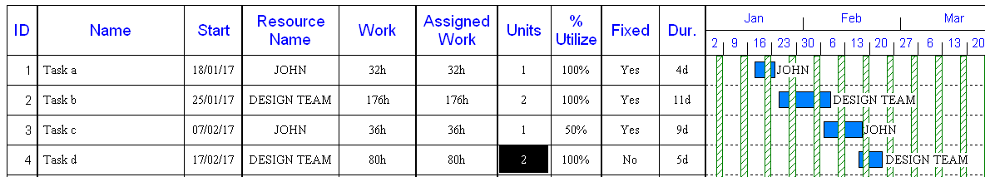

If the % is changed to 25% … the Duration will increase again..

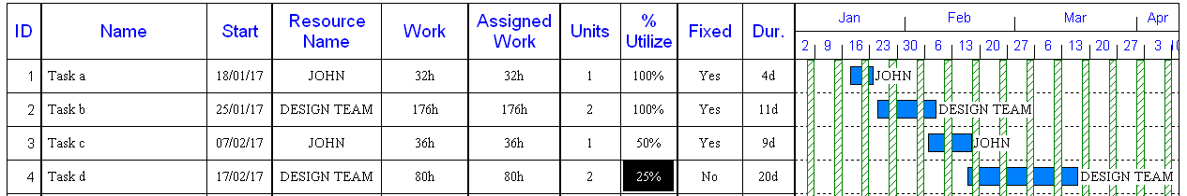

You can enter Work first before you assign a resource …

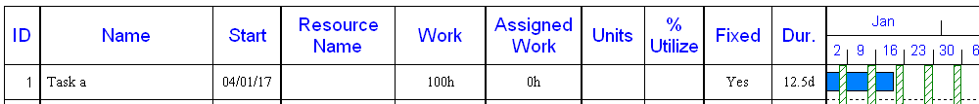

If you assign a Resource – it assumes 1 unit.
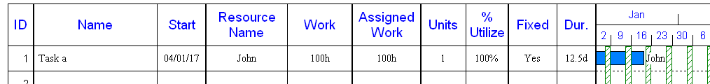

Making sure you have closed the RESOURCE ASSIGNMENT window.
Change FIXED = YES to FIXED = NO
If you change the UNITS or %UTILISE ….the WORK stays fixed and the DURATION updates …

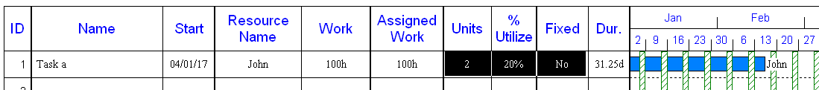

- Resource Reporting & Window
The resources are consolidated into a histogram or spreadsheet for several resources.

- Select REPORTS | REPORTS | RESOURCES |RESOURCE CHART & RESOURCE USAGE
- Click on SHOW DECIMALS
- Click on UNITS (to show the equivalent number of persons needed)

So the settings will cause a USAGE REPORT (spreadsheet) is displayed with all the resources (except any not used) calculated in average resource units – not rounded up (i.e. with one decimal place).
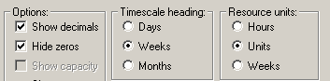
- Click on OK. This will show a combined report with a barchart at the top and a resource usage spreadsheet a the bottom of the page.

- Select RESOURCE | VIEWS | RESOURCE USAGE WINDOW (this creates an split window at the bottom of the screen for Resource or Cost information or graphs).

The Resources are listed. The UNITS column shows the number of persons needed per week for each resource and the weekly average units needed for each period.
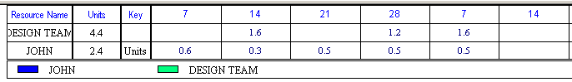

The SPLIT WINDOW dividing horizontal line can be dragged upwards or downwards to control how much the RESOURCE USAGE report is shown.

If any of the figures are in RED, this highlights the average usage in that week it means it exceeds the maximum number specified when the resource was created.

It is possible to edit the information in the RESOURCE CHART view and it will change any resource reports instantly.

The resource names are attached to the bars and so to remove the label from all bars…
- Double click on the centre of the bar
- Click on the DATA LABELS button
- Click on the DOWN ARROW against the RIGHT box and click on CLEAR ALL and OK
- Click on UPDATE ALL BARS
- Click on OK again.
It does sometimes take time to calculate changes on larger projects (ie. number of tasks and time range).

To change the resource figures to HOURS instead of persons…
- Select REPORTS | REPORTS | RESOURCES | RESOURCE CHART & USAGE
- Then OK.
The figures are shown as the total number of hours needed for each whole week.
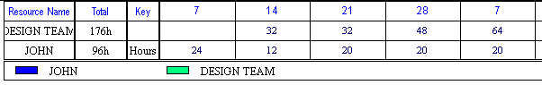
- The totalling of resources is controlled by the TIMESCALE setting, select REPORTS | REPORTS | RESOURCES | RESOURCE CHART & USAGE
- Click on MONTHS
- Click on OK

The chart on-screen will recalculate the hours on a monthly basis…
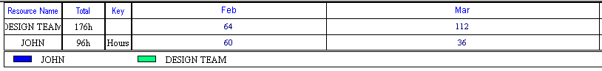

- Resource reassignment
It is also possible to change the resource on each task by …
- Click on RESOURCES | VIEWS | ASSIGN
- Click on the middle of the bar for TASK C.
- Click on the REMOVE button in the RESOURCE ASSIGNMENT window (ensuring JOHN is highlighted in the list)
- Click on the new resource ANN.
- Click on the ASSIGN button.
- Click on CLOSE.

When you re-run the REPORTS | REPORTS | RESOURCES | RESOURCE CHART & USAGE, this will cause the bottom USAGE REPORT to be recalculated for JOHN. Now ANN can be included in this report …
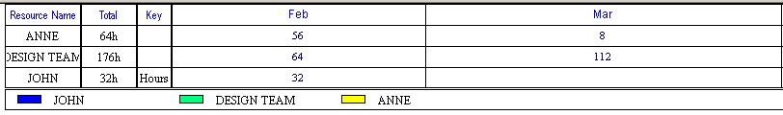

You will see that when JOHN is removed and ANNE is replaced – the assumption initially for any change of resource is made that 100% and ONE UNIT is put on the task and the EFFORT is recalculated based on the current DURATION – this may be need to be reviewed in the light of the change.
• Resource Sheet

The resources can be added/edited using the Resource Sheet. Select the RESOURCE |VIEWS |RESOURCE SHEET.

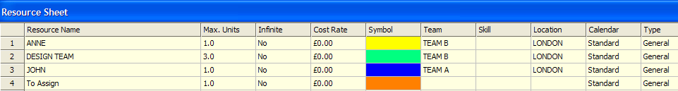

If a task has no named resource assigned to it, then the task has TO ASSIGN attached to it.

Note: Reports can be run for TEAMS, LOCATIONS & SKILLS ..
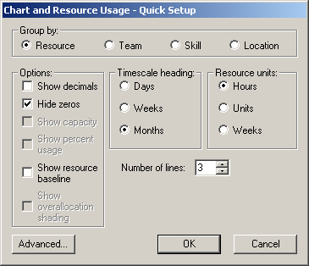

• Resource Calendars

When a new Resource is added, it is assumed that the default Calendar used for it is the Project Calendar. In order to create a customised calendar specific to that resource …
- In the RESOURCE SHEET, double click on the Calendar cell for ANNE
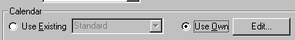
- Click on the USE OWN option (at the bottom of the screen in the CALENDAR area) and then the EDIT button.

This brings up a Calendar.

In this example only …

- Scroll to the month of February .
- Click on the 21,22,23 – this will change the background colour from white to grey and will make those days non working.
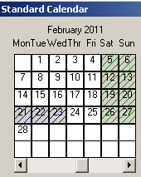
- Click on OK twice.
- Click on CLOSE.
- Select VIEW | VIEW | VIEWS | BASIC

Since a task bar was originally passing through this period, then the end of this bar will now be extended to finish on March 4 later than originally scheduled (using the Project Calendar).
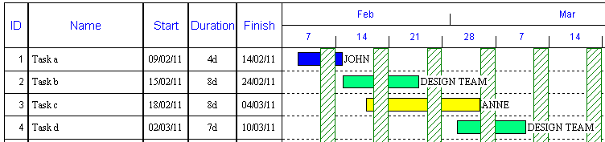

The bar is extended – but the DURATION remains 8d for eight days. The shading on the barchart conforms to the shading of the Project Calendar. However, there will be adjusted hours recorded for ANNE. In order to confirm this …

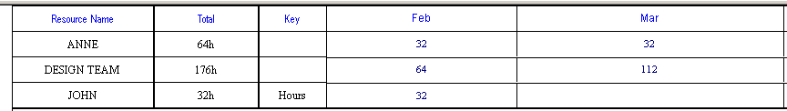

• Resource Information (some of these examples include different data from above)

Other reports include..
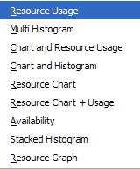

- Combined Chart and Histogram
To change the USAGE report at the bottom to a Histogram …
- Select the REPORTS | REPORTS |RESOURCES | CHART & HISTOGRAM
- Click on OK.
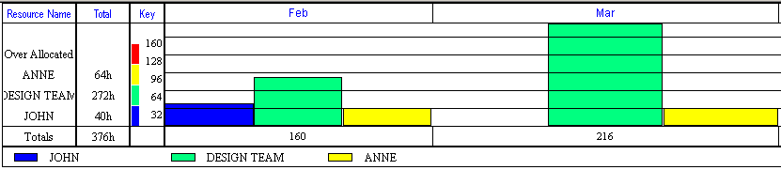

- Multi Histogram
- Select the REPORTS | REPORTS |RESOURCES | MULTI HISTOGRAM
- Click on OK.

The histogram fills the whole page.

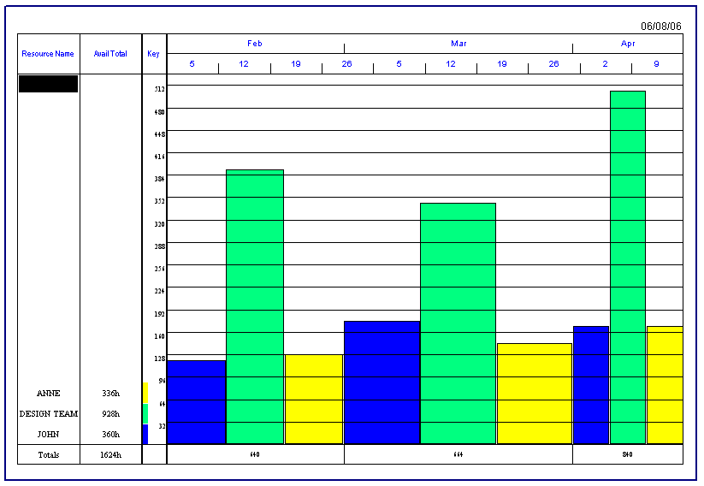
- Availability
- Select the REPORTS | REPORTS |RESOURCES | AVAILABILITY
- Click on OK.

The number of hours available including any resource holidays
also.

- Stacked Histogram
- Select the REPORTS | REPORTS |RESOURCES | STACKED HISTOGRAM
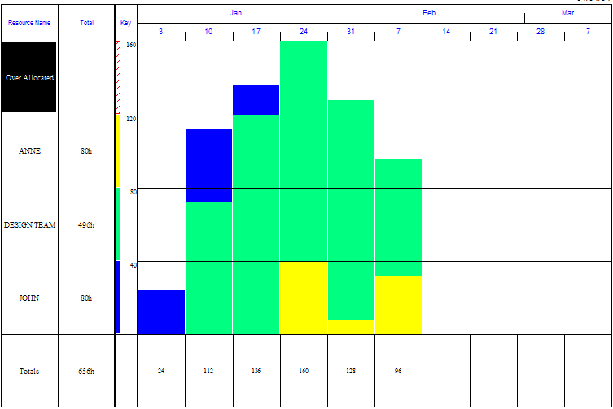
- Click on OK

This consolidates usage of each resource into one vertical bars on top of each other.

- Resource Graph
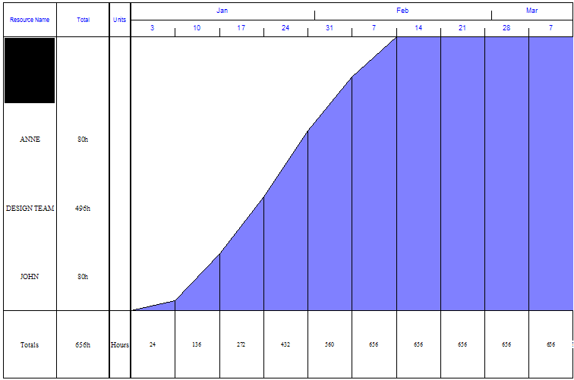
- Select the REPORTS | REPORTS |RESOURCES | RESOURCE GRAPH
- Click on OK

It shows a cumulative graph of work done for all resources.

- Group By
On any Resource report, the default is to include all resources and identify each resource. It is possible to analyse resource information against Team, Location or Skill.
- Select the REPORTS | REPORTS |RESOURCES | RESOURCE USAGE
- Click on TEAM
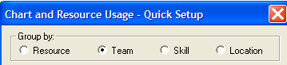
- Click on OK

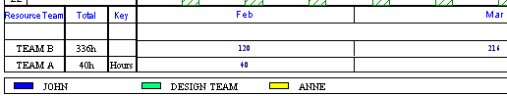

- Resource Barchart
By default, on all chart-based reports, all tasks are shown in the order in which they are input or sorted. In order to sort the whole chart quickly by each resource …
- Select the VIEW | VIEW |VIEW BY RESOURCE.
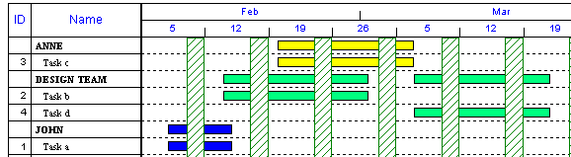

To change back to original task order...
- Select the VIEW | VIEW |VIEW BY TASK.

To colour this by the task colours (default yellow) …
- Select the FORMAT | CHART | COLOUR CHART BY | TASK.
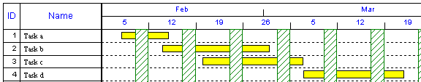

- Filter chart by Resource
It is possible to filter information so that only selected data is shown. To filter so only the resources JOHN & ANN are shown …
- Select the VIEW | DATA | FILTER | USING RESOURCE.
- Click on JOHN and ANNE.
- Click on OK.

This now shows just Row 1 & 3 (Row 2 & 4 are excluded).
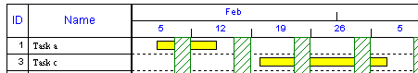

Important
The filter option only selects the data for the chart by default. Any data in the graphs / histograms / tables will include data for all resources by default.

- Filter resource data by same filter
When you run a report, it contains all data (ie. there is no filter on reports by default)
- Select the REPORTS | REPORTS |RESOURCES | CHART & RESOURCE USAGE
- Select the VIEW | DATA | FILTER | USING RESOURCE.
- Click on JOHN and ANNE.
- Click on OK.
- Select the RESOURCES | VIEWS | DISPLAY HISTOGRAM
- Click on FILTERED TASKS

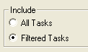

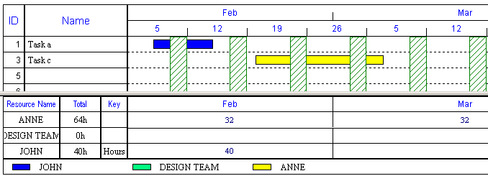

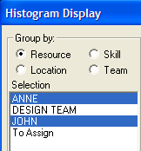
All the resources are listed – but on values are consolidated for tasks that meet the criteria in the filter.

In order to cut the list of resources...
- Select the REPORTS | REPORTS |RESOURCES | DISPLAY HISTOGRAM
- Click on the RESOURCE LIST and deselect the resources not needed (ie. Design Team)

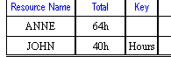

To return to all tasks…
- Select the VIEW | DATA | FILTER | ALL TASKS or Run any Resource Report – which will include all tasks.

- Filter by Skill, Location, Team
It is possible to filter based on various criteria including the contents of any information. To filter based on team …
- Select the VIEW | DATA | FILTER | COLUMN CONTENTS.
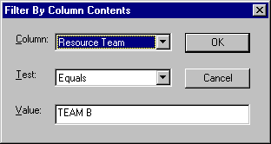
- Click on the DOWN ARROW opposite COLUMN and choose RESOURCE TEAM.
- In the VALUE box, type TEAM B.

- Click on OK.
This will show only the 2 resources – ANNE & DESIGN TEAM – and exclude JOHN.

Important notes
- Resourcing options - RESOURCE DRIVEN
The duration can be effected if you change the resource data. There are 3 options in FILE | OPTIONS | PREFERENCES and DURATIONS/RES tab. …

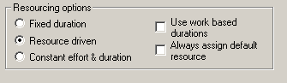

The default is FIXED DRIVEN. Change to say NO in the FIXED column in the RESOURCE CHART view (VIEW |VIEW | VIEWS), when you create a bar …
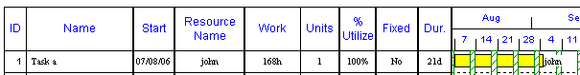

With the FIXED column = NO, then if you change the resourcing data, the duration will be recalculated.

If you increase the WORK, the duration will increase ..
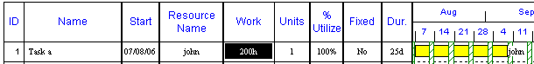

If you increase the UNITS, the duration will decrease ..

If you decrease the % UTILIZE by half, the duration will increase by double ..

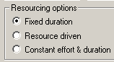
- Resourcing options - FIXED DURATION
You can edit the FIXED column and change it from NO to YES, by keying a Y into the cell. If you want to change the default for this file, select FILE | OPTIONS | PREFERENCES and DURATIONS/RES tab and click on FIXED DURATION.

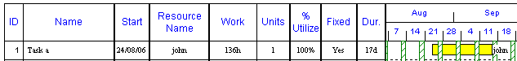

If you change the UNITS or % UTILIZE the duration will remain the same (the Work will be recalculated).
- Resourcing options - CONSTANT EFFORT & DURATION
The default can be changed as above or each task can have either of the 3 types .. in order to change FIXED to CONSTANT, simply type a letter C.
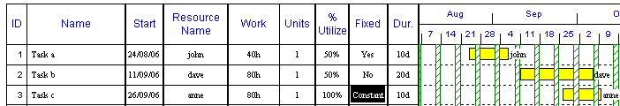

With Constant, if you change the duration, the UNITS will change so that the WORK effort remains the same (and so is spread across the new duration).
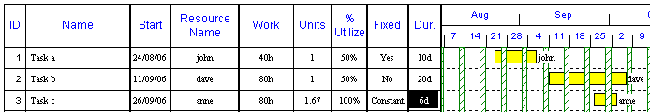

- Resources – Plant, Equipment
When you create Resources, the type defaults to GENERAL.
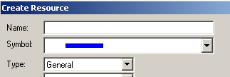
All resources – labour, subcontractors, plant & equipment can be used as General resources. This type is not suitable for materials.

- Advanced resources
Where there is a need to manage different type and resources and/or manage materials, there is a need to use the advanced resources features. These are done by analysing the resources when you create them ..
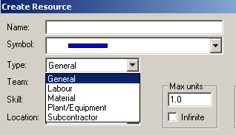

There is a comprehensive document on all aspects of advanced resources (using labour, subcontractors, plant & equipment and materials) on our website.

http://www.projectcommander.co.uk/pmsc/advanceduse.html

Tutorial 8: Multiple resources per task

This tutorial shows the user how to …

- Assign more than 1 resource to a task

- Show resource sub level
- Change assignments

• Setup chart

Select FILE | NEW.

The dates shown below will differ – as it will default to the current (today’s) date.

- Add tasks
Enter two items in the BASIC View in the NAME, START & DURATION columns (the FINISH column is calculated automatically) …
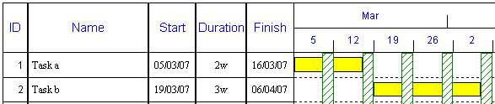

- Add resources

- Click on the RESOURCE | VIEWS | RESOURCE SHEET
- Type the first RESOURCE NAME as JOHN (& click on another cell)
- Type the first RESOURCE NAME as DAVID.
- Click on the VIEW | VIEW | VIEWS – to return to the chart and the BASIC view.
If no specific colour for the resource is chosen, the system will default to different colours for each new resource.
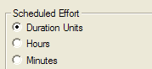
To change the units for SCHEDULED EFFORT from the default of HOURS to the same unit as used in the DURATION (ie probably days or weeks) ….
- Click on the FILE | OPTIONS | PREFERENCES
- Click on the FORMAT tab
- Click ON Duration Units.

• Resource assignments

- Multiple Resource assignments

Resources can be assigned from any View.
- With the cursor on TASK A, click on JOHN and click on ASSIGN button using RESOURCE | VIEWS | ASSIGN

This will assign ONE UNIT full time on this task. The TASK DURATION will remain the same …2w for two weeks. When a first assignment is made the SCHEDULED EFFORT for the task is calculated as the same as the duration – 2 man weeks. When further resources (if FIXED = NO) are added or the existing % of assignment is changed, the DURATION will increase/decrease accordingly.

- Click on DAVID and click on the ASSIGN button
- The TASK DURATION will change to 1w for one week – as the system shares the 2 man weeks evenly across the 2 resources assigned.
- Click on CLOSE.

In order to see the assignments …
- Select the RESOURCE | RESOURCE VIEWS | RESOURCE CHART.
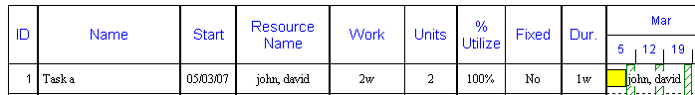

- To see more information on how each task was compiled, double click on the word TASK A. This will open the RESOURCE SUB LEVEL …
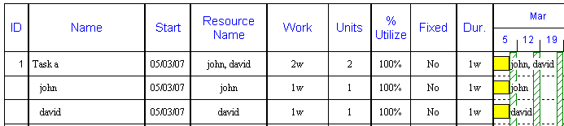

- Editing Resource assignments
Let us say that the 2 man weeks WORK for Task A, JOHN will perform 7 days and DAVE will do 3 day - enter them as 7d and 3d in the WORK column and the entry will be displayed as weeks (ie 1.4 and 0.6). This will change the bars at the Resource Sub-level. Instead of all 3 bars being 5 days (1w) long, the bar for Task A is now 7 working days (1.4w)– the same as for JOHN….
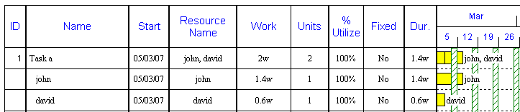

If JOHN is unfortunately unavailable to start until the week commencing the next week…

- Click on the middle of the JOHN’s bar and holding the left hand mouse button down, drag the bar to the right, until the message box confirms the Start Date is now a week late.

This will now change the Task A bar so that it now starts when the DAVE bar commences and finishes when the JOHN bar ends…
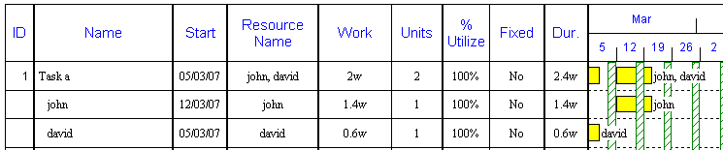

This will change the DURATION at the Task A level from 1 week originally to 2.4 weeks – but you will see the WORK at that level still remains 2 man weeks as before.

- Hide Resource assignment Sub level.
Double-click on Task A to hide the sub level and consolidate at task level…
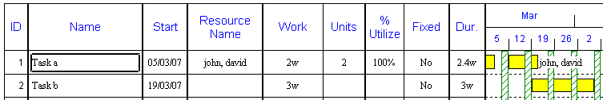

Tutorial 9: Multiple projects with summary levels

This tutorial shows the user how to …

- Create multi projects
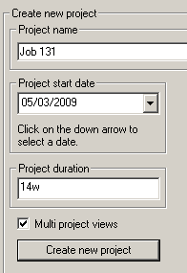
• Setup chart

Start up Project Commander or select FILE | NEW. On the initial start up screen, input a new PROJECT … Job 131 and tick the MULTI PROJECT VIEWS. Then click on CREATE NEW PROJECT.

1. Change time range
If you wish to change this click on the PROJECT | PROPERTIES.

The dates shown below will differ – as it will default to the current (today’s) date.

2. Enter first project
Enter the follows…The new PROJECT … Job 131, will be entered automatically.
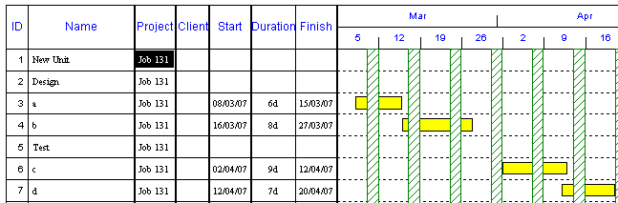

No bars should be placed against row 1-2 & 5 as these are to be made summary bars. On line 1, the NAME column is used to hold the project/job name and the PROJECT column used for the job identification – such as a contract/order number.

The CLIENT column can be excluded by right clicking on the heading name and then HIDE COLUMN.

- Enter summary levels
- In order to make all rows 2-7 under row 1, click on Design and with the left hand mouse button held down, drag down until Task D.
- Click on the INDENT ARROW using BARCHART | TASK | INDENT

- Then to put rows 3-4 under row 2, , click on Task A and with the left hand mouse button held down, drag down until Task B.
- Click on the INDENT RIGHT ARROW
- Then to put rows 6-7 under row 5, click on Task C and with the left hand mouse button held down, drag down until Task D.
- Click on the INDENT RIGHT ARROW.
The chart will now look as follows …
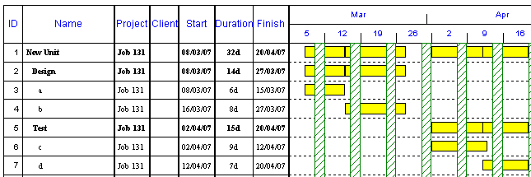

It is said that tasks are at different levels …
LEVEL 1 = New freezer unit
LEVEL 2 = Design & Test
LEVEL 3 = Task A - D

5. Enter second project
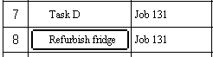
- First enter the project description under the NAME column …

By default the new description is placed on the same level as the previous task – i.e. LEVEL 3. Also the entry in the PROJECT column is also repeated on the same row.

- Click on Row 8 on the NAME cell, and then on the OUTDENT LEFT ARROW - BARCHART | TASK | OUTDENT
- Click into the next cell to the right and type in the new PROJECT … Job 136.
- A message will appear to create a new Project – click on YES.
- Enter 2 tasks – as opposite …
- Click on Row 9 and drag down to Row 10.
- Click on the RIGHT ARROW INDENT ARROW once to move these 2 tasks down to LEVEL TWO.
- Type the following dates into the START column and DURATION columns of the two rows below…
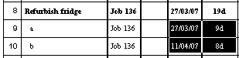

- Colour by Project
It is possible to colour bars by task (where the user colours the bar); or by an automatic colour per project or each resource.

- Select the FORMAT | CHART | COLOUR CHART BY | PROJECT
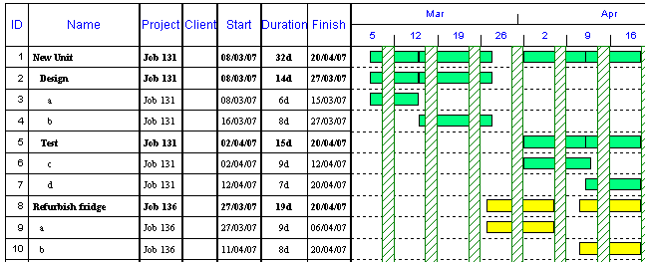
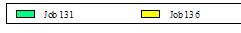

7. Show summary information
- To show just summary level tasks click on the VIEW | DATA | FILTER | SUMMARY TASKS
- Click on NO
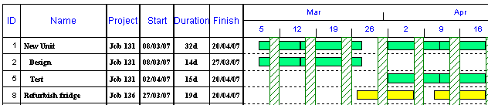

- To show just the project level information as one line, double click on the words New unit.
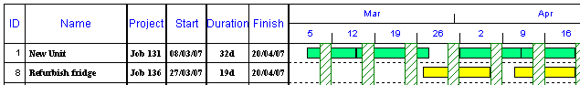

7. Filter Project
- To show just one project, select VIEW | DATA | FILTER | PROJECTS DISPLAYED.
- Click on CLEAR.
- Click on JOB 136 and OK.

Important notes
If there were any resources or cost information shown in a cost/resource report, the filter needs to be applied to the cost/resources data too.

- Summary bar display options

BARCHART | FORMAT | USE SUMMARY SYMBOL

If the USE SUMMARY SYMBOL was ticked ON, then all the summary bars were shown as white; if ticked OFF, then all the colours are displayed on all the summary bars.

you can say at what levels you wish the white summary bar to show – FILE | OPTIONS | PREFERENCES

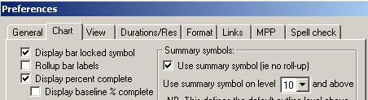

So, for example, if you have a multi level project as follows …

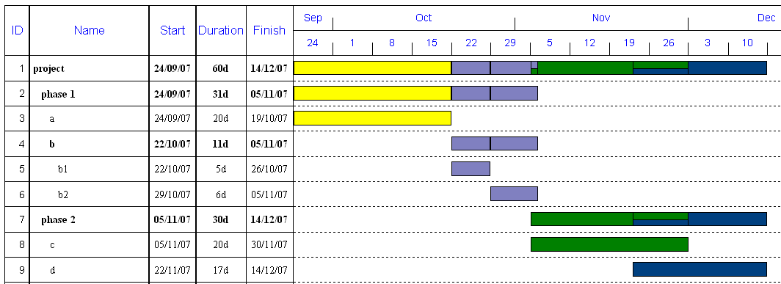

On this project, there is a four level hierarchy – Project, Phase, Task and Sub Task for row 4.
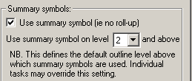
By changing the Options, Preferences, across, the white summary bar will only show at Project, Phase levels.

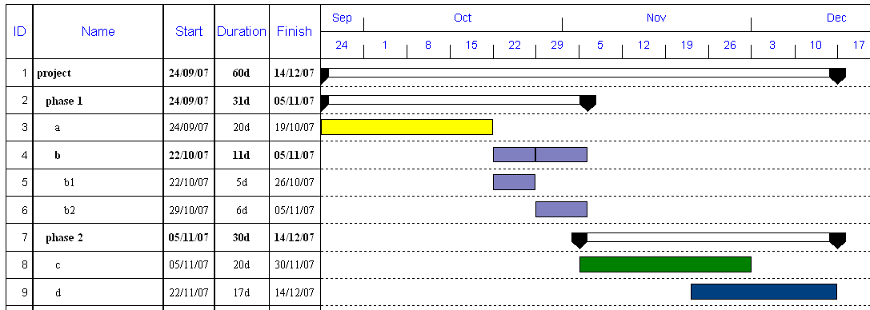

As well as changing it for a whole level, it is now possible to display white bars or coloured bars for each individual summary bar.

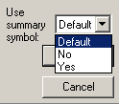
Double click on the ID number for the summary bar (for example on ID 4). In the new USE SUMMARY SYMBOL box, it will always initially say DEFAULT, meaning it will use the global settings above.

Change the option to YES and the summary bar will now show as a white bar…

- Consolidation
The Project Name is optional but is necessary if you intend to consolidate several individual files.

Tutorial 10: Lump sum costing

This tutorial shows the user how to …

- Attach costs to tasks
- Create a Cost Graph / S curve
- Actual vs Planned graphs

- Display a Cost chart
- Export to MS Excel
- Insert cost column in any report

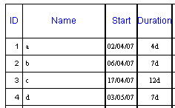
1. Add tasks
Enter the following items in the BASIC View in the NAME, START & DURATION columns (the FINISH column is calculated automatically) …
The system will use current dates (not those shown here in the example)

- Add costs
- Select the COSTS | COST VIEWS | COSTVIEW | COST.
- In the OTHER COST columns, enter the following figures in rows 1 to 4 (do not include the £ sign, it is inserted automatically).
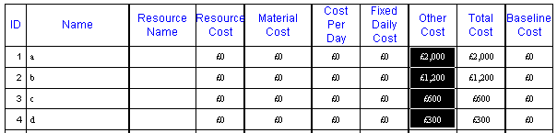
By default, the costs are spread evenly across the whole duration of a bar and the costs are rounded up to the next whole £ if entered with decimals.

- Save Baseline
- Select the PROJECT | BASELINES | SAVE
- Change the OTHER COST cell for TASK a to £5000.
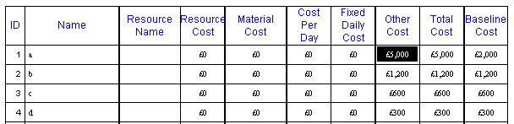

• Cash reports

1. Chart & Cost Graph (S curve)
- Select the COSTS | REPORTS | REPORTS | COST, LUMP SUM COSTS & GRAPH
- Click ROUND UP off & OK.
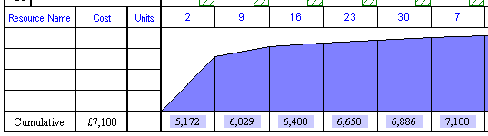
If the ROUND UP box is ticked on, the costs are rounded up to the next thousand pounds.

At the bottom of the page is now a cumulative graph showing the costs spread across all the tasks.

2. Cost Chart
- Select the COSTS | REPORTS | REPORTS | COST CHART & PERIODIC COSTS & ok.
This is like a barchart, but where there was a bar, it is replaced by cost figures …
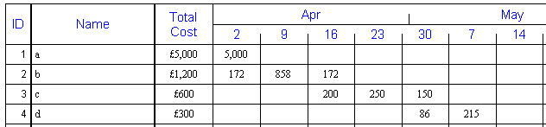

- Cost Histogram
- Select the COSTS | REPORTS | REPORTS | COST HISTOGRAM
- Click ROUND UP off & ok.
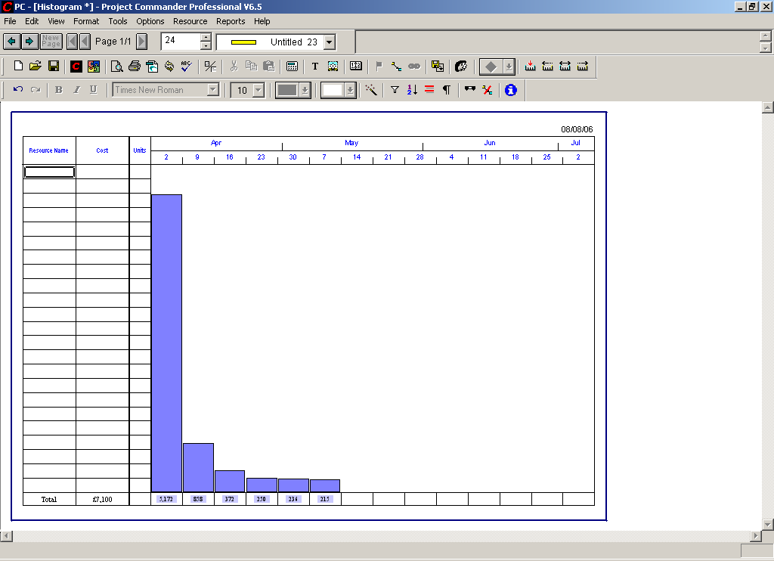

4. Totals
Costs can only be totalled by using summary levels.
- Select the COSTS | REPORTS | REPORTS | COST CHART & PERIODIC COSTS & OK.
- To add a blank line at the top of the chart, click on Task a and press the INSERT (INS) key on the keyboard.
- Type the word TOTAL on Row 1 under the NAME column and press the ENTER key on the keyboard.
- Drag down Row 2 to 5 by clicking on Task a and dragging to Task d.
- Click on the RIGHT BLUE ARROW in the toolbar (top left) – INDENT button.

As changes are made to this screen, the costs are recalculated and the figures are changed temporarily to NA while the calculation is being performed. The progress of the calculation can be seen in the bottom right hand corner of the screen – which shows a % figure increasing from 0% to 100%.

The costs now will be summated at Row 1 – the TOTAL level …
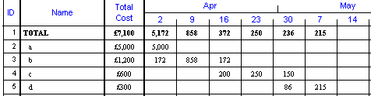
If other summary levels are inserted, the costs would be sub totalled up through each level.
5. Special one off payments
Special large one off costs may need to be made on a particular day, and not spread across the task bar as above. This is done by creating a task with a one day duration (or a milestone symbol). To do this, create a separate task…
- Select the VIEW | VIEW | VIEWS | BASIC.
- To create a blank line, click on Task c and press the INSERT key on the keyboard.
- Enter a new task at Row 4 as below with 1d (you could create a milestone symbol on this date as an alternative to a task)…..
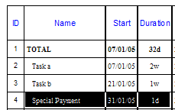
- Select the COSTS | COST VIEWS | COST VIEWS | COST.
- In the OTHER COST columns, enter the following figures in rows 4 (do not include the £ sign, it is inserted automatically).
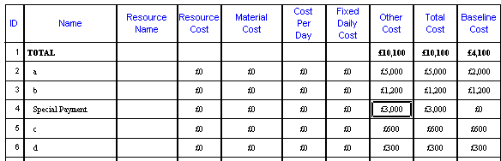

6. Edit costs

To change the costs, you can also double click on the ID column for Row 3 – Task b and edit the white box at the bottom left for OTHER…..
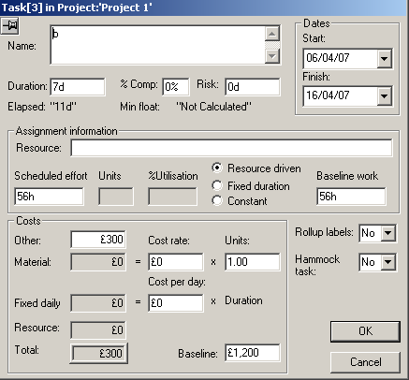

- Click on OK.
To see the effect…..
- Select the COSTS | COST VIEWS | COST VIEWS | COST
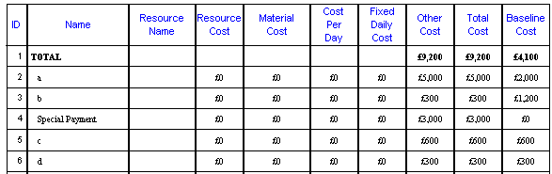

7. Export costs to MS Excel

- Click on the IMPORT/EXPORT | EXPORT | EXCEL

- Click on the option COST CHART.
- Click on OK.

It will start up Microsoft Excel and put all the fields into the spreadsheet ….
The summary level totals are excluded in order to prevent accidental double counting of costs.
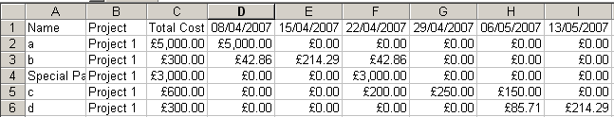
- Select the FILE | EXIT, to quit Excel.

Important - It is possible your pc may not start up Excel and a warning message appears to say that it cannot find Excel and therefore the file can be saved to .csv in the folder indicated in the message displayed on screen. the user is prompted to save the export into any selected folder. The file then needs to be opened up within Excel as a text file.

8. Monthly totals
Above the figures were weekly. To change this to monthly, you need to change the timescale to months…
- COSTS | REPORTS | REPORTS | COST CHART & PERIODIC COSTS
- Click MONTHS on
- Click on OK
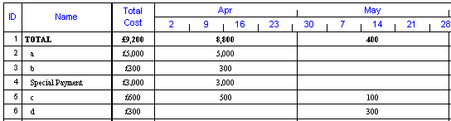
The costs are now consolidated into monthly totals.

9. Insert Cost columns

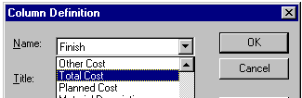
The Cost column can be inserted into any View…
- Select the VIEW | VIEW | VIEWS | BASIC.
- Right click on the FINISH column heading & INSERT COLUMN.
- Click on the DOWN ARROW for the NAME box……
- Scroll down the list and click on TOTAL COST.
- Click on OK.

10. Actual vs Planned graphs

After a Baseline is saved, the current costs are saved in the PLANNED COSTS column and can be used to graph comparison costs.
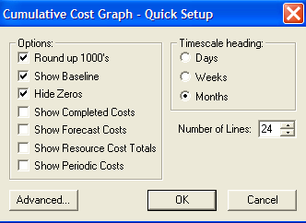
- Select the COSTS | REPORTS | REPORTS | CUMULATIVE COST GRAPH.
- Click SHOW BASELINE on.
- Click on OK.

The graph shows a blue area graph showing the Current Cost and a darker line graph representing the Original Cost.

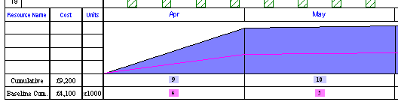

Important notes
COST REPORT DATA – other items in the Quick Setup wizards
- Show completed costs
This shows the actual cost (ie Total Cost x % complete)
- Show Forecast costs (this predicts full cost based on % complete)
This shows the Actual Cost x 100% / % complete
- Show Resource Costs (for costed resources)
This shows the cost of each costed resource
- ADVANCED
The list of items placed on the left of the graphic can be de-selected by clicking on the Advanced button and click any item to remove the blue highlight and so remove them from the list.

Tutorial 11 : Full costing

This tutorial shows the user how to …

- Cost labour resource
- Resource hourly rates
- Cost materials

- Total costs
- Estimates

Tasks can either be costed out by lump sum or by costing out Labour Resources on an hourly rate with material and other costs.

If more than one project is held on the file, the costs are consolidated for all tasks and projects on file. In order to isolate costs for one project, you can filter charts and cost graphs or you can Copy & Paste all the tasks to a new Project Commander file.

• Setup chart

Start up Project Commander or select FILE | NEW.

The dates shown below will differ – as it will default to the current (today’s) date.

1. Add tasks
Enter the following items in the BASIC View in the NAME & DURATION columns (the START & FINISH columns are calculated automatically) …

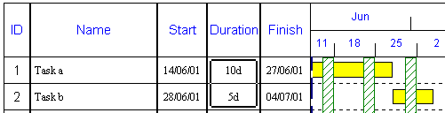
- Add labour resources

- RESOURCE | VIEWS | RESOURCE SHEET
- Type the first RESOURCE NAME as JOHN.
- Type £20.00 in the COST RATE PER HOUR box.

- Click on OK.
- Type the next RESOURCE NAME as ANNE
- Type £25.00 in the COST RATE PER HOUR box.

• Resource assignments

- Select the RESOURCE |VIEWS | RESOURCE VIEWS | RESOURCE CHART.
- Click on TASK A on the chart behind.
- Click on JOHN in the list using RESOURCES |VIEWS | ASSIGN
- Click on the ASSIGN button.
- Next, click on TASK B on the chart.
- Click on ANN in the list in the RESOURCE ASSIGNMENT window.
- Click on the ASSIGN button.
- Click on the CLOSE button.

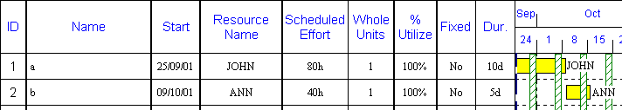

• Resource costs

- Select the COSTS | COST VIEWS | COST VIEWS |COST.
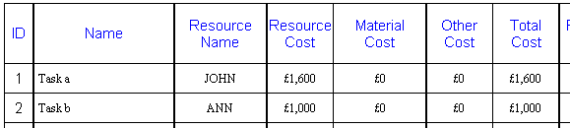
The labour cost is calculated in the RESOURCE COST column above using the HOURLY COST RATE for the Resource above and the DURATION of the task multiplied by the STANDARD WORKING HOURS from the Calendar; 8 hours per day (default).

• Material costs

- Select the VIEW | VIEW \ VIEWS | MORE VIEWS | MATERIAL.
- Type the following entries ….
The MATERIAL COST total column is calculated automatically multiplying the COST RATE and the UNITS columns.
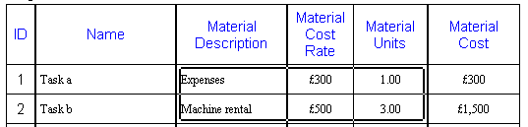

• Total costs

- Select the COSTS | COST VIEWS | COSTVIEWS | COST.
- Type £100 in the cell below….

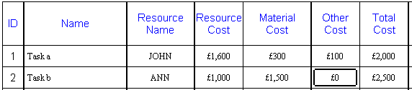
The RESOURCE COST & MATERIAL COST is calculated automatically and are read only in this View and cannot be edited in this View. The RESOURCE COSTS comes from the Resource assignment; the MATERIAL COST comes from the MATERIAL VIEW.

The TOTAL COST is a summation of RESOURCE, MATERIALS & OTHER COSTS and cannot be edited.

• Estimate costs (Optional)

- Select the COSTS | COST VIEWS |VIEWS | COST ESTIMATE.
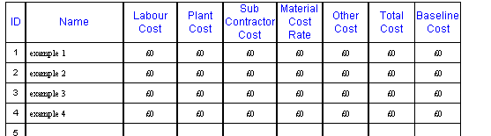

This allows you to enter the analysis of the Estimate – as an alternative.

Important notes
- Advanced resources
Where there is a need to manage different type and resources and/or manage materials, there is a need to use the advanced resources features. These are done by analysing the resources when you create them ..

Tutorial 12 : Advanced topics

This tutorial shows the user how to …

- What ifs
- Copy & paste cells
- Undo
- Copy & paste tasks
- Copy & paste to & from MS Excel
- Transfer data to MS Excel
- Transfer data to MS Access
- Export chart to MS Word

• Setup chart

Start up Project Commander or select FILE | NEW.

The dates shown below will differ – as it will default to the current (today’s) date.

- Add tasks
Enter the following items in the BASIC View in the NAME, START & DURATION columns (the FINISH column is calculated automatically) …

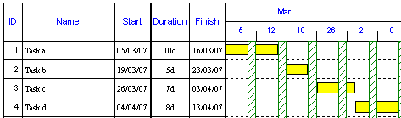

- Save the file
Select the FILE menu & SAVE AS and name the file as tut9..

• What if

It is possible to open up more than one version of the file..
- Select the FILE | START ANOTHER PC SESSION.
- Select the FILE | OPEN and choose the tut9 file.

So now two copies of the file are open and can be changed separately. Each copy is made active by clicking on the PROGRAM BAR at the bottom of the window….

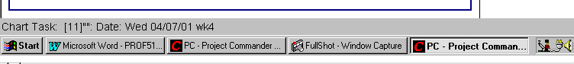
The one file copy that needs to be retained can be saved and overwrite the previous file and the unwanted file is closed and not saved.

• Copy & paste cells

Using the original tut9 file…

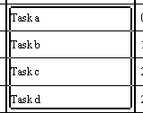
- Click on Task a and drag the mouse down to Task d.

- Click on the BARCHART | TASK | COPY

- Click on Row 5 under the NAME column
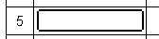
- Click on the BARCHART | TASK | PASTE
This will duplicate the task descriptions as follows…
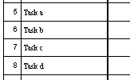

• Undo

There are a maximum of 20 levels only of UNDO (and REDO), that will reverse the last operations. To undo the last paste, select the UNDO on the QUICK ACCESS TOOLBAR. This will erase the task descriptions in Rows 5 to 8.

• Copy & paste whole tasks

- Click on the Row 1 (under the ID column) and drag the mouse down to Row 2…

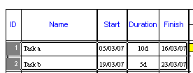

- Click on the BARCHART | TASK | COPY …

- Click on Row 5 under the NAME column.
- Click on the BARCHART | TASK | PASTE
- This will duplicate all the tasks.
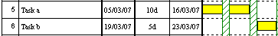

• Copy & Paste to MS Excel and other spreadsheets

It is possible to Copy & Paste ranges of cells to spreadsheets. Only cells of data can be copied to spreadsheets – not the whole chart or the bars. To copy cells to Microsoft Excel or any spreadsheet…
- Start up the spreadsheet.
- Copy the all cells in the first 4 rows of Project Commander, by dragging with the mouse and clicking on the COPY icon - BARCHART | TASK | COPY
- Click on the spreadsheet and click on the PASTE icon.
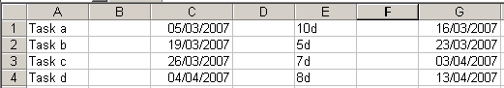

• Copy & Paste from MS Excel and other spreadsheets

It is possible to Copy & Paste ranges of cells from spreadsheets to Project Commander. In order to copy tasks and start & finish dates ….
- Delete the DURATION column in the spreadsheet.
- Drag across all the cells in the spreadsheet for TASK DESCRIPTION, START & FINISH and then click on the COPY ICON -
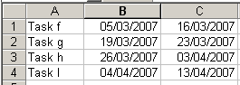

In Project Commander, select the VIEW | VIEW | VIEWS |TASK DATES. Paste it into the next blank line by clicking on the Row 7 under the NAME column and then the PASTE icon - BARCHART | TASK | PASTE
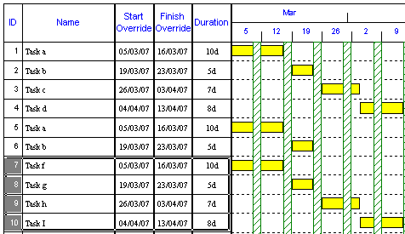
The DURATION column is automatically calculated using the dates.

• Interface to MS Excel and other spreadsheets

To copy the whole database to Microsoft Excel, first close Excel by FILE menu & EXIT….
- Click on the IMPORT/EXPORT | EXPORT | EXCEL
- Click on the option ALL TASKS.
- Click on OK.
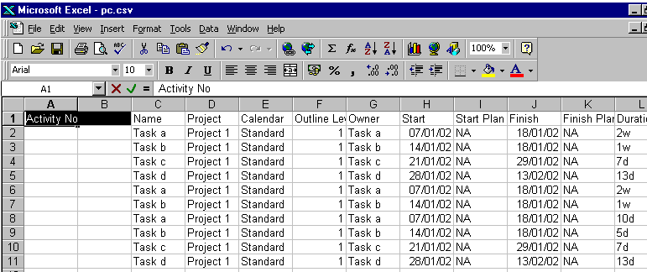
It will start up Microsoft Excel and put all the fields into the spreadsheet ….

• Export to MS Access and other databases (disabled in Demo version)

To export the whole project information to an external database…
- Save the file as a CSV file, by selecting the FILE | SAVE AS.
- Click on the DOWN ARROW for SAVE AS TYPE box.
- Choose the TEXT option.
- Type a FILE NAME – EXPORT.
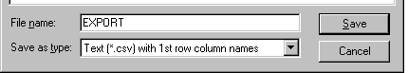
- Click on SAVE.

To import the file into Microsoft Access..
- In Access, click on NEW DATABASE and OK.
- Type a FILE NAME and click on CREATE.
- Select FILE menu, GET EXTERNAL DATA & IMPORT.
- Select TEXT files as the FILE TYPE.
- Next choose the saved CSV file and click on the IMPORT button and this will then run the IMPORT WIZARD (refer to your Microsoft Access Special Topics Manual and help for assistance).
- Click on DELIMITED option and then the NEXT button.
- Click on FIRST ROW CONTAINS FIELD NAMES and then the NEXT button.
- Continue to click on NEXT until the end.

• Export chart to MS Word or any word processor (disabled in Demo version)

To export the whole chart to Microsoft Word….
- In Project Commander, select the IMPORT/EXPORT | EXPORT | FILE.
- Click on DOWN ARROW for SAVE AS TYPE and click on WINDOWS METAFILE.
- Type a file name in the FILE NAME box.
- Click on SAVE and this will save a .WMF file.
Then start up Microsoft Word (if present) and then
- Open an existing or new document in Word.
- Select the INSERT menu, PICTURE & FROM FILE

Important for the on screen chart - only the current page is pasted – so for multiple pages, they must be copied one at a time.
Tutorial 13 : Management Information

This tutorial shows the user how to …

- Comments
- Alerts
- Material Notes
- Material Lists
- Log File Timeline
- Calendar view
- Calendar export to Outlook
- To Do List

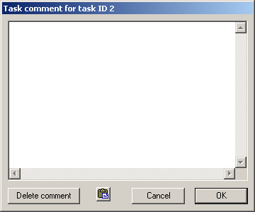
Comments

Comments can be added to any row. Right click on the ID or Row number and select Insert Comments. Multiple lines can be saved in the comment window.

The Comments are saved with the file and are saved against each task. There is a massive a capacity to store any information here against any task.

There is a Paste button – to allow you to copy any information from a Windows based system (Word document, email, Excel table, etc) into the comments box, which can be scrolled.

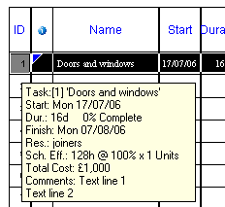
Once saved by clicking on OK, the comment for any task, can be displayed on-screen by clicking on the ID (or Row number) and holding the left mouse down.

A box will appear showing data regarding the task and at the bottom will be all the comments text.

The text can be seen on it’s own, by right clicking on the ID and selecting Edit Comment.

It is possible to see an indicator (yellow triangle) if you insert the Information column, by clicking on VIEW | SHOW/HIDE | INFO COLUMN . This inserts a column next to the ID column.

You can print the comments on their own, by FILE | PRINT | TASK COMMENTS or you can print them at the end of the barchart on a separate sheet by FILE | PRINT and click a tick in Print task comments on the Print Dialogue Window.

Important
All notes word wrap to the page size. If you paste Excel tables, they will look very strange in both the printed output and the on screen window (activated by holding the left hand mouse button down on the ID number.

To restrict the comments printed - you can use CONTROL CLICK to choose which Task Comments you print.

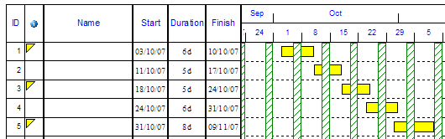

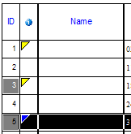
In order to choose only Row 3 & 5 comments to print, you hold the CONTROL KEY down and click the mouse (left hand button) on the ID 3 and ID 5. Then go to FILE | PRINT | TASK COMMENTS

Note: In order to see which tasks have a Comment, you can still click on the Information icon - VIEW | SHOW/HIDE | INFO COLUMN on the toolbar. It will show as a yellow triangle in the top left hand corner.

Important
This feature above is also available if you choose to print the Task Comments with the chart. Also when you print the printer will still be set to the one you use for the chart, so it will probably be in Landscape and could be A3 or higher. So it is good to change the Printer Properties to say A4 and Portrait for this.

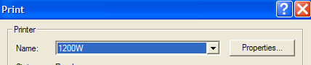

Also Task Comment prints are not shown in Print Preview. You can only see the Barchart reports in the Print Preview.

Alerts

Alert Dates are useful for users that update their projects to reflect revised new task start/end dates and want Project Commander to warn if a task is starting/ending too early/late. The warning will appear continually at start up of the file unless resolved.

Alert Dates are input using the VIEW | SHOW/HIDE | TASK FORM – Links, constraints TAB.

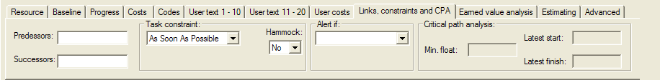

There are 4 alerts …

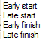

Early start - an alert message/icon is triggered if the task start date is before this date.
Late start - if task start date is after this date.
Early finish - if the task end date is before this date.
Late finish - if task end date is after this date.

A diamond shape in the centre of the cell shows that an ALERT is present.
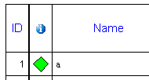
A green diamond shows an ALERT that is present - but is not signalled as a warning.
A red diamond shows an ALERT that is present and is signalled as a warning that the task does not meet the alert status.
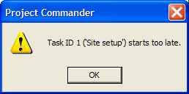
When you enter an alert date in the Task Form, an Alert warning message will immediately appear on-screen, if the alert is triggered.

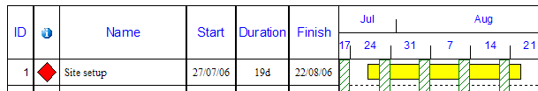

A white arrow appears (and will print out) where on the alert date – whether on the bar or outside the bar.

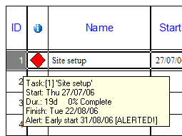
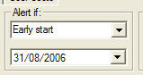

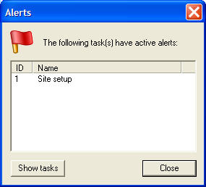
Once added, the alert can be seen also by clicking on the ID Number and holding the left hand mouse button down.

Note- only one alert can be placed on each task.

Each time you start up the file, a warning message will show for Alerts activated. At this stage, you can ask to see a filter report on-screen by clicking on SHOW TASKS or go direct to the whole plan by clicking CLOSE.
If you choose to Show the Alerts, you will get a filtered view, and all tasks that do not have Alerts or activated Alerts.

Then to return to a unfiltered view (ie see all tasks), select VIEW | DATA | FILTER | ALL TASKS and click on NO.

Note – you will see that once you have filtered a view, then a message appears at the top of the page under the project title.

In order to switch this off, select, the BARCHART | FORMAT | TITLE and click OFF the tick for Show Filter/Sort Description.

Also it is possible to view all task bars and show the bars that are effected by Alerts without having the Information column present on screen. Select the View menu, Colour Chart By, Alert. It will show activated alerts in red, unactivated alerts in green and all other bars in white.
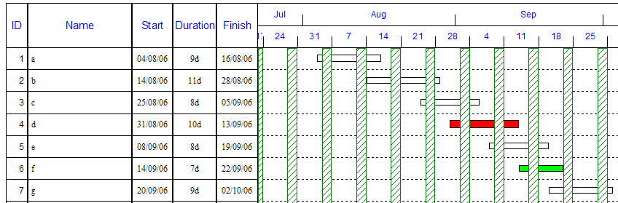

In order to revert the colouring system back, Select the View menu, Colour Chart By, Task.

Material Notes

There are 2 types of notepads. For general information use the Comments Notepad and for Material information use the Material Notes.

Both allow you to input your text or copy and paste text/tables from other Windows applications. To open the notepads right mouse click on the ID Number.

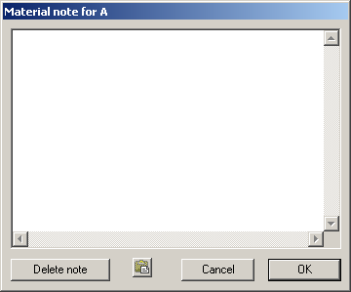

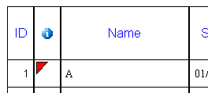
Note: In order to see which tasks have a Comment, you can still click on VIEW | SHOW/HIDE | INFO COLUMN. It will show as a red angle in the top left hand corner.

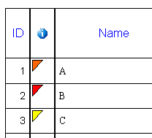
If the triangle is yellow, it means that only a Task Comment is saved.
If the triangle is orange, it means that both a Task Comment and Material Note are present.

PRINTING

The Material Notes can be printed out in full either as a separate print or as an addendum to the chart.

To print out as a separate report, simply select the FILE | PRINT | PRINT MATERIAL NOTES

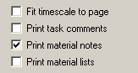

Important
This feature above is not available if you choose to print the Material Notes with the chart. Also when you print the printer will still be set to the one you use for the chart, so it will probably be in Landscape and could be A3 or higher. So it is good to change the Printer Properties to say A4 and Portrait for this.

Also Task Comment prints are not shown in Print Preview. You can only see the Barchart reports in the Print Preview.

You can use CONTROL CLICK to choose which Material Notes you print.

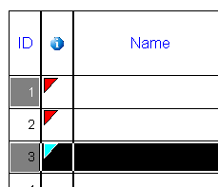
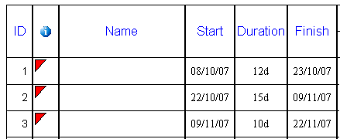

In order to choose only Row 1 & 3 Material Notes to print, you hold the CONTROL KEY down and click the mouse (left hand button) on the ID 1 and ID 3. before printing.

Material Lists

The Materials Notes are for entering a list of materials required copied and pasted from other systems or manually input.

The Materials List is for managing the orders and deliveries.

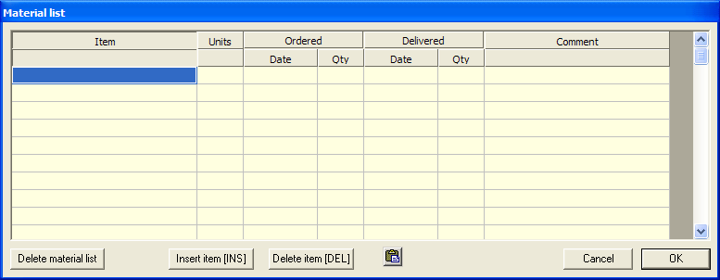

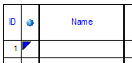
Note: In order to see which tasks have a Material List, click on VIEW | SHOW/HIDE | INFO COLUMN. It will show as a blue angle in the top left hand corner.

If the triangle is purple, it means that both a Material List and Material Note are present.
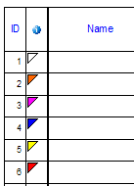
If the triangle is white, it means that all three - a Material List, Task Comment and Material Note are present.
If the triangle is red, it means that only a Material Note is saved.
If the triangle is yellow, it means that only a Task Comment is saved.
If the triangle is orange, it means that both a Task Comment and Material Note are present.

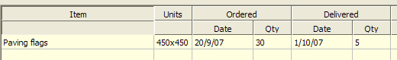

All the columns can be widened by dragging the dividing lines in the grey header area and the COMMENTS column can be extended to show more text (in which case a scroll bar will appear at the bottom of the window.

ITEM column is for the material description.
UNITS column is for the Unit of measure
ORDERED DATE & QTY are for each individual order. There is a copy & paste icon that allows you to copy multiple entries by dragging across the required cells to copy.
DELIVERED DATE & QTY are for the cumulative delivery situation.
COMMENTS can be used for the Order Number or Delivery Note Number or a record of deliveries or any other important information

There is no feature to list multiple deliveries in detail – unless you edit the order to correspond with the delivery and copy a new order.

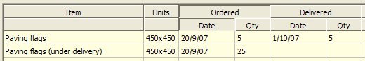

In order that these deliveries are kept together, you can insert a blank line in the list by clicking on the INSERT button at the bottom of the window.

PRINTING

The Material List can be printed out in full either as a separate print or as an addendum to the chart.

To print out as a separate report, simply select the FILE | PRINT | PRINT MATERIAL LISTS.

Important
This feature above is also available if you choose to print the Material Lists with the chart. Also when you print the printer will still be set to the one you use for the chart, so it will probably be in Landscape and could be A3 or higher. So it is good to change the Printer Properties to say A4 and Portrait for this.

Log file

For users where several people access the file to update it, there is a CHANGE LOG tab – where each user can record the changes made. It may be useful for single users that wish to keep an audit trail of changes to the file.

A log of changes can be stored with the file and viewed and printed separately. No entries can be deleted once entered – to ensure the audit trail.
The extent of the log, depends totally on if it is used extensively by all users of the file.

The window can be moved and resized and stays on top of the screen until closed.

Click on the New Document icon

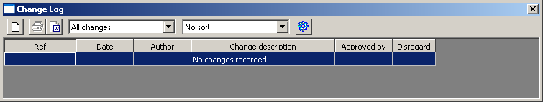

- Ref
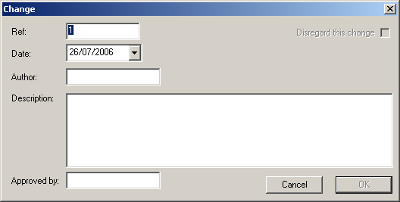
This field has been designed for numerics and will increase the number by 1 when you create the next entry. However, you can edit this box and enter any alphanumeric entry as a unique reference number.

- Date identified
The current date is generated here – but can be changed if the issue was entered later.

- Author
Person entering the log.

- Description
You can enter a full description (especially for printing)

- Approved by
Person authorising entry

ALL FIELDS MUST BE ENTERED to allow you to save the entry.
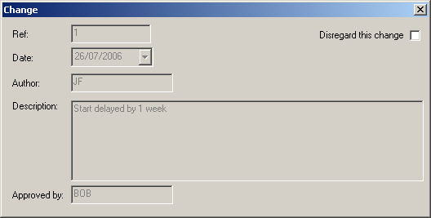
No entries can be deleted once saved – but can be disregarded by double clicking and tick the DISREGARD box.

- Timeline

VIEW | VIEW | TIMELINE

The Timeline allows users to roll up random bars into an overview on a time-ranged roadmap.

This creates a grey box above the chart – where the TIMELINE displays.

To add task bars to the TIMELINE .. click on task name to highlight it and then TASK | PROPERTIES | SHOW IN TIMELINE.

The Timeline has it’s own Ribbon.
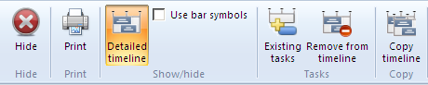

On the example below … we will put ID 1,2,3,4 & 6 on the Timeline

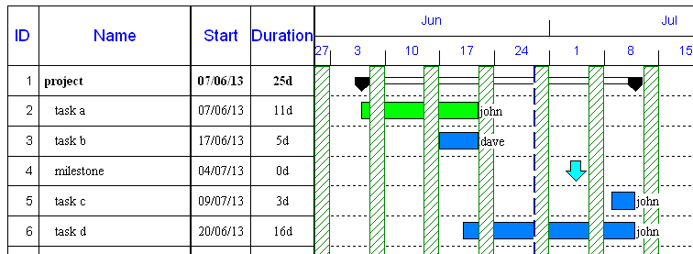

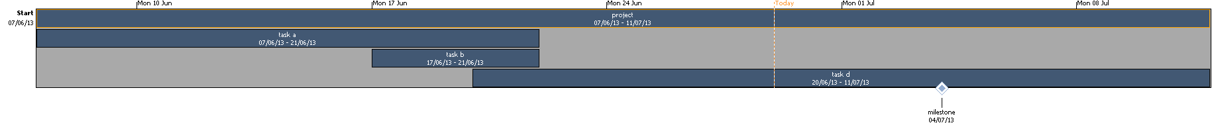

The options are displayed on the TIMELINE tab

USE BAR SYMBOLS

With the USE BAR SYMBOLS off – all summary and task bars are shown as blue bars with white writing and milestones are shown as diamond shapes. The start date and finish date along with the task description is displayed on each bar. The task description is centralised – so if the bar is shorter than the task name – the first bit and the end bit of the name is cut off.

With the USE BAR SYMBOLS ticked on - all summary and task bars are shown using the actual colours of the bars. Even though the colouring of bars can be by task, project, resource, alert or msp defaults – the colouring system used by the Timeline is always the task colouring – even if the barchart below has a different colouring system. For instance if you run a resource report, the barchart colours the bats with the colours in the Resource Sheet; in this case the Timeline colours would be different to the barchart.

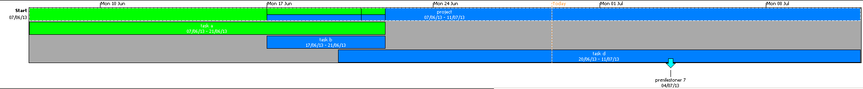

If the rounded bar option is turned on the bars colouring is not solid – it is graduated. In this mode – the white writing on the top of the bar will not be as easy to read for the task description.

Note: % complete markings and baselines do not display on the Timeline.

DETAILED TIMELINE

If this is clicked – it will hide the text on the bars and create a condensed Timeline

If this is clicked again – it will turn the text back on.

EXISTING TASKS

Tasks can be added or removed from the Timeline
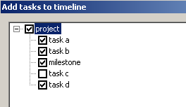

REMOVE FROM TIMELINE

Tasks can be removed from the Timeline by first highlighting the task/s and then click on this icon.

COPY TIMELINE

The Timeline can be copied to the clipboard by clicking this icon.

TASK DATA

If the mouse is hovered over any bar or milestone on the Timeline – a small yellow tool tip will appear to give extra data on the task.

In order to see more data – you can open the TASK FORM at the bottom of the screen .. VIEW | SHOW HIDE and tick TASK FORM. Then if a bar/milestone is clicked on in the Timeline or the Barchart – the full data for that task is shown in the Task Form below.

PRINT

Printing of the Timeline can be selected on the Timeline tab or FILE | PRINT. When printing – the print on the bars are black.

This default option is normally the best option for printing using the USE BAR SYMBOLS off. The white text on the bars in the Timeline is printed as black text on paper.

HIDE

In order to close the Timeline tab, click on HIDE and it returns to the main Ribbon.

Calendar View

VIEW | VIEW | CALENDAR

The Calendar view shows daily date in a week or month format with a TASK FORM at the bottom of the screen. The TASK FORM shows all the details for the bar and can be edited and so update the Calendar above and the subsequent project. Bars are highlighted by clicking on the task description section of the bar

The Calendar has it’s own Ribbon.

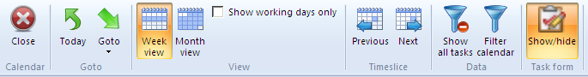

GO TO

These highlight a specific date or week or month.

VIEW

Each screen is in a weekly or monthly format. The default is to show the week commencing on the Monday and displaying all seven days of the week. There is an option to exclude the non working days as specified in the Working Week defined in the Project Calendar BARCHART | PROJECT | CALENDAR.

TIMESLICE

The NEXT & PREVIOUS buttons move the calendar along by a week or a month depending on the option highlighted in the VIEW group.

Calendar Export to Outlook

IMPORT EXPORT | EXPORT | CALENDAR

The task data can be exported to Outlook’s calendar.

Filters can be set to restricted data saved in the export file.
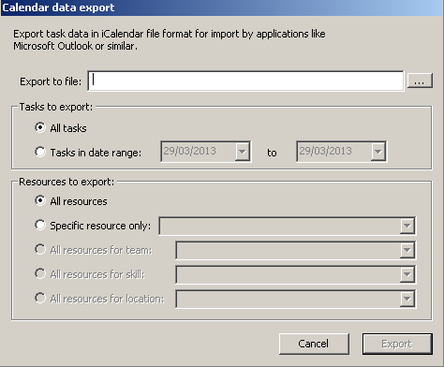

In Outlook 2010, FILE | OPEN | IMPORT and choose IMPORT AN ICALENDAR (.ics).

There are then 2 options to create a new calendar or to add to the current (/highlighted) calendar.

Note: If the same tasks are imported more than once (even with different dates) – the tasks will be duplicated. If a project is dynamic and tasks being rescheduled – the calendar/s used for import may need to manually edited to prevent duplicates.

To do LIst

VIEW | VIEW | TO DO LIST

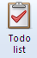

Important

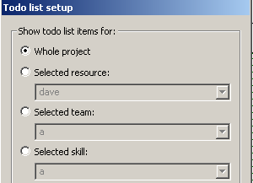The To Do List only displays tasks that are not marked as 100% complete (in the Actual % column).

The To Do List can be filtered by

- Whole project or selected tasks using individual resources or resource groups (skill, location or location)

2. Period

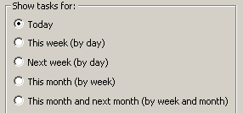

- Other

There are two other options

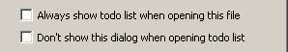

- Show the ToDo List when the file is opened (this will run the ToDo List at the opening of the file.
- 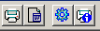Do not show the ToDo List Setup window (this can be turned on again using the third icon for ToDo List Setup.

The resultant screen can be viewed and/or printed.
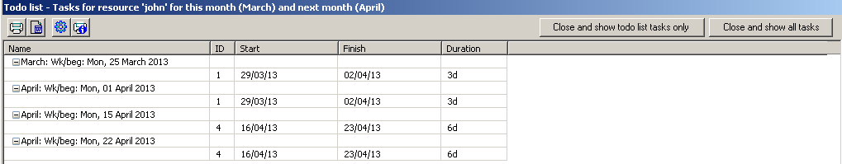

The screen can be printed or transferred to Word using the first two icons

The last 2 icons

- The third icons control the current selections (as in the Setup), which can be edited/rerun and the print out settings..
- The last icon controls the options used in the print out.
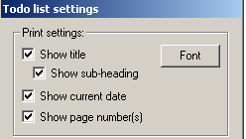

When ended, the window can be closed by either going back to the previous view with all tasks showing or the filtered tasks (from the ToDo list) just displayed.

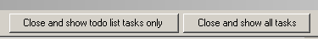

Note: If you return to a filtered chart – you can remove the filter to show the whole project list of tasks by VIEW | DATA | SHOW ALL TASKS and click on NO to display original ID numbers.

Tutorial 14 : Integration with Microsoft Project & other project software

MICROSOFT PROJECT

Project Commander can open the following Microsoft Project …

MPP files from Microsoft Project 2000, 2002, 2003, 2007, 2010 , 2013 & 2016

XML files from Microsoft Project – more recent versions 2007-16.

Most of the files will open with the whole data, but Due to some of the funnies in MS Project, we cannot guarantee 100% that we can open any mpp file, but the majority of straightforward files will be ok. If you have a problem or you think there are any errors, please email the mpp file to us at office@projectcommander.co.uk and we are happy to either update our software or to convert the mpp file to a .pc file ourselves.

You should always ask people that send you a hard copy of a mpp file as well as the electronic file and you should check that the data transferred into Project Commander is identical to the original in Microsoft Project.

A list of incompatibilities and which fields are opened are available by selecting the HELP button | SUPPORT MATERIALS | OPENING MPP FILES.

In the FILE |OPTIONS | PREFERENCES | MPP,XML tab, you can opt not to transfer over Resources – just programme data to create a barchart.

If the above option is ticked, you can then opt to store the Resource names only in USER 20 in Project Commander.

To open a MS Project file, when in Project Commander in FILE | OPEN, choose the file type as MPP or MPX or XML.

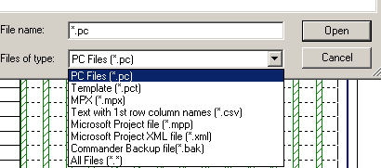

It is possible when you open a file that there a number of WARNING MESSAGES – which you can suppress if being repeated by clicking on DO NOT SHOW AGAIN.

Project Commander can save to a file format that can be read by any version of Microsoft Project, by saving as MPX or to more recent versions using XML

FILE | SAVE AS, choose the file type as MPX or XML.

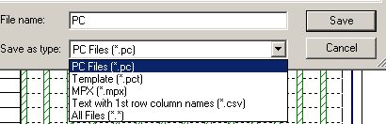

A list of which fields are saved are available by selecting the HELP button | SUPPORT MATERIALS | MPX FILES or XML FILES.

XML is now recommended as the best option for MS Project 2007-13 versions.

OTHER SOFTWARE

Other popular project software such as PowerProject & Primavera have the facility to open and save MPX files – so that can be used as a mechanism for transferring data.

If you have a problem or you think there are any errors, please email the mpx file to us at office@projectcommander.co.uk and we are happy to either update our software or to convert the mpx file to a .pc file ourselves.

Many other products have a MPX facility if they used to transfer data to MS Project years ago.

Tutorial 15 : Integration with Microsoft Excel

IMPORT

It is possible to copy and paste similar formatted data by cell or range of cells between Excel and Project Commander.

There are other ways of importing data from Excel….

- Link to Excel cells
Link any Project Commander cell to any Excel cell for updating on file opening.

EXPORT

To export data to Excel, click on IMPORT/EXPORT | EXPORT & click on EXCEL

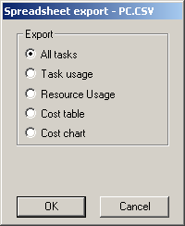
The options are ..

ALL TASKS – export the whole database fields including summary tasks (but not blank lines and row sub headings)
TASK USAGE – exports periodic resource hours per task
RESOURCE USAGE – exports periodic resource hours for each individually named resource
COST TABLE – exports periodic cost data for resources and cost types
COST CHART – exports the periodic cost data for each task (not summaries)

