Border – Editing standard ones

FRAME

By default a FRAME that is blue is drawn around the chart. To change or remove it select FORMAT menu, and EDIT ....
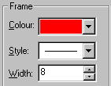
The FRAME colour for all the BORDER is controlled by the next option.. the STYLE which is blue by default and a line style and width.

The margin between the Frame/Border and the outside of the chart is determined by GAPS option and is set at 5mm all around.

It is possible to place a more elaborate Border around the chart with boxes and text. This colour is also used to differentiate the three boxed areas for the Border on the top, bottom and right of the paper.

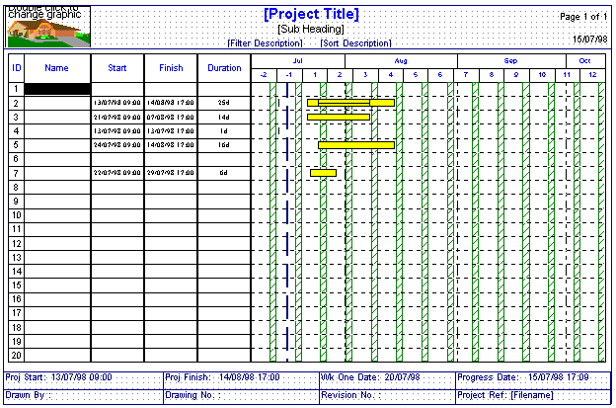

DIFFERENCE BETWEEN FREEFORM TEXT ON THE CHART AND IN THE BORDER

The method of putting in the freeform text in the BORDER area is slightly different after clicking on the T icon.

In the chart area, a click opens a box and that boxes resizes wider and deeper as more text is typed in it. In the BORDER, you draw a TEXT BOX after the T icon and the text must fit within it. If not, the box must be resized.
STANDARD BORDERS

This feature is aimed at creating a layout around the chart to three sides(maximum). There are 12 standard layouts (see later in chapter) and they can be ..
- turned on or off
- edited
- new one created and saved
- switched from one layout to another

To open a standard layout, FORMAT menu, BORDER and OPEN .... and open the BORDERS sub directory.

This will list all the standard border files (.bdr) and click on a particular file - the layouts are shown later.

This will place the BORDER around the chart - fitting the layout to whatever size of paper.

Dots appear in the Border area – but are not printed out.

In order that a particular border is used as a default for all new files, choose the OPTIONS menu, PREFERENCES, GENERAL and click on the BORDER options at the bottom left of the window.

In any standard layout…
- Pre-formatted FREEFROM TEXT may already be placed inside the border (eg TENDER above)
- PRE-FORMATTED information is extracted from the project (eg PROJECT TITLE above)
- GRAPHIC files can be inserted
- TEXT can be inserted
- Any entries can be edited or deleted
- Change the margin heights of the border and the gap between the border and the chart.

Important
The BORDER layout will fit on the edge of the paper and the chart will fit the rest of the page.
The BORDER layout of boxes is LOCKED by default, and the boxes cannot be increased or decreased until this option is turned off by selecting FORMAT menu, BORDER & LOCK POSITIONS – so that the tick is removed.

• Pre-formatted FREEFORM TEXT

To edit the text, click on the text and this will highlight it and change the text in the EDIT box at the top right of the screen ...
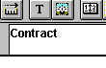
When finished, click on the chart area in a cell on the left and it will repaint the text.

• Pre-formatted information

In most of the standard borders, much of the text is created automatically. In this example below, all the text at the top is taken from the project automatically and has not been typed in as freeform text. Therefore, here the PROJECT TITLE is only shown if the Project Title is entered in the normal way - by the FORMAT menu TITLE ..
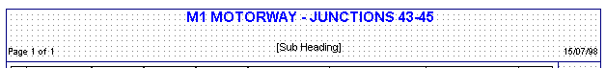

• Delete information

Click on the text and then EDIT menu, DELETE FREEFORM TEXT. This will erase this project information.

• Extend text area

In most cases for standard borders, the text boxes are restricted to one line and therefore if more lines of text are added (for instance in the Project Title), it will not show. The system does not allow the size or position of text boxes to be edited as the default is set to locking their initial positions. To remove this, FORMAT menu, BORDER and LOCK POSITIONS.

To stretch the text area, click on the text and drag any of the SQUARES. If you drag the centre one at the bottom down, it will increase the depth of the text area to make room for both the lines ....
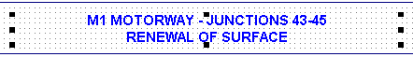
If required to hide the Border while inputting data on the chart, click on the FORMAT menu, BORDER & SHOW. To reshow the same Border, click on the FORMAT menu, BORDER & SHOW again.

Important
If you edit a standard Border, you must save the Border to a file (otherwise if you load it later, it would display the original default layout). To save a Border, click on the FORMAT menu, BORDER & SAVE AS. The border is saved as a file for use with any project in future.

• Edit existing graphics

In certain standard Borders, example graphics files are already inserted. In order to change the graphic, double click on it and a window will prompt for you to choose another file ...just click on the BROWSE button to find the file.

• Delete graphics

Click on the graphic area once (highlighting it) and EDIT menu, DELETE GRAPHIC.

• Highlight project information

Click on the text, for instance project title, in order to highlight the text. The default background colour is transparent, so to enclose it in a frame with a fill colour, then double click on the text to bring up the FREEFROM TEXT window. Then, click OFF the TRANSPARENT option, choose the fill colour by clicking on the DOWN ARROW for COLOUR and click ON the DRAW BORDER option for the frame.

• Edit the font of any text

Click on the text once to highlight it, then double click on the text and the window will show the current settings, click on SELECT and choose another font ...

• Change project data displayed

Click on the text once to highlight it, then double click on the text and the window will show the current settings. Click on the DOWN ARROW opposite DISPLAY and change it to any of the options in the list by scrolling.

• Move text around

In the Border, click on the text to highlight it. Then to move the mouse into the centre of the text and a CROSS will appear. Hold down the left hand mouse button and drag the box to the new position and release the mouse button.
Remember the LOCK POSITIONS option must be turned off.

• Input new text

In order to add extra text, it is important to realise that text placed on the Border have a defined area - even if it is blank and text cannot be placed over other text areas. This area is clearly seen when you click on some text - a number of squares are drawn around the text.

To insert text, it is best to zoom up the screen to full size. Then first click on the T icon in the toolbar, and the cursor will change to a +A - if the mouse goes over an existing text area thick black cross will appear. Text can only be placed when the +A is showing.

To create the text box, hold the left mouse button down and drag the mouse to draw a rectangle and release the button and the box will appear.

Then double-click inside the squares and the cursor will start blinking ready for the first text character to be typed. When finished click on the T icon to end the text mode.

Important
In order to input more than one row of text, press the ENTER key - but you must make sure the TEXT BOX is large enough to accommodate it. In order to resize the box, double click on it and grab any of the squares around the text and drag them - holding the left mouse button down.

The chart always fits into the available paper area. If any Border is opened, the chart is shrunk inside the Border automatically.

• Changing the Border area

In order to extend the Border area itself, first ensure the Border that needs changing is present on the screen and then click on FORMAT menu, BORDER & EDIT.

The BORDER is present on only 3 sides and the area of the top, bottom and right areas are controlled separately in the DIMENSIONS boxes. The PREVIEW shows how the border looks in relation to the whole page.

The margin between the Border and the outside of the chart is determined by GAPS option.

When the border dimensions are changed the existing BORDER text and graphics and chart will fit into the new format.

• Saving the Border

If a Border is changed, when the file is saved, the new border is saved as well only for that file. If a new file is opened, the default border layout is used.

If the newly edited border is to be saved, it can either overwrite the existing border file or be saved to a new border file name, by selecting FORMAT menu, BORDER, SAVE AS.

• Grids & Snapping

These options are available by selecting the FORMAT menu, BORDER, GRID SNAPPING.

When a Border is opened, the area is defined using dots on the screen as a grid to assist in positioning text. This can be shown or hidden and the interval between dots can be varied.

Snapping is turned ON by default and means that when drawing boxes or hanging the position of any side of the frame around the text, the lines line up on the nearest line of dots.

Important
When resizing boxes or editing text, it is useful, to zoom the screen up to a larger size by the VIEW menu, ZOOM.
BORDER FILES

All Borders are contained in the BORDERS sub directory and there are 12. By default the Borders are not shown on the start up screen. To access a Border, click on FORMAT menu, BORDER & OPEN.
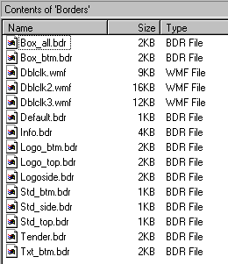

box_all.bdr
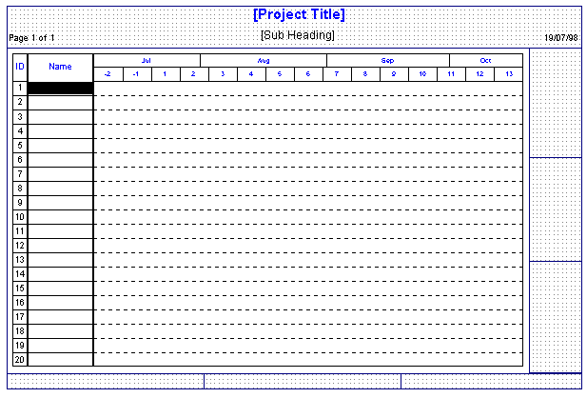
box_btm.bdr
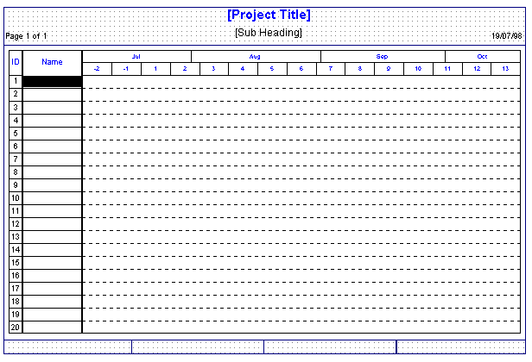

default.bdr
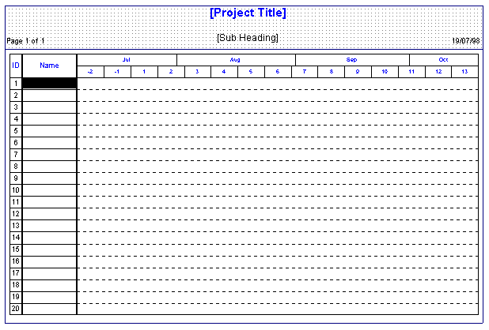

info.bdr
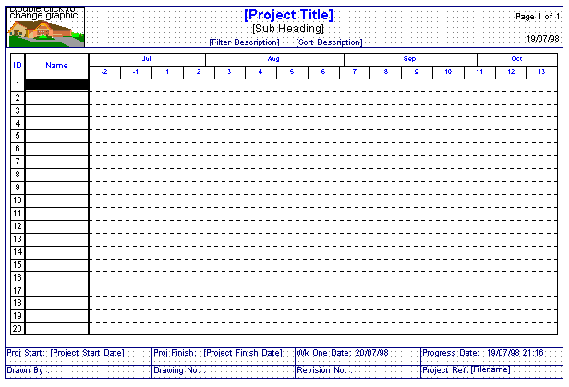

logo_btm.bdr.
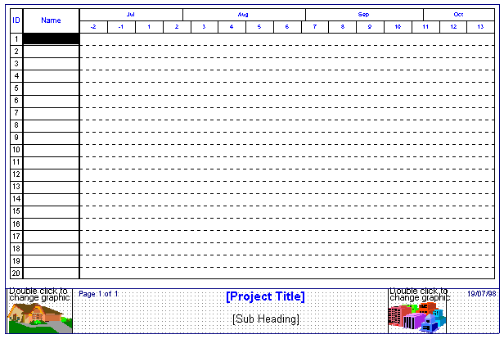

logo_top.bdr
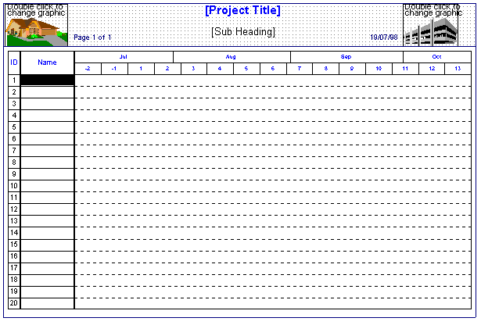

logoside.bdr
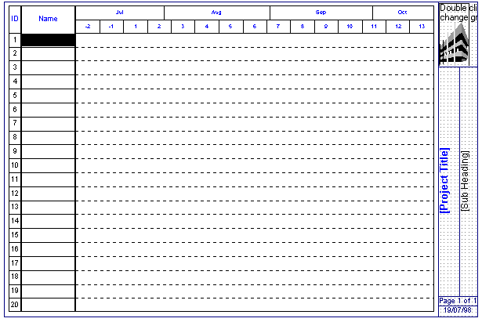
std_btm.bdr
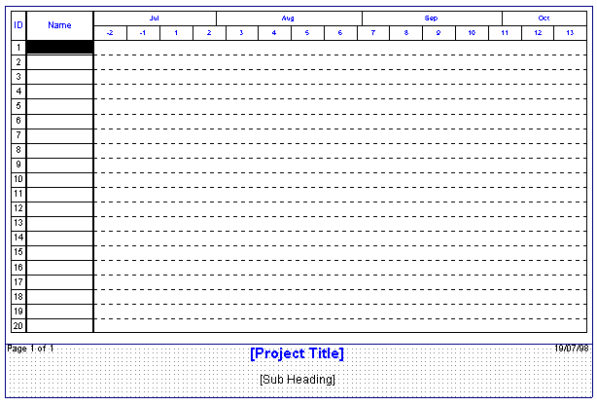

std_side.bdr
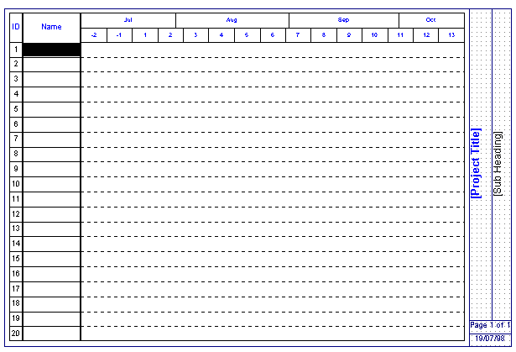

std_top.bdr
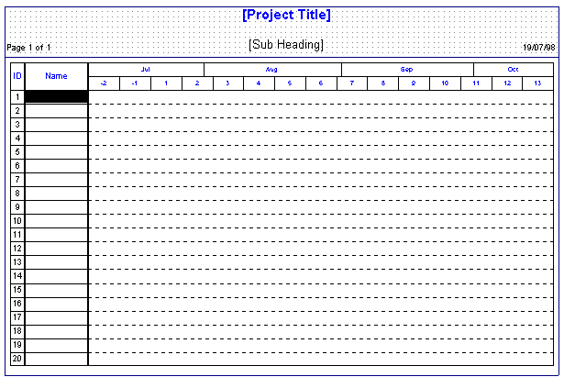

tender.bdr
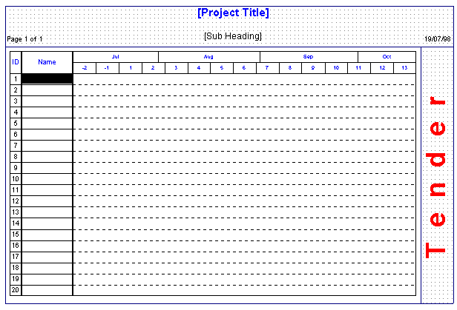

txt_btm.bdr
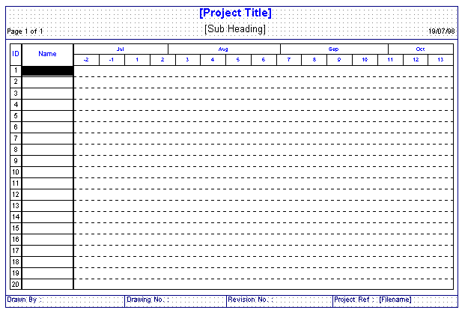

Borders – creating new ones

To create a new layout from scratch, click on the FORMAT menu, BORDER and NEW.

This brings up the EDIT BORDER window..
- In the DIMENSIONS, the width of each of the three sides are input ( a value of zero means no border on that side).
- FRAME controls the colour of the rectangle on each side and the line style.
- The GAP is the gap between the chart and the border.

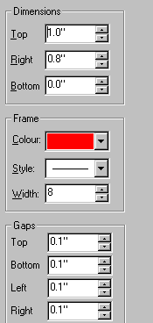
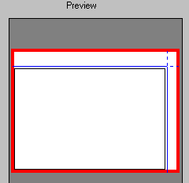
The following options, would place 2 empty boxes for the Border around the chart.

When drawing boxes or inputting text, it is useful, to zoom the screen up to a larger size by the VIEW menu, ZOOM.

• Company Logo

To insert any graphics file, click on FILE menu and IMPORT GRAPHICS. The cursor appearance will change. Then hold down the left hand mouse button and draw a rectangle on the screen in the Border area. As the mouse is released, the user is prompted for the File. After choosing the file and clicking on OK, the graphic is drawn in the box. The graphic can be stretched or condensed by dragging at the corners or the sides of the image. To move the image, click on the centre of the graphic and drag it anywhere inside the Border area.

• Freeform Text

Next, text can be placed anywhere in the Border and the font, colour and background colour can be user defined.

First, click the T icon and then holding down the left hand mouse button, draw a box outline. This will create an text box outline.

Then double click in the centre of the outline and a BOX will open with the cursor blinking at the left. More than line of text can be entered by using the ENTER key.

To end the text, click on the T icon and the text will display using the default font of 12pt and black lettering on a white background. To change the font and background colour, double click on the text, edit the current settings.

• Project Information

Click on the T icon and draw a TEXT BOX. Click on the box and then double click inside the box and an EDIT FREEFORM TEXT window appears and click on the DOWN ARROW opposite DISPLAY. You can pick between several fields of project information ....
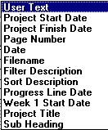

To show the Project Title, click on the option on the list ..
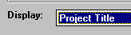

If the TITLE is not input yet, it will show the PROJECT INFORMATION FIELD in a bracket ..
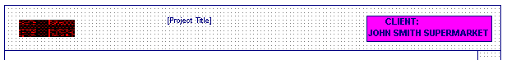

When the TITLE is input, it will appear automatically ...but at the default font of 12pt.
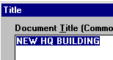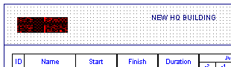

The font can be changed by double clicking on the text ..and click on SELECT.

• Vertical Freeform Text

To create vertical text down the side - click on the T icon and drag a box that is longer vertically.

Click inside the box and type the text (it will not all show inside the box as the default is that text is shown horizontal - but it will show in the ENTRY BAR at the top of the screen)

Then double click on the text box and in the EDIT BOX, change the settings to ..
DOWN & a bold and larger font size ...( FRAME & BACKGROUND colour can be placed around the text by changing options in the BACKGROUND section.

If the text box needs to lengthened or widened, then remember to take off the LOCKED POSTIONS option before.

• File Name

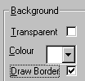
To put a file name in a box , first create a TEXT BOX as before and click in the box and then double click again. In the FREEFORM TEXT window, click off TRANSPARENT and DRAW BORDER on.

Then in the DISPLAY, click FILENAME on the list.

The BORDER can be saved as a FILE - to be used for the future, by FORMAT menu, BORDER & SAVE AS.

Important
If you are regularly going to use a border, it can be set as a default for all new files and it will appear automatically. Click on OPTIONS menu, PREFERENCES & GENERAL (Tab)... then use click ON - USE BORDER FILE and then BROWSE to find the Border file.

